GSFC ESDIS CMO
6/6/2018
Released

National Aeronautics and
Space Administration
Goddard Space Flight Center
Greenbelt, Maryland

Revision 1.2
Earth Science Data and Information Systems (ESDIS) Project, Code 423

Unified Metadata Model - Variables (UMM-Var)

Signature/Approval Page

Prepared by:
Name |  | Date
Title/Role
Organization
Reviewed by:
Name |  | Date
Title/Role
Organization
Approved by:
Name |  | Date
Title/Role
Organization
Concurred by:
Name |  | Date
Title/Role
Organization

[Electronic] Signatures available in B32 Room E148
online at: / https://ops1-cm.ems.eosdis.nasa.gov/cm2/
Preface
This document is under ESDIS Project configuration control. Once this document is approved, ESDIS approved changes are handled in accordance with Class I and Class II change control requirements described in the ESDIS Configuration Management Procedures, and changes to this document shall be made by change bars or by complete revision.

Any questions should be addressed to: esdis-esmo-cmo@lists.nasa.gov
ESDIS Configuration Management Office (CMO)
NASA/GSFC
Code 423
Greenbelt, Md. 20771

Abstract
This document describes the Unified Metadata Model for Variables (UMM-Var) to be used by the NASA Earth Science community and addresses the need for describing the types of variables that exist within data products that are described by the UMM-G metadata records. Developers, engineers and architects should reference this document and the UMM as a guide while implementing CMR components, CMR clients or services that make use of the CMR or CMR clients. Data providers should use this model as a guide during metadata generation.

This version of the variable model focuses on what is the minimum variable metadata needed to support the User Interface/User Experience (UI/UX) leading to an improved user experience. Since there will be many thousands of variables in the CMR, it also supports the notion of auto-population of variable metadata records. This aims to reduce the workload on the metadata curator in their task to manage variable metadata over time.

Keywords: UMM-Var, UMM-Common, UMM-S, UMM-G, Variables, NASA Earthdata Search, EOSDIS, ESDIS, CMR
Change History Log

Revision | Effective Date | Description of Changes
V0.8.0 | July 2015 | - Provisional NASA Internal Review Release.
V0.9.0 | August 2015 | - Provisional NASA Internal Review Release.
V1.0.0 | September 2015 | - Updated from the September Earth Science Data and Information System (ESDIS) Standards Office (ESO) review comments.
V1.0.0 | July 2016-Sep 2017 | - Reworked model to be "Variable" centric versus "Parameter" centric.  - Kept the version number the same to match what the CMR has for the implemented version number.
V1.1.0 | April 2018 | - Removed the required constraint on science keywords and removed the Service definition.
V1.2.0 | June 2018 | - Revised to address the ESO UMM-Var 10/2017 review comments.

Table of Contents
1 Introduction 8
1.1 Purpose 10
1.2 Scope 10
1.3 Impact 10
1.4 Copyright Notice 10
1.5 Feedback 10
1.6 Document Conventions 11
1.7 Related Documentation 11
1.7.1 Applicable Documents 12
1.7.2 Reference Documents 12
2 Unified Metadata Model - Variables 13
2.1 Variable Context Diagram and Metadata Model Relationships 13
2.2 Use Cases 13
2.2.1 Browse Variables of a Collection 13
2.2.2 Faceted Browse 15
2.2.3 Update Variable Associations 18
2.2.4 Search Relevancy Ranking 20
2.2.5 Cross-site Data Subsetting 22
2.2.6 Access Variables, including Ancillary Variables (extension of the Cross-Site Subsetting Use Case). 27
2.2.7 Integrating Global Imagery Browse Services (GIBS) with Web-Based Clients 28
2.2.8 Measurement Comparison of two in-situ measurements of Species X 30
2.3 UMM-Var Metadata Model 32
2.3.1 Variable 34
2.3.1.1 Name [R] 34
2.3.1.2 LongName [R] 44
2.3.1.3 Definition [R] 44
2.3.1.4 Unit [R] 45
2.3.1.5 DataType [R] 46
2.3.1.6 Scale 47
2.3.1.7 Offset 48
2.3.1.8 VariableType 49
2.3.1.9 VariableSubType 49
2.3.2 Characteristics 50
2.3.2.1 GroupPath 50
2.3.3 ScienceKeywords 51
2.3.3.1 ScienceKeywords 52
2.3.4 FillValues 52
2.3.4.1 Value [R] 53
2.3.4.2 Type [R] 53
2.3.4.3 Description 54
2.3.5 Dimensions [R] 54
2.3.5.1 Name [R] 55
2.3.5.2 Size [R] 55
2.3.6 ValidRange 56
2.3.6.1 Min 57
2.3.6.2 Max 57
2.3.6.3 CodeSystemIdentifierMeaning 57
2.3.6.4 CodeSystemIdentifierValue 58
2.3.7 Measurements [O] 58
2.3.7.1 MeasurementName 59
2.3.7.1.1 Object [R] 61
2.3.7.1.2 Quantity [R] 62
2.3.7.2 MeasurementSource 62
2.3.8 Sets 63
2.3.8.1 Name [R] 68
2.3.8.2 Type [R] 69
2.3.8.3 Size [R] 69
2.3.8.4 Index [R] 70
2.3.9 Sampling 70
2.3.9.1 SamplingMethod [R] 71
2.3.9.2 MeasurementCondition 71
2.3.9.3 ReportingCondition 71
Appendix A: Tags Glossary 73
Appendix B: Inputs 74
Appendix C: Keywords and Measurements Governance Structure 76
Appendix D: Analysis of CSDMS and CF Standard Names as a Source of Tagging 78
Appendix E: Abbreviations and Acronym List 80

List of Figures
Figure 1: Variable (UMM-Var) as part of the UMM context diagram 15
Figure 2: Use Case: Browse Variables of a Collection 16
Figure 3: Activity Diagram: Browse Variable of a Collection 16
Figure 4: Sequence Diagram: Browse Variables of a Collection 17
Figure 5: Use Case: Faceted Browse 18
Figure 6: Activity Diagram: Faceted Browse 19
Figure 7: Sequence Diagram: Faceted Browse 19
Figure 8: Use Case: Update Variable Associations 20
Figure 9: Activity Diagram: Update Variable Associations 21
Figure 10: Sequence Diagram: Update Variable Associations 22
Figure 11: Use Case: Search Relevancy Ranking 23
Figure 12: Activity Diagram: Search Relevancy Ranking 23
Figure 13: Sequence Diagram: Search Relevancy Ranking 24
Figure 14: Use Case: Cross-site Data Subsetting 25
Figure 15: User interface view for a user to choose a subset of variables for the AIRX2RET collection 26
Figure 16: User interface view for a user to choose a subset of variables for the OMDOAO3 collection 27
Figure 17: User interface view for a user to choose a subset of variables for the MOD08 collection 27
Figure 18: Activity Diagram: Cross-site Data Subsetting 28
Figure 19: Sequence Diagram: Cross-site Data Subsetting 28
Figure 20: Use Case: Access Variables including Ancillary Variable 29
Figure 21: Activity Diagram: Access Variables including Ancillary Variable 30
Figure 22: Sequence Diagram: Access Variables, including Ancillary Variable 30
Figure 23: Use Case: Integrating GIBS with web-based clients 31
Figure 24: Activity Diagram: Integrating GIBS with web-based clients 32
Figure 25: Sequence Diagram: Integrating GIBS with web-based clients 32
Figure 26: Use Case, Measurement Comparison of two in-situ measurements of Species X 33
Figure 27: Activity Diagram: Measurement Comparison of two in-situ measurements of Species X 34
Figure 28: Sequence Diagram: Measurement Comparison of two in-situ measurements of Species X 34
Figure 29: UMM-Var Metadata Model 35
Figure 30: The sea_surface_temperature variable highlighted within the VIIRS_SST_NPP L3C-GHRSST-SST Data Set 37
Figure 31: The sea_surface_temperature variable structure 37
Figure 32: A sea_surface_temperature variable plot 38
Figure 33: The quality_level variable structure 38
Figure 34: he LST_Day_1km variable highlighted within the MOD11A1 Data Set 39
Figure 35: The LST_Day_1KM variable structure 39
Figure 36: A LST_Day_1km plot 40
Figure 37: The QC_Day variable structure 40
Figure 38: The CERES_SW_Filtered_Radiances_Upwards variable highlighted within the CER_BDS_Aqua-FM3_Edition1 Data Set structure 41
Figure 39: The CERES_SW_Filtered_Radiances_Upwards variable structure 41
Figure 40: CERES_SYN_1km Data Set structure 42
Figure 41: The SW_TOA_Clear-Sky variable highlighted within the CERES_SYN_1km Data Set structure 42
Figure 42: The SW_TOA_Clear-Sky variable structure 43
Figure 43: A SW_TOA_Clear-Sky variable 43
Figure 44: The mole_fraction_of_carbon_dioxide_in_free_troposphere variable highlighted within the AIRS.2012.02.09.L3.CO2Std008 data set 44
Figure 45: The mole_fraction_of_carbon_dioxide_in_free_troposphere variable structure 44
Figure 46: A mole_fraction_of_carbon_dioxide_in_free_troposphere plot 45
Figure 47: Subset variable choices for the MOD08 collection 66
Figure 48: SMAP_L3_SM_P variables representing the morning (AM) crossing 69
Figure 49: SMAP_L3_SM_P variables representing the afternoon (PM) crossing 70
​Figure 50: Suggested Governance Structure 78

List of Tables
Table 1: Cardinality 13
Table 2: Applicable Documents 14
Table 3: Reference Documents 14
Table 4: Example values for the variable's unit 47
Table 5: HDF4 user guide as a possible source 48
Table 6: HDF5 user guide as a possible source 49
Table 7: Tags Glossary 75
Table 8: Abbreviations and Acronyms 82

Introduction
The NASA Earth Observing System Data and Information System (EOSDIS) generates, archives, and distributes massive amounts and a large variety of Earth Science data via twelve Distributed Active Archive Centers (DAACs). Reliable, consistent and high-quality metadata are essential to enable cataloging and proper use of these data. To improve the quality and consistency among its metadata holdings, EOSDIS has developed models for metadata that it archives and maintains. This model aims to document vital elements that may be represented across various data models and standards and unify them through mainstream fields useful for data discovery, data use, and service invocations. This unified model, aptly named the Unified Metadata Model (UMM) will be used by the CMR and will drive search metadata cataloged within that system and retrieve data discovered through such searches.

This document describes the Unified Metadata Model for Variables (UMM-Var). It includes the uses cases for UMM-Var model itself and its relationship with other UMM models, element descriptions, and examples.

Listed below are some definitions with examples that will help the reader understand this model.

- Measurement: The act or process of measuring an observable property, usually geophysical, geo-biophysical, physical, or chemical. In the case of air temperature, for instance, the object of the measurement is air and the property being measured is temperature. For models, it is a simulated observable property.
  - Using Scott Peckham's model as a basis for a measurement naming convention, the Measurement names can be expressed as: <<object, quantity>>, e.g. object = "Aerosol", quantity = "Optical Depth".
  - Examples: Aerosol Optical Depth, Air Temperature, Surface Albedo, Solar Irradiance, Surface Reflectance, Atmospheric Moisture, Methane Concentration, Sulphur Dioxide Concentration, Ozone Concentration.

- Variable: A named set of data that contains the recorded values of a measurement. In this context, the variable is described by its name and characteristics. For instance, a variable contained within the MYD08_M3V5 dataset is called: Optical_Depth_Land_Maximum. There are other variables in the set, including variables which contain information about geographic position and quality.

The description of the variable may include what was intended to be measured (i.e., the observable property, and how the variable was measured (e.g., measurement technique and the instrument used).

Variables may be classified as science variables, quality variables and ancillary variables (or other, when one of these classifications cannot be used). A variable can also be the output of a model.
  - Examples: Aerosol Optical Depth 550nm (Dark Target), Aerosol Optical Depth 550nm (Deep Blue, Land Only), Air Temperature (Daytime/Ascending), Air Temperature at 2m, Air Temperature at Surface (Daytime/Ascending), Air Temperature at Surface (Nightime/Descending), Relative Humidity (Daytime/Ascending), Relative Humidity (Nightime/Descending), Water Vapor Mass Mixing Ratio (Daytime/Ascending), Water Vapor Mass Mixing Ratio (Nightime/Descending), Methane Total Column (Nightime/Descending), SO2 Column Mass Density, SO2 Column Mass Concentration, Ozone - reported in parts per billion by volume.

- ​Sample Illustration:
  - Example 1:
    - Measurement:
      - Aerosol Optical Depth
    - Variables:
      - Aerosol Optical Depth 550nm (Dark Target) - this is a science variable example
      - Aerosol Optical Depth 550nm (Deep Blue, Land Only) - this is another science variable example
      - Deep_Blue_Aerosol_Optical_Depth_550_Land_QA - this is a quality variable example
      - Deep_Blue_Algorithm_Flag_Land - this is an ancillary variable example
  - Example 2:
    - Measurement:
      - Ozone Mixing Ratio reported in parts per billion by volume
    - Variable:
      - O3_ppbv - this is a science variable example
  - Example 3:
    - Measurement:
      - Integrated Column NO2 loading
    - Variables:
      - NO2_Column - this is a science variable example

The term "Measurement" is the act or process of measuring an observable property, and is mostly likely to be used as a search term, as an alternate to the Science Keywords. The term "Variable" is an artifact that represents a Measurement. The UMM-Var model is not interested in the direct measurement that the instrument made. It is the "feature of interest" and the "observed property" represented by the data that are of interest. The Variable class will be used to store metadata about each variable. The Variable metadata will consist of its name and other characteristics. The CMR Variable class can be utilized to simplify search and retrieval of data products at the variable level.

In terms of the data product and its file structure, variables are stored within a data granule, e.g. Aerosol Optical Depth 550nm (Dark Target), Aerosol Optical Depth 550nm (Deep Blue, Land Only), along with its associated data quality variables, and ancillary variables ( e.g. latitude, longitude information).

Purpose
The purpose of UMM-Var is to express a variable model applicable to CMR that stores variable metadata. In addition, the UMM-Var model is related to the other CMR metadata models, e.g. UMM-S, which supports the specification of variables which have associated services.

Note: the previous variable design principally addressed the concept of parameters. The parameter version of this model, known as UMM-P, sought to bridge the divide between variables and collection-level additional attributes. However, this new model, UMM-Var, considers variables in their own right. Now variables can be stored and discovered in ways described by a new set of use cases. Granule data may be subsetted by variable, or transformed in other ways, as supported by services. The user experience guides what selections and choices a user makes at the UI for typical data transformations, e.g. spatial subsetting, reprojection, reformatting, etc. The user is exclusively concerned about what choices are available for a specific data set and the back-end services take care of any needed processing.

This document provides information to the National Aeronautics and Space Administration (NASA) Earth Science community. Distribution is unlimited.

Scope
This document describes the Unified Metadata Model - Variables (UMM-Var) model.

Impact
This document outlines a model intended to be compatible with existing NASA Earth Science metadata implementations within the CMR. It will impact providers from NASA Distributed Active Archive Centers (DAACs), non-DAAC data providers, instrument PIs, Common Metadata Repository (CMR) client developers, metadata catalog developers, and users. Users will be impacted specifically in terms of data discovery and data use. This is very important for science research purposes.

Copyright Notice
The contents of this document are not protected by copyright in the United States and may be used without obtaining permission from NASA.

Feedback
Questions, comments and recommendations on the contents of this document should be directed to support@earthdata.nasa.gov

Document Conventions
Each section of this document describes an element of the model. Elements that feature in multiple models are fully documented in the UMM-Common model. Any references to the UMM-Common model are included, as required. Elements that are unique to the Variable model are documented in the following way:

- Element Specification: Identifies the individual fields for the element.
- Description: Provides background information on the purpose of the element and how it should be used. Any notes about the current usage of this element are documented here as well as any recommendations for usage or unresolved issues.
- Cardinality: Indicates the specification of counts for this element, summarized in the following table:
Table 1: Cardinality
Value | Description
1 | Exactly one of this element is required
0..N | This element is optional; up to and including N number of this element may be present
0..* | Optionally, many of this element may be present
1..* | At least one of this element is required, many may be present
1..N | At least one of this element is required, up to and including N number of this element may be present

Interaction diagrams presented in this document are based on the UML Notation.

Related Documentation
There is a document that fully describes metadata elements that are used in multiple models. This document, the UMM-Common (https://wiki.earthdata.nasa.gov/display/CMR/CMR+Documents) is documented separately. The Variable model makes several references to the UMM-Common throughout.

The latest versions of all documents below should be used. The latest ESDIS Project documents can be obtained from URL: https://ops1-cm.ems.eosdis.nasa.gov. ESDIS documents have a document number starting with either 423 or 505. Other documents are available for reference in the ESDIS project library website at: http://esdisfmp01.gsfc.nasa.gov/esdis_lib/default.php unless indicated otherwise.

Applicable Documents
The following documents are referenced within, are directly applicable, or contain policies or other directive matters that are binding upon the content of this document.

Table 2: Applicable Documents
CMR Life Cycle | https://wiki.earthdata.nasa.gov/display/CMR/CMR+Documents
UMM-Common | https://wiki.earthdata.nasa.gov/display/CMR/CMR+Documents
SERF | https://gcmd.nasa.gov/Aboutus/xml/serf/serf.xsd  https://gcmd.nasa.gov/add/serfguide/index.html
CMR End-To-End Services Study (Task 25) EED2-TP-025 | https://drive.google.com/open?id=0BzJ0Mge7A2GEQ0NlZ0tnQktlbnM

Reference Documents
The following documents are not binding on the content but referenced herein and amplify or clarify the information presented in this document.

Table 3: Reference Documents
Tags | http://en.wikipedia.org/wiki/Tag_%28metadata%29
Translators | Translators to ISO can be found at https://cdn.earthdata.nasa.gov/iso/resources/transforms/
XPath | XPath is a language for addressing parts of an XML document, designed for use with XSLT.
XLinks | http://en.wikipedia.org/wiki/XLink
MENDS | More information on the Base Metadata Requirements established by the MENDS group: https://wiki.earthdata.nasa.gov/display/NASAISO/NASA+Base+Metadata+Requirements http://www.w3schools.com/schema/el_choice.asp

Unified Metadata Model - Variables

Variable Context Diagram and Metadata Model Relationships
Figure 1 shows the UMM-Var metadata model at a high level and its relationships with other key models: Collection (UMM-C), Granule (UMM-G), and Service (UMM-S). It is a high-level diagram, with abbreviated models, showing the key associations between the new UMM-Var and the other models in the UMM. Note that the figure specifically highlights the Variable model's role in the context of the Unified Metadata Model.
​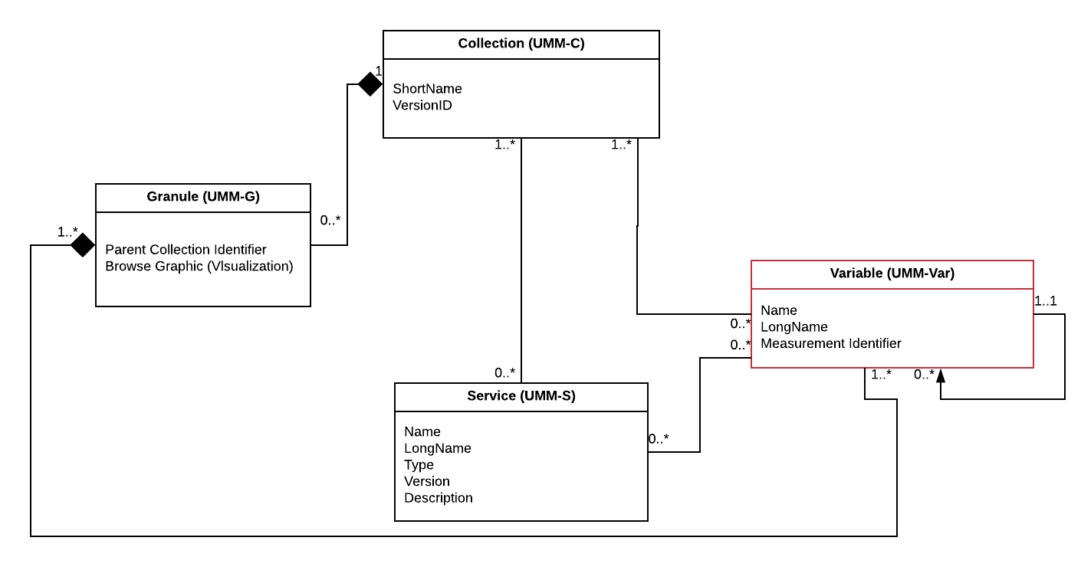​
Figure 1: Variable (UMM-Var) as part of the UMM context diagram

Use Cases
This section provides information about use cases identified for the UMM-Var. In keeping with the UML methodology, we provide a use case diagram showing the actor's interaction with the system. An activity diagram shows the flow of data, in terms of the user experience, and a sequence diagram which shows the sequences of actions within the system, and the key components of the system.

Browse Variables of a Collection
Scenario: A user starts with a collection and wants to know what variables it includes.

Outcomes: Enables a user without any knowledge of variable names to search for collections, select one, and be presented with a list of variables for that collection, grouped by measurement.

See the use case diagram below.
​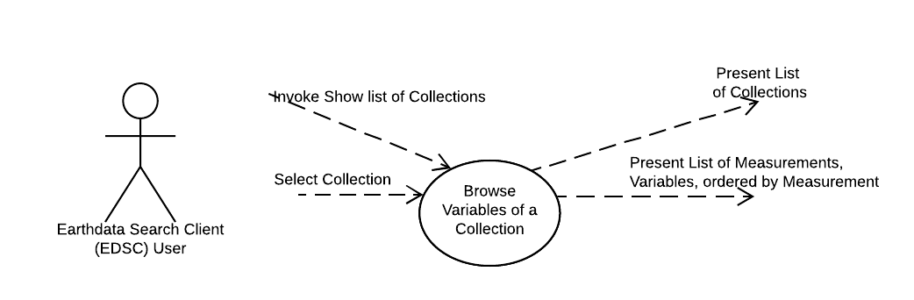​
Figure 2: Use Case: Browse Variables of a Collection

See the user experience activity diagram below.
​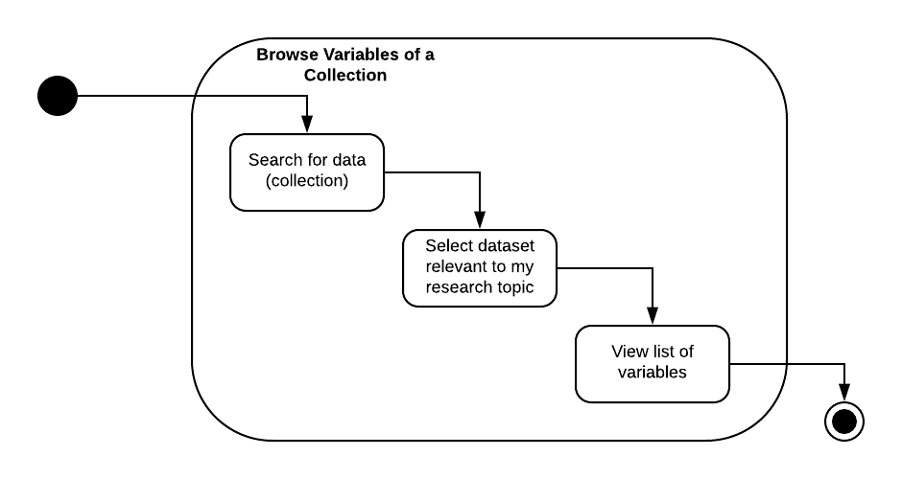​
Figure 3: Activity Diagram: Browse Variable of a Collection

See the system workflow sequence diagram below.
​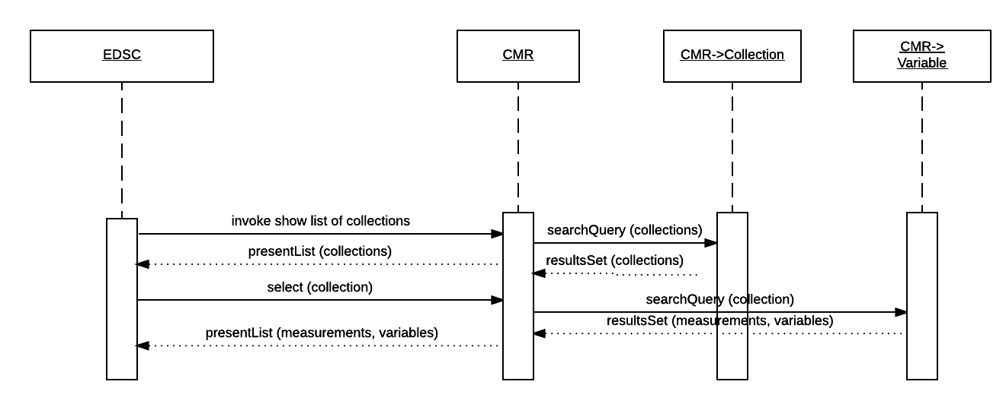​
Figure 4: Sequence Diagram: Browse Variables of a Collection

Faceted Browse
Scenario [a]: A user of a search tool, i.e. Earthdata Search Client (EDSC - https://search.earthdata.nasa.gov), can get a list of Measurement facets from the CMR.
Scenario [b]: A user of the EDSC can click on a "Measurement" facet value and constrain the lists to the collections that match the selected Measurement type and any other constraints (i.e. spatial, temporal) that have been selected.

Outcomes: A user of the EDSC, with no knowledge of the types of Measurements available within the CMR, can get a list of types of Measurements, and can further constrain the lists to Collections which match by selecting that type of Measurement, and any other constraints.
Note: The user can select a Measurement type to see the list of Variables available for that Measurement type, and an associated list of quality and ancillary variables. The association between Measurement types and Variables may be made previously by the Metadata Curator using the MMT, or a client specific to that provider.

Note: Scenarios [a] and [b] are related, in that the first represents a starting point for faceted browse, whereby the user can see a list of facets. Typically, the user wants to narrow the search criteria as much as possible, so starting with the list of facets (scenario[a]), the user selects one or more facets (scenario[b]) and via the EDSC UI, this yields a search result which displays those variables available in association with a specific Measurement type.

See the use case diagram below
​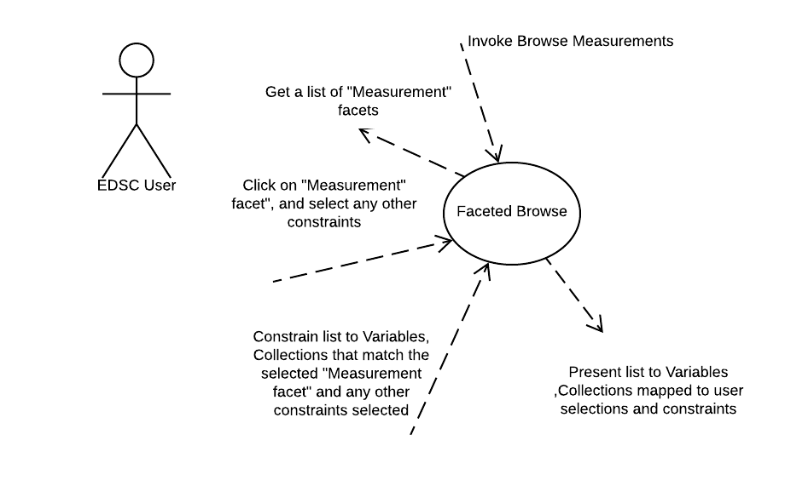​
Figure 5: Use Case: Faceted Browse

See the user experience activity diagram below
​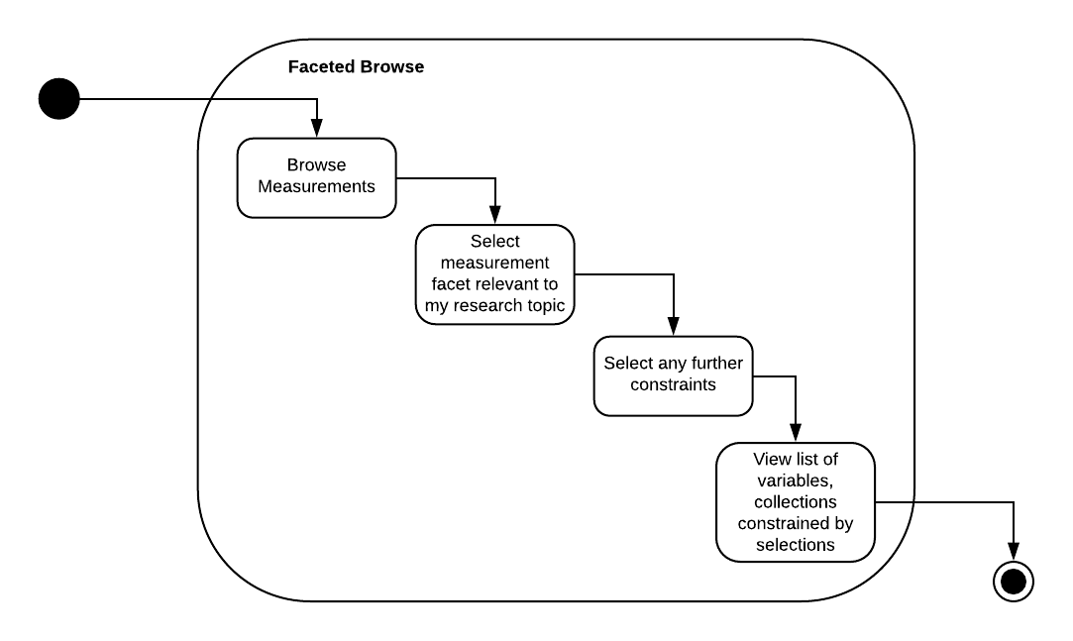​
Figure 6: Activity Diagram: Faceted Browse

See the workflow sequence diagram below
​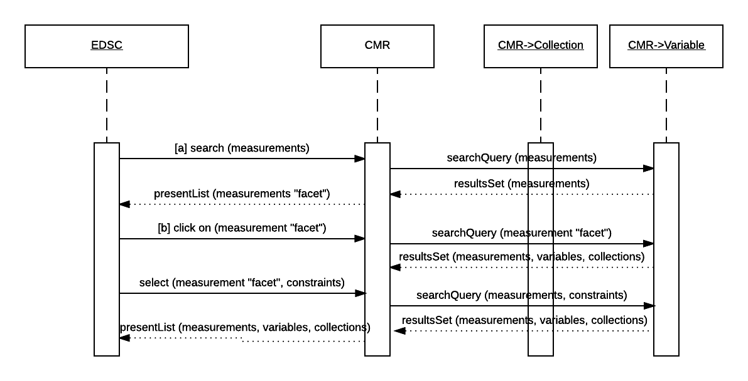​
Figure 7: Sequence Diagram: Faceted Browse

Update Variable Associations
Scenario [a]: A user of the CMR client, such as the Metadata Management Tool (MMT) or other suitable metadata curation tool, can associate multiple variables with a collection.
Scenario [b]: A user of the CMR client, can submit multiple collections and all of the variables listed for each collection.
Scenario [c]: A metadata curator can populate the list of valid measurements associated with variable with selections from the Science Keywords hierarchy, Community Surface Dynamics Modeling System (CSDMS) or NetCDF Climate and Forecast (CF) metadata convention.

Outcomes: The curator seeded the CMR with new valid measurements chosen from the Science Keywords hierarchy and allowed editors to maintain variable and collection associations. A metadata curation tool, e.g. MMT, or another suitable metadata curation tool, may be used to maintain/update the variable and collection associations.

See the use case diagram below.
​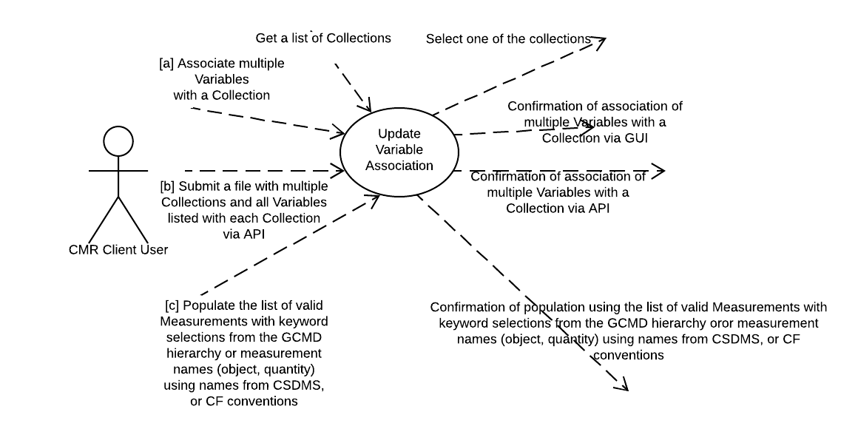​
Figure 8: Use Case: Update Variable Associations

See the user experience activity diagram below.
​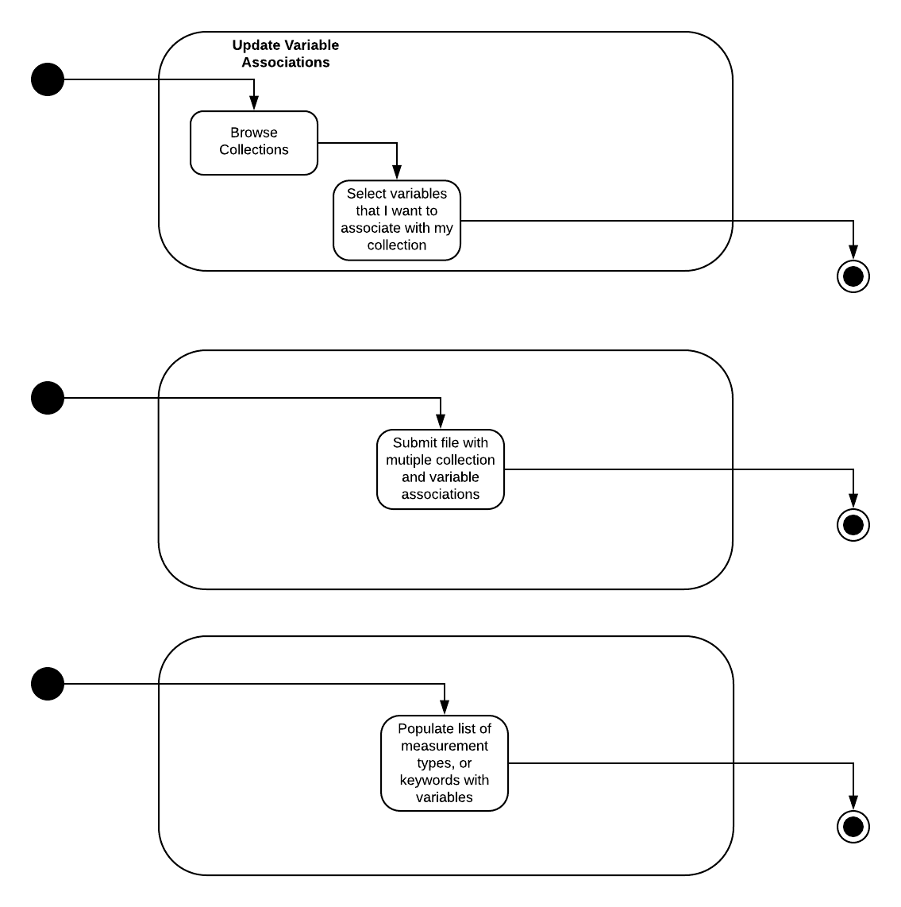​
Figure 9: Activity Diagram: Update Variable Associations

See the workflow sequence diagram below.
​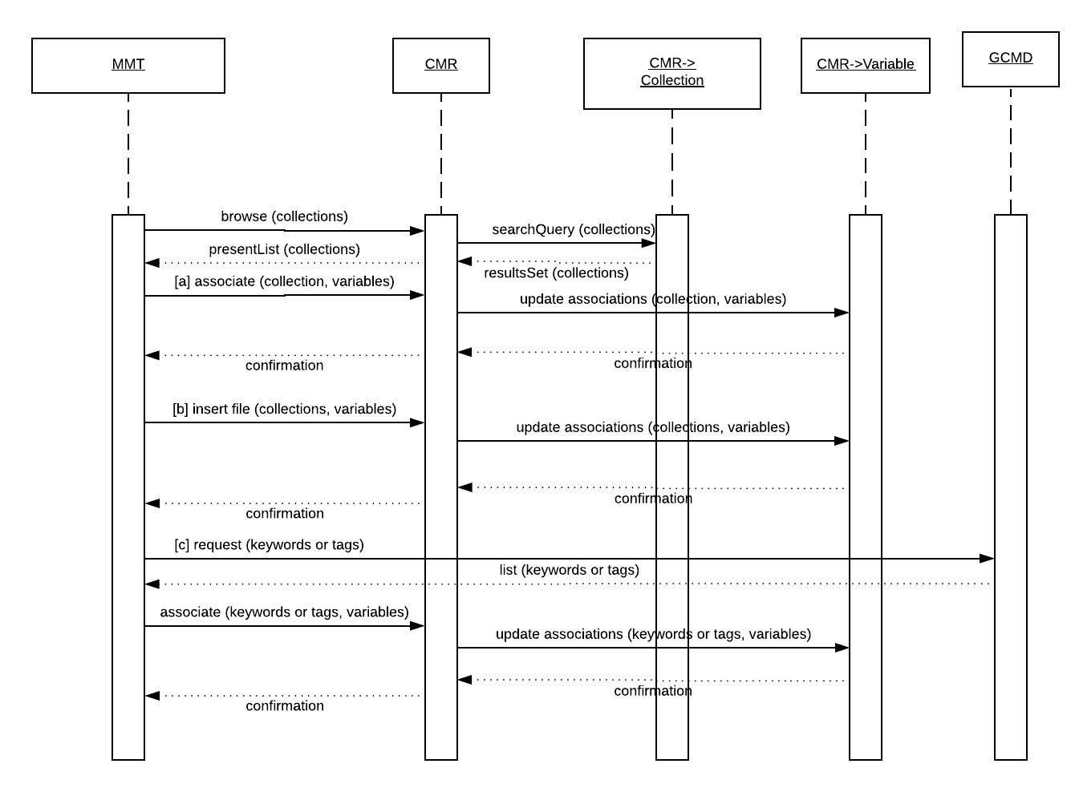​
Figure 10: Sequence Diagram: Update Variable Associations

Search Relevancy Ranking
Scenario: As a search engine (CMR), I can rank collections with a high relevance ranking when one or more of the search words appear in the measurement terms associated with the variables in the collection, as opposed to more generic fields such as the summary or references.

Outcomes: Returns to the user a list of Collections ranked by relevancy to the words used in the search term matching a measurement term.

See the use case diagram below.
​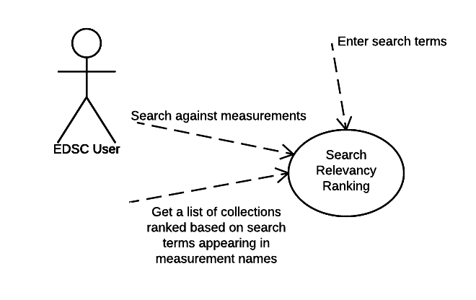​
Figure 11: Use Case: Search Relevancy Ranking

See the user experience activity diagram below.
​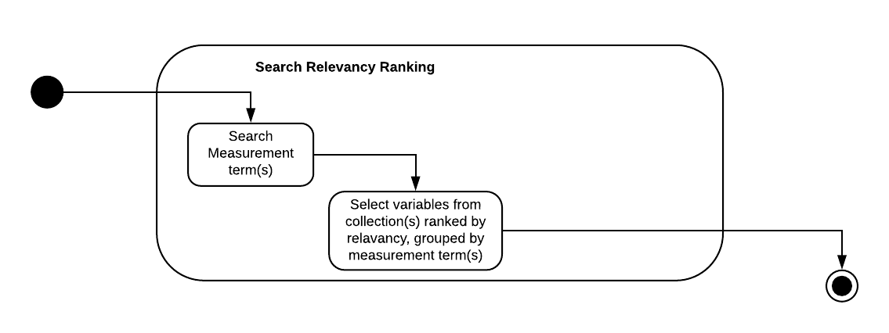​
Figure 12: Activity Diagram: Search Relevancy Ranking

See the workflow sequence diagram below.
​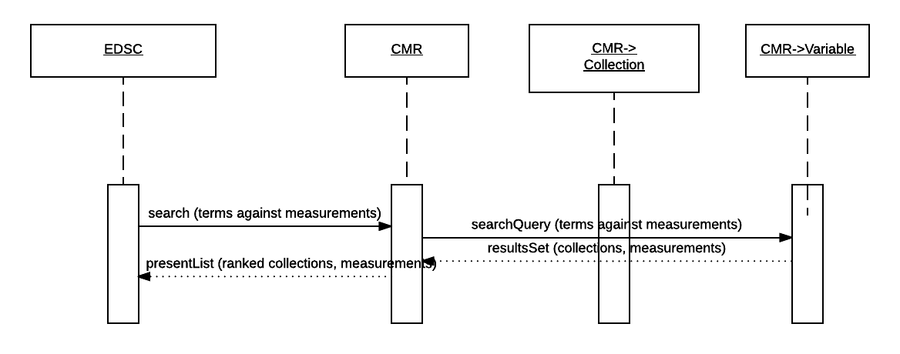​
Figure 13: Sequence Diagram: Search Relevancy Ranking

Cross-site Data Subsetting
Scenario: As a subsetting GUI, I can present the variables for a given collection in a logically categorized way, such as by measurement, and further subset the data into more specific groups based on additional criteria.

Outcomes: Enables users of a subsetting GUI to perform cross-site subsetting variables based on the selection of a collection and categorized by measurement. Cross-site subsetting occurs when a variable (by its association with a granule) can exist in more than one collection and these collections may be sourced from multiple sites (i.e. GES DISC, LAADS, etc.). The CMR can perform a cross-site search since it houses metadata from all sites. This use case enables a user to go on to perform subsetting via a GUI.

Note: In the example shown below, the measurement term used was "Ozone". This resulted in three collections being returned from the search: AIRX2RET v005, OMDOAO3 v003, and MOD08 v006. In the subsetting GUI, variables are shown grouped for each collection. The user will be able to subset the variable fields for specific granules of interest.

See the use case diagram below.
​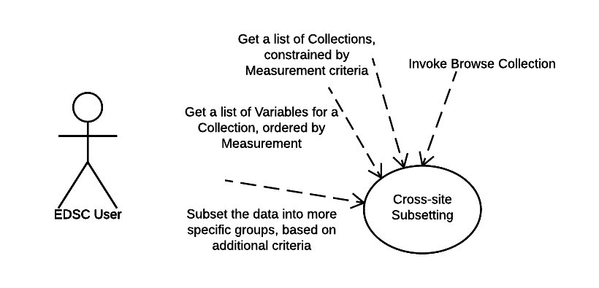​
Figure 14: Use Case: Cross-site Data Subsetting

​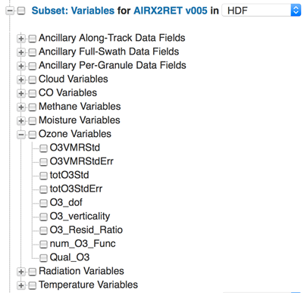​
Figure 15: User interface view for a user to choose a subset of variables for the AIRX2RET collection
​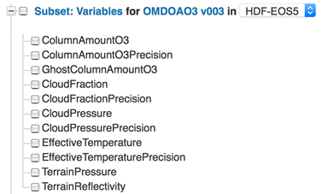​

Figure 16: User interface view for a user to choose a subset of variables for the OMDOAO3 collection
​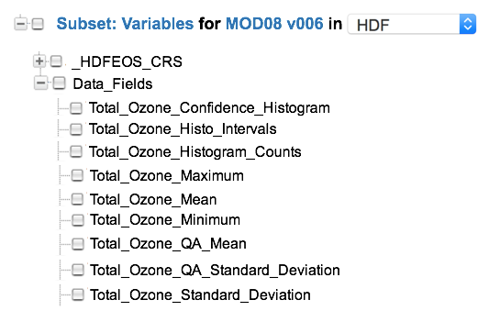​
Figure 17: User interface view for a user to choose a subset of variables for the MOD08 collection

See user experience activity diagram below.

​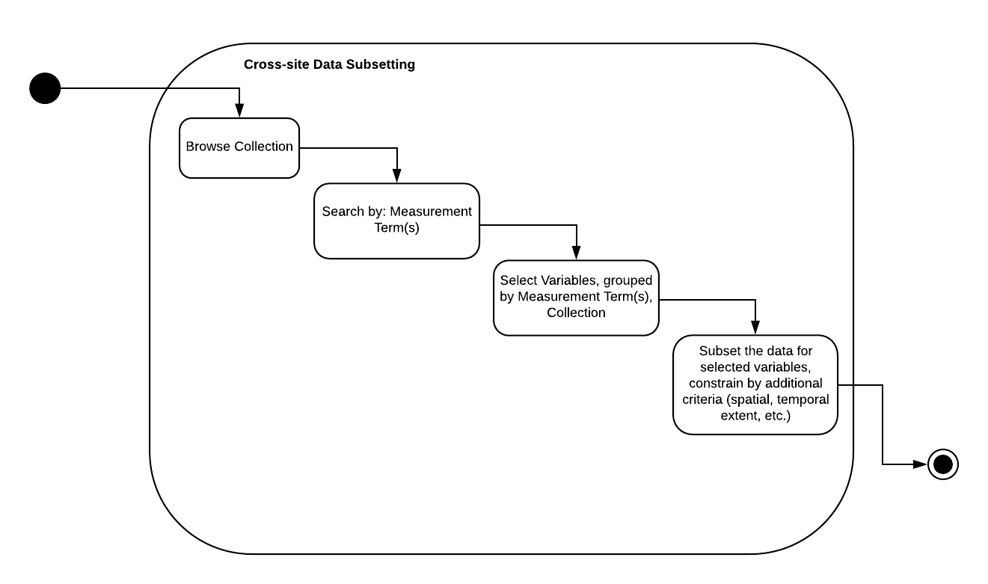​
Figure 18: Activity Diagram: Cross-site Data Subsetting

This following depicts the case where collections are searched for across DAACs. See the workflow sequence diagram below.

​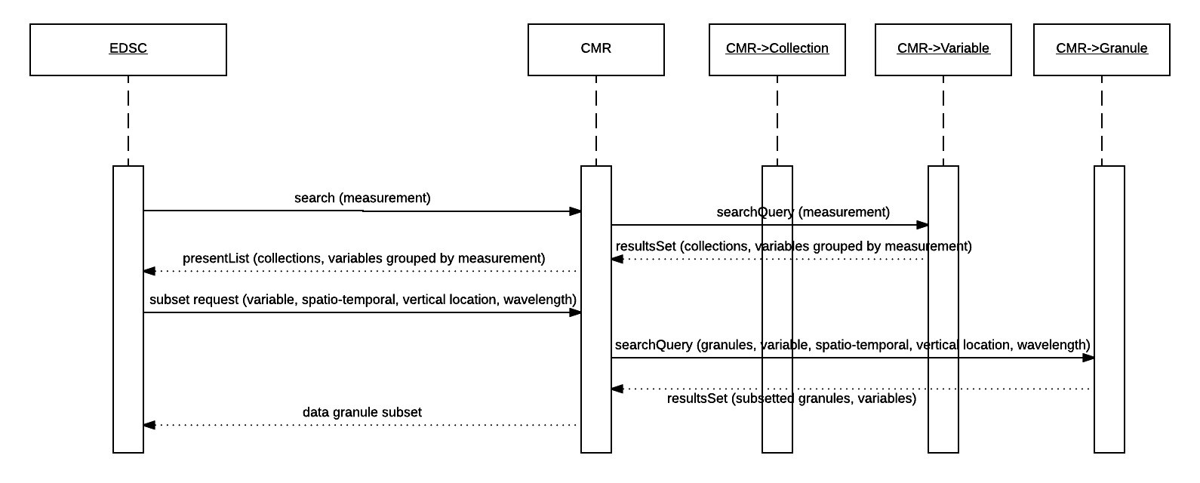​
Figure 19: Sequence Diagram: Cross-site Data Subsetting

Access Variables, including Ancillary Variables (extension of the Cross-Site Subsetting Use Case).
Scenario: The user starts with a list of science variables, e.g., {"sea surface height", "10.7 micron band", "NIR radiances", ... }, and wants to know which collections contain the specified variables (and may also want to know about data quality, instrument calibration, brightness temperature). These variables may be needed to fully understand the data.

Outcomes: Enables a user without any knowledge of the available variables to locate those variables of interest, and constrain these by collection metadata, e.g. calibration, spatial extent, temporal extent, spacecraft orbit location, etc. which contain a variable containing properties selected from the initial list of properties. Allows the subsequent discovery of associated variables, e.g. ancillary, calibration, geolocation, data quality variables, which are directly related to the science variable selected.

See the use case diagram below.

​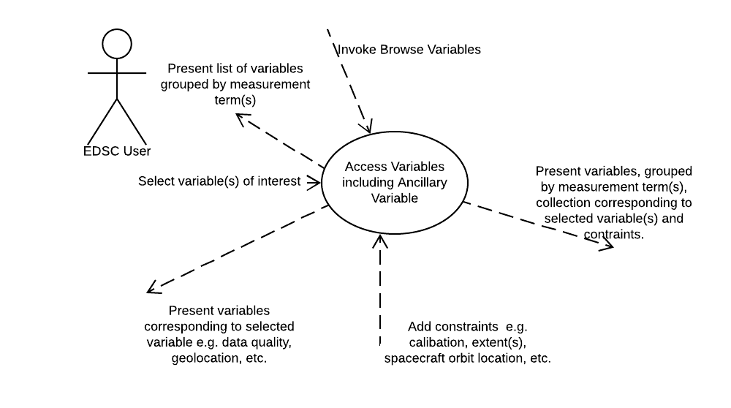​
Figure 20: Use Case: Access Variables including Ancillary Variable

See the user experience activity diagram below.

​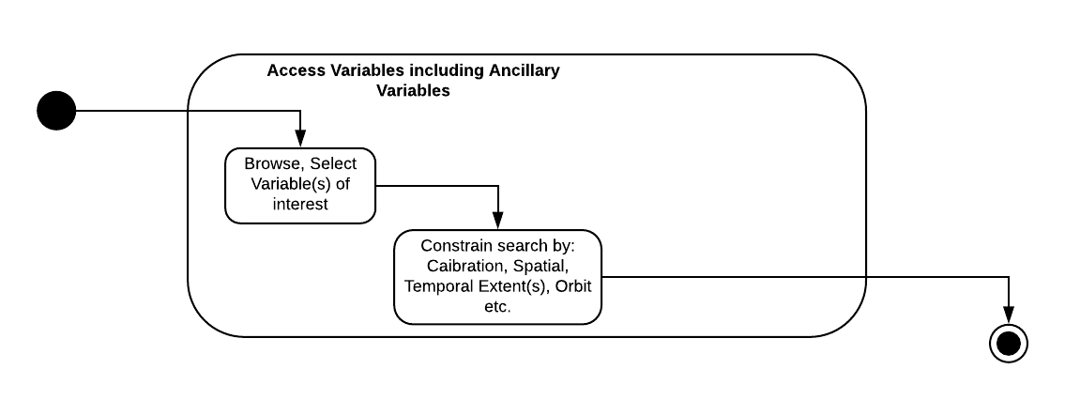​
Figure 21: Activity Diagram: Access Variables including Ancillary Variable

See the workflow sequence diagram below.

​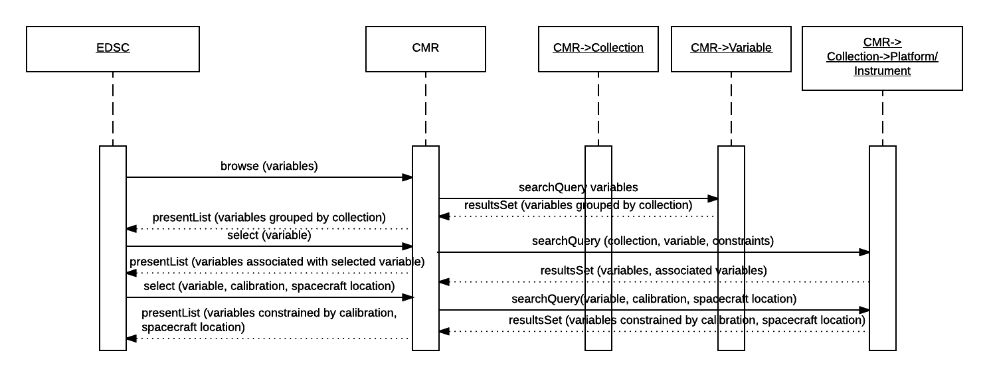​
Figure 22: Sequence Diagram: Access Variables, including Ancillary Variable

Integrating Global Imagery Browse Services (GIBS) with Web-Based Clients
Scenario: As a user of a GIBS client (e.g. EDSC, Worldview, GloVIS - https://glovis.usgs.gov/), I can view a pre-generated visualization for a specific granule or a daily composite of multiple granules with a specific collection and variable. Through CMR, I can locate the granules, the corresponding data variable from which the layer was generated, and any ancillary variables that need to go along with that variable (geolocation, data quality, etc.). Ideally, I can transform that information into a set of subsetting request URLs that will fetch just those data variables from the appropriate granules.

Outcomes: Allow users of a GIBS client to fetch data subsets based on their layer selections, and any associated variables.

Note: It may be a prerequisite for this use case to have a way to invoke "show layers" for a collection, and selected variable(s), per the GIBS client. Also, providers may be providing a single image per granule to GIBS, e.g. if it's a L3/L4 product. But for L1/L2 products, this is not always the case. For one provider, LP DAAC, the only non-composited L1/L2 granule imagery available is for the AST_L1T product.

See the use case diagram below.

​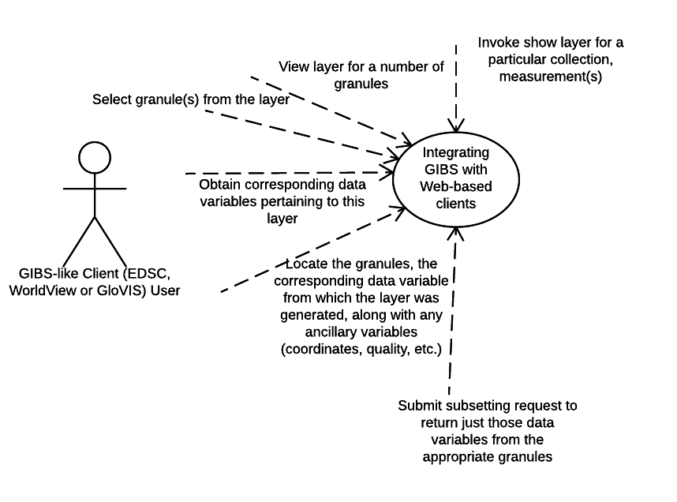​
Figure 23: Use Case: Integrating GIBS with web-based clients

See the user experience activity diagram below.

​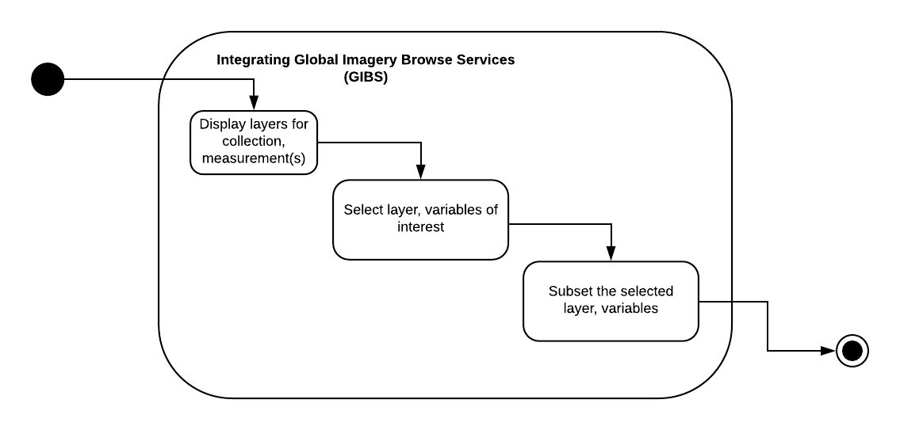​
Figure 24: Activity Diagram: Integrating GIBS with web-based clients

See the workflow sequence diagram below.

​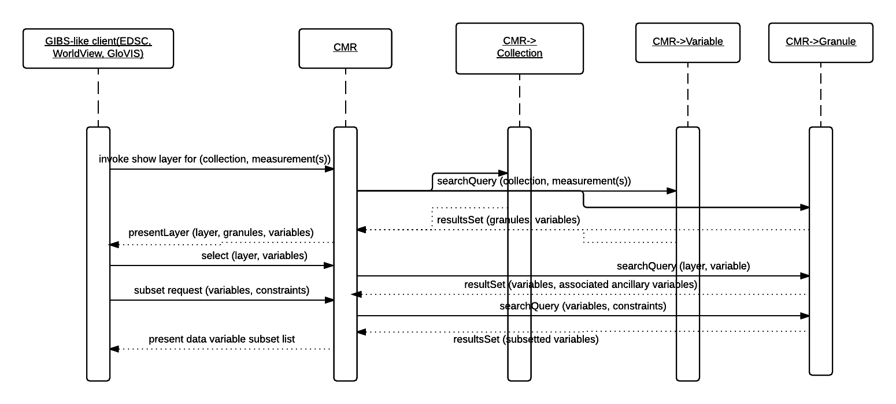​
Figure 25: Sequence Diagram: Integrating GIBS with web-based clients

Measurement Comparison of two in-situ measurements of Species X
Scenario: Measurement Comparison of two in-situ measurements of Species X, which is critical to understanding of tropospheric chemistry. In this scenario, the measurement techniques are not well established. Find collections (and variables) which are tagged with measurement terms for Species X (e.g. X = Nitrous Oxide).

Outcomes: User obtains collections (and variables) for Principal Investigator (PI)-related data files containing Species X from instrument A and instrument B.

See the use case diagram below.

​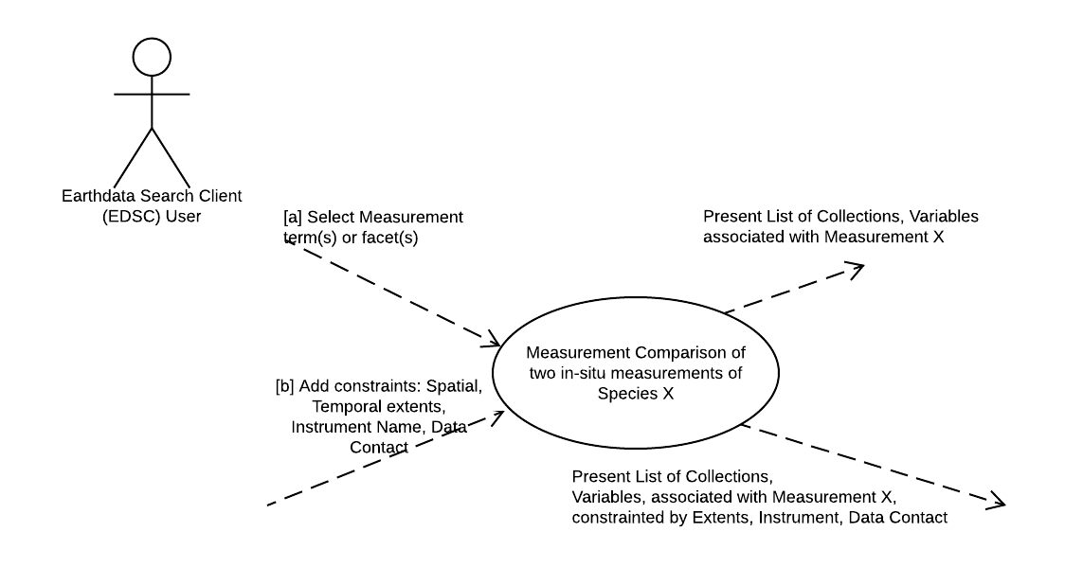​
Figure 26: Use Case, Measurement Comparison of two in-situ measurements of Species X

See the user experience activity diagram below

​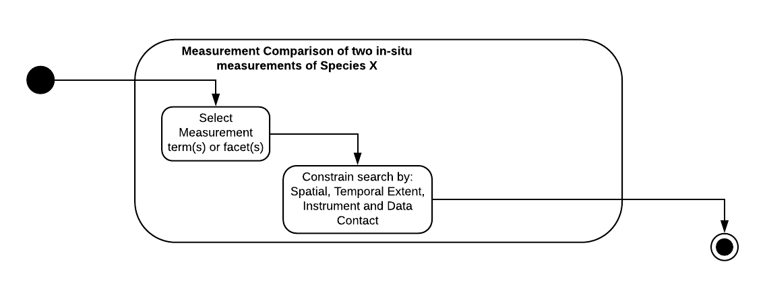​
Figure 27: Activity Diagram: Measurement Comparison of two in-situ measurements of Species X

See the workflow sequence diagram below.

​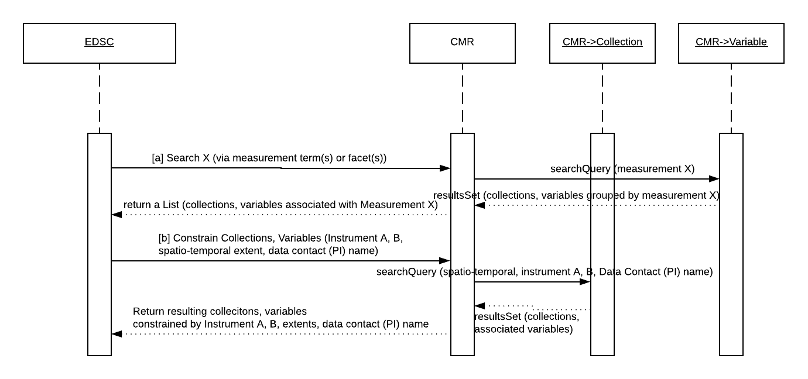​
Figure 28: Sequence Diagram: Measurement Comparison of two in-situ measurements of Species X

UMM-Var Metadata Model
As shown in Figure 29, the UMM-Var Metadata Model asserts that a Variable metadata instance is related to one or more Collections, one or more Granules, one or more Variables (e.g. a Science Variable may have a related Quality or Ancillary Variable). The remaining classes: Characteristics, ScienceKeywords, Measurements, Sets, FillValues and Dimensions are discussed in more detail throughout the remainder of this document. Each class and relationship express a different type of information conveyed by the variable.
​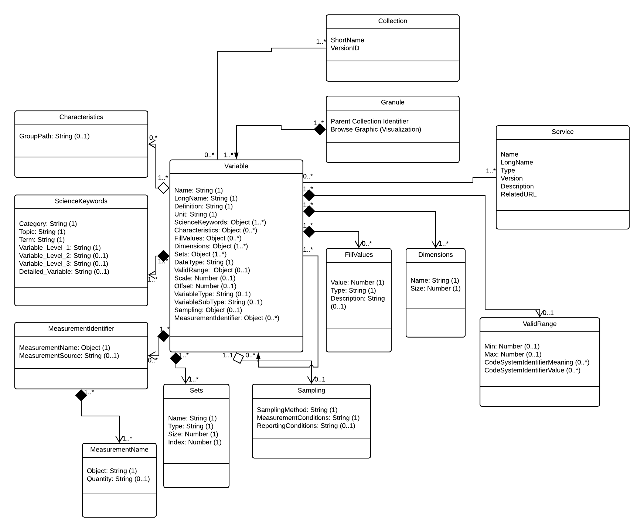​
Figure 29: UMM-Var Metadata Model

The author of a Variable metadata record should be cognizant of the following:

1. A Collection has zero or more Variables.
2. A Granule aggregates one or more Variables. Note the Variable class lifecycle is dependent on the Granule class instance lifecycle. Meaning that a Granule is defined by the Science Team first, and then each Variable which is aggregated by the Granule is defined. The metadata within the CMR simply reflects this.
3. A Variable may be related to zero or more Variables. For example, a Variable with VariableType: Science may have a related Variable(s) with VariableType: Quality and/or a Variable with VariableType: Ancillary.
4. The elements within the Characteristics section apply to a Variable. Not all Variables have all the elements contained within the Characteristics class.
5. The elements of the ScienceKeywords section also apply to a Variable. The ScienceKeywords may be sourced from GCMD Keywords. (See Appendix C).
6. The elements of the Measurement section apply to a Variable. The Measurement names may be sourced from the CSDMS standard names or the CF Convention standard names. This process will be dictated by a GCMD-style Governance process. (See Appendix D).
7. Information in the Characteristics section should be derived only from the Granule's data file. Granule selected should be from a collection that is associated with the variable.
8. A Variable record may be created / updated via the MMT GUI or XML file.
9. A Variable's record should answer all parts of the following question: What measurement type, collections, variables, granules, visualizations are associated with the Variable?
10. A mechanism within the UMM-S model enables the association of Services with specific Variables.

Variable
Elements
Variable [1..N]
Variable/Name [R]
Variable/LongName [R]
Variable/Definition [R]
Variable/Unit [R]
Variable/DataType [R]
Variable/Scale
Variable/Offset
Variable/VariableType

Description
The required fields: Name, LongName, DataType are derived from the Variable fields in the data set. The non-mandatory fields. Units, ValidRange, Scale and Offset are derived from the data set, if available. The Definition and the VariableType fields are set by the metadata curator via the MMT client.

Name [R]
Element Specification
Variable/Name (1)

Description
A variable short name given by the data provider.

Variables are available in a wide range of forms. These variables are named similarly across a family of collections, but these names differ considerably across collections. The variety of variables is illustrated using some examples across a sample of collections below.

The VIIRS_SST_NPP L3C-GHRSST-SST Data Set structure is represented as:

​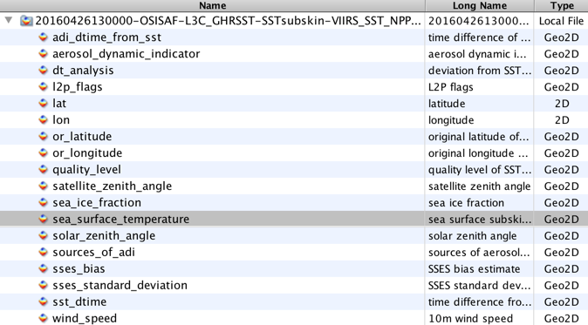​
Figure 30: The sea_surface_temperature variable highlighted within the VIIRS_SST_NPP L3C-GHRSST-SST Data Set

The highlighted sea_surface_temperature variable structure is shown as the following figure. Note the dimensionality of the variable is: time=1, nj=3072 and ni=4096.

​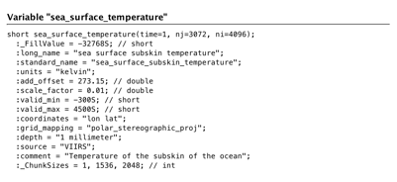​
Figure 31: The sea_surface_temperature variable structure

​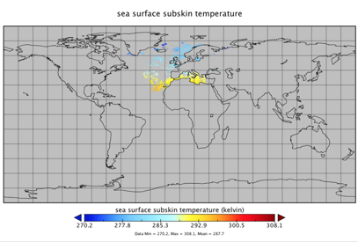​
Figure 32: A sea_surface_temperature variable plot

The corresponding data quality variable is shown below. Note the dimensionality of the variable is: time=1, nj=3072 and ni=4096.

​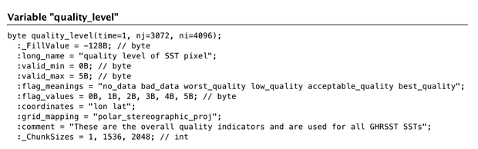​
Figure 33: The quality_level variable structure

Conversely, the LST variable contained within the MOD11A1 Data Set Structure is shown as:

​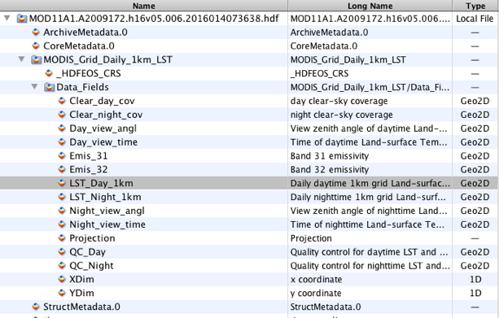​
Figure 34: he LST_Day_1km variable highlighted within the MOD11A1 Data Set

The LST_Day_1km variable structure is represented as shown below. Note the dimensionality of the variable is: YDim=1200 and XDim=1200.
​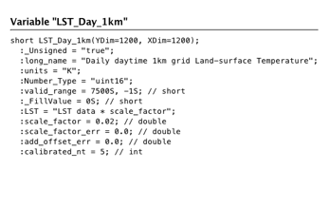​
Figure 35: The LST_Day_1KM variable structure

LST_Day_1km plot

​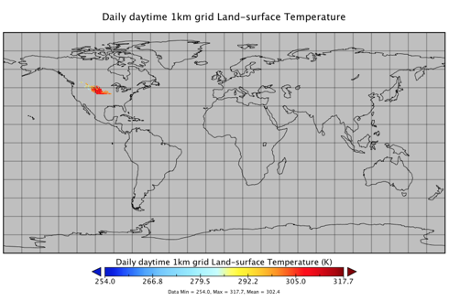​
Figure 36: A LST_Day_1km plot

The corresponding quality variable is represented as shown below. Note the dimensionality of the variable is: YDim=1200 and XDim=1200.

​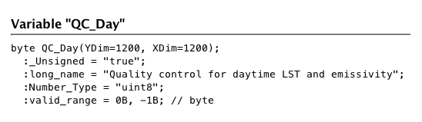​
Figure 37: The QC_Day variable structure

CER_BDS_Aqua-FM3_Edition1 Data Set structure

​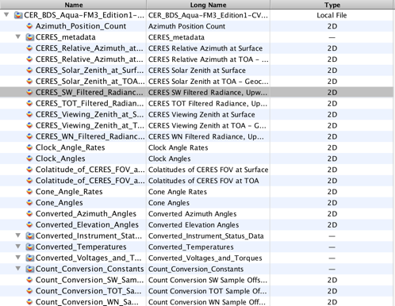​
Figure 38: The CERES_SW_Filtered_Radiances_Upwards variable highlighted within the CER_BDS_Aqua-FM3_Edition1 Data Set structure

The selected CERES_SW_Filtered_Radiances_Upwards variable structure is represented as shown below. Note the dimensionality of the variable is: Records=13091 and Samples=660.
​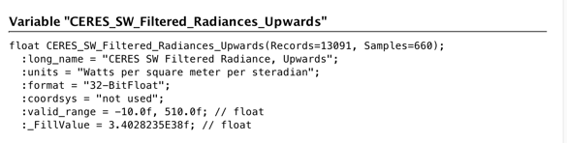​
Figure 39: The CERES_SW_Filtered_Radiances_Upwards variable structure

CERES_Solar_Zenith_at_Surface variable structure
​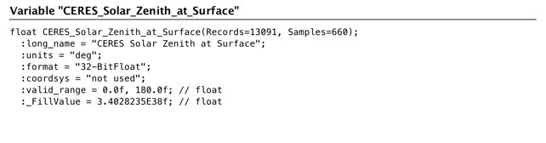​
Figure 40: CERES_SYN_1km Data Set structure

​​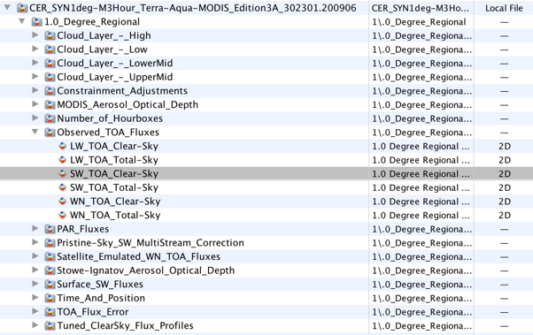​
Figure 41: The SW_TOA_Clear-Sky variable highlighted within the CERES_SYN_1km Data Set structure

SW_TOA_Clear-Sky variable structure. Note the dimensionality of the variable is: Mean_&_Stdev=2, Synoptic_Hours_(1, 4, 7, 10, 13, 16, 19, 22)=8, 1.0_deg.regional_colat.zones=180 and 1.0_deg._regional_long._zones=360.

​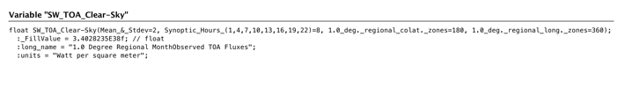​
Figure 42: The SW_TOA_Clear-Sky variable structure

SW_TOA_Clear-Sky variable plot

​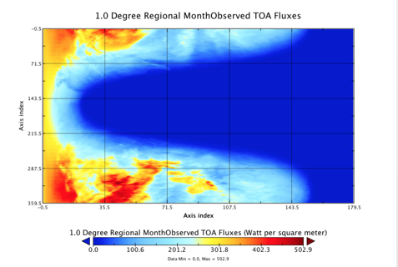​
Figure 43: A SW_TOA_Clear-Sky variable

AIRS.2012.02.09.L3.CO2Std008 data set structure

​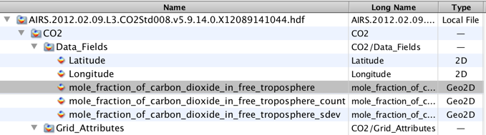​
Figure 44: The mole_fraction_of_carbon_dioxide_in_free_troposphere variable highlighted within the AIRS.2012.02.09.L3.CO2Std008 data set

The highlighted mole_fraction_of_carbon_dioxide_in_free_troposphere variable structure. Note the dimensionality of the variable is: LatDim=91, LonDim=144.
​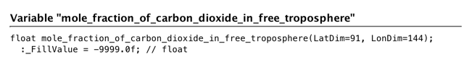​
Figure 45: The mole_fraction_of_carbon_dioxide_in_free_troposphere variable structure

​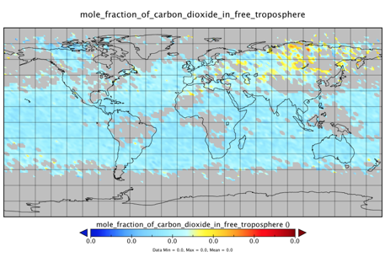​
Figure 46: A mole_fraction_of_carbon_dioxide_in_free_troposphere plot

Sample Values (given in bold) below:

sea_surface_temperature (sea surface temperature)
quality_level (quality level of the sea surface temperature)
LST_1KM_Day (daily daytime 1km grid land surface temperature)
QC_day (quality control for daytime LST and emissivity)
CERES_SW_Filtered_Radiances_Upwards (CERES SW filtered radiances, upwards)
CERES_Solar_Zenith_at_Surface (CERES solar zenith at surface)
SW_TOA_Clear-Sky (1 degree regional month observed TOA fluxes)
mole_fraction_of_carbon_dioxide_in_free_troposphere (mole fraction of carbon dioxide in free troposphere)
psl (mean sea level pressure)
O3_ppbv (ozone mixing ratio reported in parts per billion by volume)
Scat_550 (total dry aerosol scattering coefficient at 550 nm)
Sur_Refl_b01 (surface reflectance band 1)
WDB_L3MCA10 (Aerosol Optical Depth 550nm (Land Only) )

Tags
Required, Free Text Search

Sample Mappings
ISO 19115-1:
/mdb:MD_Metadata/mdb:identificationInfo/mri:MD_DataIdentification/mri:citation/cit:CI_Citation/cit:identifier/mcc:MD_Identifier[mcc:description/gco:CharacterString[.='Name']]/mcc:code/gco:CharacterString

LongName [R]
Element Specification
Variable/LongName (1)

Description
The expanded or long name given by the data provider.

Sample values (given in bold) below:

sea_surface_temperature (sea surface temperature)
quality_level (quality level of the sea surface temperature)
LST_1km_Day (daily daytime 1km grid land surface temperature)
QC_day (quality control for daytime LST and emissivity)
CERES_SW_Filtered_Radiances_Upwards (CERES SW filtered radiances, upwards)
CERES_Solar_Zenith (CERES solar zenith at surface)
SW_TOA_Clear-Sky (1 degree regional month observed TOA fluxes)
>mole_fraction_of_carbon_dioxide_in_free_troposphere (mole fraction of carbon dioxide in free troposphere)
psl (mean sea level pressure)
O3_ppbv (ozone mixing ratio reported in parts per billion by volume)
Scat_550 (total dry aerosol scattering coefficient at 550 nm)
LST_1KM_Day (daily daytime 1km grid land surface temperature)
Sur_Refl_b01 (surface reflectance band 1)
WDB_L3MCA10 v004 (Aerosol Optical Depth 550nm (Land Only))

Tags
Required, Free Text Search

Sample Mappings
ISO 19115-1:
/mdb:MD_Metadata/mdb:identificationInfo/mri:MD_DataIdentification/mri:citation/cit:CI_Citation/cit:identifier/mcc:MD_Identifier[mcc:description/gco:CharacterString[.='LongName']]/mcc:code/gco:CharacterString

Definition [R]
Element Specification
Variable/Definition (1)

Description
The definition of the variable given by the data provider. This can typically be found in the Collection User Guide corresponding to the variable.

Ideally, it should include the details of what is being measured, the scope of the measurement and any other information to help a scientist to understand what is particular to this variable. See the Sampling class for details about the sampling method and the measurement and reporting conditions.

Sample value: "Angstrom Exponent is an exponent that expresses the spectral dependence of aerosol optical thickness (τ) with the wavelength of incident light (λ). The spectral dependence of aerosol optical thickness can be approximated (depending on size distribution) by, τa = β λα where α is Angstrom exponent (β = aerosol optical thickness at 1 μm)".

Tags
Required

Sample Mappings
ISO 19115-1:
/mdb:MD_Metadata/mdb:identificationInfo/mri:MD_DataIdentification/mri:abstract/gco:CharacterString

Unit [R]
Element Specification
Variable/Unit (1)

Description
The unit used to report the variable.

The list of units will be sourced from the Dataset Interoperability Working Group (https://wiki.earthdata.nasa.gov/display/ESDSWG/Dataset+Interoperability+Working+Group).

The list will be managed as a KMS-managed list.

Sample values:

Table 4: Example values for the variable's unit
Coordinate Variable | Unit Value | Examples
latitude | degrees_north | 89.9 degrees_north
longitude | degrees_east | -179.9 degrees_east
pressure | Pa or hPa | 50 Pa
height (depth) | meter (m) or kilometer (km) | 10,000 m
time | Seconds, minutes, hours, days, etc., since a specific starting point in time, often (but not always) representing a canonical time (e.g., 1 Jan 1970, TAI93, start of mission, etc.). | Time is in ISO- 8601 format. seconds since 1992-10-08T15:15:42.5-6:00 days since 1970-01-01T00:00:0

Tags
Required

Sample Mappings
ISO 19115-1:
/mdb:MD_Metadata/mdb:contentInfo/mrc:MD_CoverageDescription/mrc:attributeGroup/mrc:MD_AttributeGroup/mrc:attribute/mrc:MD_SampleDimension/mrc:units/gml:UnitDefinition/gco:uomName
with
/mdb:MD_Metadata/mdb:contentInfo/mrc:MD_CoverageDescription/mrc:attributeGroup/mrc:MD_AttributeGroup/mrc:attribute/mrc:MD_SampleDimension/mrc:units/gml:UnitDefinition/gco:uomSymbol
with
/mdb:MD_Metadata/mdb:contentInfo/mrc:MD_CoverageDescription/mrc:attributeGroup/mrc:MD_AttributeGroup/mrc:attribute/mrc:MD_SampleDimension/mrc:units/gco:UomAngle/gco:measureType/gco:MeasureType/gco:CharacterString

DataType [R]
Element Specification
Variable/DataType (1) <"byte", "string", "float", "float32", "float64", "double", "uchar", "uchar8", "short", "long", "int8", "int16", "int32", "int64", "uint8", "uint16", "unit32", "uint64", "ubyte", "ufloat", "ufloat32", "ufloat64", "OTHER">

Description
Specifies the basic computer science data type of a variable. These types can be either short, long, character, binary, etc.

Table 5: HDF4 user guide as a possible source
HDF Data Type | Data Type Flag and Value | Description
char8 | DFNT_CHAR8 (4) | 8-bit character type
uchar8 | DFNT_UCHAR8 (3) | 8-bit unsigned character type
int8 | DFNT_INT8 (20) | 8-bit integer type
uint8 | DFNT_UINT8 (21) | 8-bit unsigned integer type
int16 | DFNT_INT16 (22) | 16-bit integer type
uint16 | DFNT_UINT16 (23) | 16-bit unsigned integer type
int32 | DFNT_INT32 (24) | 32-bit integer type
uint32 | DFNT_UINT32 (25) | 32-bit unsigned integer type
float32 | DFNT_FLOAT32 (5) | 32-bit floating-point type
float64 | DFNT_FLOAT64 (6) | 64-bit floating-point type

Table 6: HDF5 user guide as a possible source
HDF5 Data Type | Data Type Flag and Value | Description
string | NC_STRING | string type
char | NC_CHAR | character type
ubyte | NC_UBYTE | unsigned byte type
ushort | NC_USHORT | unsigned short type
uint | NC_UINT | unsigned integer type
uint64 | NC_UINT64 | 64-bit unsigned integer type
byte | NC_BYTE | byte type
short | NC_SHORT | short type
int | NC_INT | integer type
int64 | NC_INT64 | 64-bit integer type
double | NC_DOUBLE | double type

Sample value: "float".

Tags
Required

Sample Mappings
ISO 19115-1:
/mdb:MD_Metadata/mdb:contentInfo/mrc:MD_CoverageDescription/mrc:attributeGroup/mrc:MD_AttributeGroup/mrc:attribute/mrc:MD_SampleDimension/mrc:sequenceIdentifier/gco:MemberName/gco:attributeType/gco:TypeName/gco:aName/gco:CharacterString

Scale
Element Specification
Variable/Scale (0..1)

Description
The Scale is the numerical factor by which all values in the stored data field are multiplied in order to obtain the original values. May be used together with Offset. The formula by which the Scale and Offset are applied is usually one of the following:

- Additive Offset formula: actual data value = (scale factor * scaled value) + offset
- Subtractive Offset formula: actual data value = scale factor * (scaled value - offset)

Ref:
https://support.hdfgroup.org/release4/doc/UG_PDF.pdf (Section 3.10.6 Calibration Attributes)

Also,
https://cdn.earthdata.nasa.gov/conduit/upload/495/netcdf_UG_3.6.3.pdf (See Appendix B Attribute Conventions)

Note: the additive offset formula is the standard one, with the subtractive being non-standard, and rarely used. Exceptions include science variables from: MODIS MOD08_M3 (MODIS/Terra Aerosol Cloud Water Vapor Ozone Monthly L3 Global 1Deg CMG)and MCD43A4 (MODIS/Terra+Aqua BRDF/Albedo Nadir BRDF-Adjusted Ref Daily L3 Global - 500m) which use the subtractive offset formula.

Sample value: 0.00100000004749745

Tags
Recommended

Sample Mappings
ISO 19115-1:
/mdb:MD_Metadata/mdb:contentInfo/mrc:MD_CoverageDescription/mrc:attributeGroup/mrc:MD_AttributeGroup/mrc:attribute/mrc:MD_SampleDimension/mrc:scaleFactor/gco:Real

Offset
Element Specification
Variable/Offset (0..1)

Description

The Offset is the value which is either added to or subtracted from all values in the stored data field in order to obtain the original values. May be used together with Scale. The formula by which the Scale and Offset are applied is usually one of the following:

- Additive Offset formula: actual data value = (scale factor * scaled value) + offset
- Subtractive Offset formula: actual data value = scale factor * (scaled value - offset)

Ref:
https://support.hdfgroup.org/release4/doc/UG_PDF.pdf (Section 3.10.6 Calibration Attributes)

Also,
https://cdn.earthdata.nasa.gov/conduit/upload/495/netcdf_UG_3.6.3.pdf (See Appendix B Attribute Conventions)

Note: the additive offset formula is the standard one, with the subtractive being non-standard, and rarely used. Exceptions include science variables from: MODIS MOD08_M3 (MODIS/Terra Aerosol Cloud Water Vapor Ozone Monthly L3 Global 1Deg CMG)and MCD43A4 (MODIS/Terra+Aqua BRDF/Albedo Nadir BRDF-Adjusted Ref Daily L3 Global - 500m) which use the subtractive offset formula.

Sample value: 0.0

Tags
Recommended

Sample Mappings
ISO 19115-1:
/mdb:MD_Metadata/mdb:contentInfo/mrc:MD_CoverageDescription/mrc:attributeGroup/mrc:MD_AttributeGroup/mrc:attribute/mrc:MD_SampleDimension/mrc:offset/gco:Real

VariableType
Element Specification
Variable/VariableType (0..1) <"SCIENCE_VARIABLE", "QUALITY_VARIABLE", "ANCILLARY_VARIABLE", "OTHER">

Description
Specifies the basic type of a variable. These types can be either: "SCIENCE_VARIABLE", "QUALITY_VARIABLE", "ANCILLARY_VARIABLE", "OTHER". This field is selected by the Metadata Curator via a suitable GUI, i.e. MMT, or an alternate metadata curation tool.

Sample value: "SCIENCE_VARIABLE".

Tags
Recommended

Sample Mappings
ISO 19115-1:
/mdb:MD_Metadata/mdb:contentInfo/mrc:MI_CoverageDescription/mrc:attributeGroup/mrc:MD_AttributeGroup/mrc:contentType/mrc:MD_CoverageContentTypeCode and
/mdb:MD_Metadata/mdb:contentInfo/mrc:MI_CoverageDescription/mrc:attributeGroup/mrc:MD_AttributeGroup/mrc:contentType/mrc:MD_CoverageContentTypeCode/@codeListValue

VariableSubType
Element Specification
Variable/VariableSubType (0..1) <"SCIENCE_SCALAR", "SCIENCE_VECTOR", "SCIENCE_ARRAY", "SCIENCE_EVENTFLAG", "OTHER">

Description
Specifies the sub type of a variable. This field is selected by the Metadata Curator via a suitable GUI, i.e. MMT, or an alternate metadata curation tool. There are different types of science variables and this information is variable specific and important for data use.

Sample values:
"SCIENCE_SCALAR"
"SCIENCE_VECTOR"
"SCIENCE_ARRAY"
"SCIENCE_EVENTFLAG"
"OTHER"

The sub-types can be used in the following way: science_scalar (e.g., O3, NO, NO2, CH2O, CN, etc.); science_vector (e.g., wind direction); science_array (e.g., radiation spectrum, aerosol number size distribution); science_eventflag (e.g., cloud flag, pollution plume). There are other types of variables not included here.

Tags
Recommended

Sample Mappings
ISO 19115-1:
TBD

Characteristics
Elements
Characteristics (0..1)
Characteristics/GroupPath

Description
The elements of this section apply to a Variable.

Tags
Recommended

GroupPath
Element Specification
Characteristics/GroupPath (0..1)

Description
The full path to the variable within the Granule structure. The main purpose of this field is to capture the full path of the variable from within the granule file structure. Sets of variables which are nested a levels below the "/' root level can be located correctly.

In the example shown here, the set named "/Data_Fields" is nested in a path called '/MODIS_Grid_Daily_1km_LST". This important structural information is not lost once the Variable records have been ingested into the CMR.

Sample Value: '/MODIS_Grid_Daily_1km_LST/Data_Fields'

Tags
Recommended

Sample Mappings
ISO 19115-1:
/mdb:MD_Metadata/mdb:contentInfo/mrc:MD_CoverageDescription/mrc:attributeGroup/mrc:MD_AttributeGroup/mrc:attribute/mrc:MD_SampleDimension/mrc:otherProperty:Structure/gco:CharacterString

ScienceKeywords
Elements
ScienceKeywords (0..N)
ScienceKeywords/Category [R]
ScienceKeywords/Topic [R]
ScienceKeywords//Term [R]
ScienceKeywords/Variable_Level1
ScienceKeywords/Variable_Level2
ScienceKeywords/Variable_Level3
ScienceKeywords/Detailed_Variable

Description
Science Keywords are selected by a Metadata Curator via a suitable GUI or directly in the metadata file. Science Keywords are derived from a controlled source; in this case the GCMD Keywords. Science Keywords are provided to enable better searches by the use of human-readable measurement terms. Note that GCMD Keywords have a more complex structure than the Measurement class.

ScienceKeywords are hierarchical with the higher level keywords, e.g. Category, Topic, Term required and the lower level keywords, e.g. VariableLevel1, VariableLevel2 and VariableLevel3 and DetailedVariable are optional. It is important to recognize that the measurement terms are sometimes used in any one of the lower level keywords. So for example the measurement term "Methane" may be entered into the field "DetailedVariable" for a collection which possesses Methane variables, e.g. AIRX3STD.006.

Science Keywords search is offered as the primary way to discover variables. ScienceKeywords and Measurements could be used interchangeably for faceted browse in search clients. Elements in this category are used for search and faceting purposes.

Tags
Recommended

ScienceKeywords

Element Specification
ScienceKeywords (0..N)
ScienceKeywords/Category [R]
ScienceKeywords/Topic [R]
ScienceKeywords/Term [R]
ScienceKeywords/Variable_Level1
ScienceKeywords/Variable_Level2
ScienceKeywords/Variable_Level3
ScienceKeywords/Detailed_Variable

Description
These elements describe controlled science keywords describing the measurements/variables. The controlled vocabulary for Science Keywords is maintained in the Keyword Management System (KMS). These will be sourced from GCMD Keywords. See Appendix C.

Sample Values:
"Category": "EARTH SCIENCE", "Topic": "ATMOSPHERE", "Term": "ATMOSPHERIC CHEMISTRY", "Variable_Level1": "NITROGEN COMPOUNDS", "Variable_Level2": "Peroxyacyl Nitrate".

Tags
Recommended, Controlled Vocabulary

Sample Mappings
ISO 19115-1:
/mdb:MD_Metadata/mdb:identificationInfo/mri:MD_DataIdentification/mri:descriptiveKeywords/mri:MD_Keywords[mri:type/mri:MD_KeywordTypeCode/@codeListValue='Keyword']/mri:keyword/gco:CharacterString

FillValues
Element Specification
FillValues [0..N]
FillValues/Value [R]
FillValues/Type [R]
FillValues/Description

Description
The fill value of the variable in the data file. It is generally a value which falls outside the valid range. For example, if the valid range is '0, 360', the fill value may be '-1'. The fill value type is data provider-defined. It is typically a value out of valid range, although some cases have been reported of exceptions to this rule.

Tags
Recommended

Value [R]
Element Specification
FillValues/Value (1)

Description
The fill value of the variable in the data file.

Sample values:
-1
-9999

Tags
Required

Sample Mappings
ISO 19115-1:
/mdb:MD_Metadata/mdb:identificationInfo/mri:MD_DataIdentification/mri:citation/cit:CI_Citation/cit:identifier/mcc:MD_Identifier[mcc:description/gco:CharacterString[.='FillValue']]/mcc:code/gco:CharacterString = Value:

Type [R]
Element Specification
FillValue/Type (1) <"SCIENCE_FILLVALUE", "QUALITY_FILLVALUE", "ANCILLARY_FILLVALUE", "OTHER">

Description
Type of fill value of the variable in the data file.

Sample values:
SCIENCE_FILLVALUE

Tags
Required

Sample Mappings
ISO 19115-1:
/mdb:MD_Metadata/mdb:identificationInfo/mri:MD_DataIdentification/mri:citation/cit:CI_Citation/cit:identifier/mcc:MD_Identifier[mcc:description/gco:CharacterString[.='FillValue']]/mcc:code/gco:CharacterString = Type:

Description
Element Specification
FillValue/Description (0..1)

Description
Description of the fill value of the variable in the data file.

Sample values:
Valid Science Fill Value

Tags
Recommended

Sample Mappings
ISO 19115-1:
/mdb:MD_Metadata/mdb:identificationInfo/mri:MD_DataIdentification/mri:citation/cit:CI_Citation/cit:identifier/mcc:MD_Identifier[mcc:description/gco:CharacterString[.='FillValue']]/mcc:code/gco:CharacterString = Description:

Dimensions [R]
Element Specification
Dimensions [1..N]
Dimensions/Name [R]
Dimensions/Size [R]

Description
A variable consists of one or more dimensions. An example of a dimension name is 'XDim'. An example of a dimension size is '1200'. Variables are rarely one dimensional. Mode commonly, they are two or three dimensional.

Sample values:

For the sea_surface_temperature variable, the dimensionality is: time=1, nj=3072 and ni=4096.
For the quality_level variable variable, the dimensionality is: time=1, nj=3072 and ni=4096.
For the LST_Day_1KM variable, the dimensionality is: YDim=1200 and XDim=1200.
For the QC_Day variable, the dimensionality is: YDim=1200 and XDim=1200.
For the CERES_SW_Filtered_Radiances_Upwards variable, the dimensionality is: Records=13091 and Samples=660.
For the SW_TOA_Clear-Sky variable, the dimensionality of the variable is: Mean_&_Stdev=2, Synoptic_Hours_(1, 4, 7, 10, 13, 16, 19, 22)=8, 1.0_deg.regional_colat.zones=180 and 1.0_deg._regional_long._zones=360.
For the mole_fraction_of_carbon_dioxide_in_free_troposphere variable, the dimensionality of the variable is: LatDim=91, LonDim=144

Tags
Recommended

Name [R]
Element Specification
Dimensions/Name (1..N)

Description
The name of the dimensions of the variable represented in the data field. For example, 'XDim.

Sample values:
YDim, lat

Tags
Required

Sample Mappings
ISO 19115-1:
/mdb:MD_Metadata/mdb:contentInfo/mrc:MD_CoverageDescription/mrc:attributeGroup/mrc:MD_AttributeGroup/mrc:attribute/mrc:MD_SampleDimension/mrc:sequenceIdentifier/gco:MemberName/gco:attributeType/gco:TypeName/gco:aName/gco:CharacterString

Size [R]
Element Specification
Dimensions/Size (1..N)

Description
The size of the dimensions of the variable represented in the data field. For example, '1200'.

Sample values:
1200, 3600

Tags
Required

Sample Mappings
ISO 19115-1:
/mdb:MD_Metadata/mdb:contentInfo/mrc:MD_CoverageDescription/mrc:attributeGroup/mrc:MD_AttributeGroup/mrc:attribute/mrc:MD_SampleDimension/mrc:sequenceIdentifier/gco:MemberName/gco:attributeType/gco:TypeName/gco:aName/gco:CharacterString

ValidRange
Element Specification
Variable/ValidRange (0..1)
Variable/ValidRange/Max (0..1)
Variable/ValidRange/Min (0..1)
Variable/ValidRange/CodeSystemIdentifierMeaning (0..N)
Variable/ValidRange/CodeSystemIdentifierValue (0..N)

Description
ValidRange specifies the minimum and maximum valid values of the variable represented in the data field.

Sample values:

Variable/ValidRange/Max: 5000
Variable/ValidRange/Min: -100

Optionally, if the valid range is not continuous, a code system can be defined. An example of such a code system is shown below:

Sample values:

Variable/ValidRangeCodeSystemIdentifierMeaning: <no_data, bad_data, worst_quality, low_quality, acceptable_quality, best_quality>
Variable/ValidRange/CodeSystemIdentifierValue: <0B, 1B, 2B, 3B, 4B, 5B>

Tags
Recommended

Sample Mappings
ISO 19115-1:
/mdb:MD_Metadata/mdb:contentInfo/mrc:MD_CoverageDescription/mrc:attributeGroup/mrc:MD_AttributeGroup/mrc:attribute/mrc:MD_SampleDimension/mrc:minValue/gco:Real
and
/mdb:MD_Metadata/mdb:contentInfo/mrc:MD_CoverageDescription/mrc:attributeGroup/mrc:MD_AttributeGroup/mrc:attribute/mrc:MD_SampleDimension/mrc:maxValue/gco:Real

Min
Element Specification
ValidRange/Min (0..1)

Description
The minimum value of the variable represented in the data field. For example, '0.0'.

Sample values:
0.0

Tags
Recommended

Max
Element Specification
ValidRange/Max (0..1)

Description
The maximum value of the variable represented in the data field. For example, '1.0'.

Sample values:
1.0

Tags
Recommended

CodeSystemIdentifierMeaning
Element Specification
ValidRange/CodeSystemIdentifierMeaning (0..N)

Description
This element can be used to specify a code system identifier meaning. For example, Open Shrubland corresponds to '7'.

This element can be used for variables which do not use a typical continuous range of valid values. If there is a discrete number system used for the data values, then there needs to be a code system identifier.

An example of each meaning is shown here:

For the GHRSST SST variable, it has a discrete code system used to identify the quality of each grid cell.

Meaning: <no_data, bad_data, worst_quality, low_quality, acceptable_quality, best_quality>
Value: <0B, 1B, 2B, 3B, 4B, 5B>

Examples are cloud masks, or land surface classification variables. (e.g. if the code system is IGBP, and the value is set to 7, then there is a way of determining that this is Open Shrubland). If the code system identifier for NODATA is -1, then, this field would be set to -1.

Sample values:
7

Tags
Recommended

CodeSystemIdentifierValue
Element Specification
Variable/ValidRange/CodeSystemIdentifierValue (0..N)

Description
ValidRange specifies valid values of the variable represented in the data field using the defined code system.

The code system identifier value is the textual or numerical value assigned to each meaning.

An example of each value is shown here:

For the GHRSST SST variable, it has a discrete code system used to identify the quality of each grid cell.

Meaning: <no_data, bad_data, worst_quality, low_quality, acceptable_quality, best_quality>
Value: <0B, 1B, 2B, 3B, 4B, 5B>

Tags
Recommended

Measurements [O]
Elements
Measurements (0..*)
Measurements/MeasurementName
Measurements/MeasurementName/Object [R]
Measurements/MeasurementName/Quantity [R]
Measurements/MeasurementSource

Description
Elements in this category are used for search purposes. Measurement names are added to the metadata by a Metadata Curator via the MMT, an alternate metadata curation tool, using bulk updates, or via a JSON metadata file. The measurement name is structured according to the form defined by Scott Peckham. This is: <<object, quantity>>

Therefore, the specification of the MeasurementName class will be:
Measurements/MeasurementName (0..1)
Measurements/MeasurementName/Object [R]
Measurements/MeasurementName/Quantity [R]

and the source of the names can be identified by the following field:

Measurements/MeasurementSource

Every standard name has an object part that describes a particular object and a quantity part that describes a particular attribute of the object that can be quantified. These names are sorted alphabetically and other sorting methods can be added later. When using the MeasurementSource field to identify measurement names source from CSDMS system, use: CSDMS. When sourcing measurement names from other sources, e.g. CF convention, use "CF".

Membership criteria are given by:
Object = "Aerosol"
Quantity = "Optical Depth"

More discussion on MeasurementName valid values is given in the MeasurementName object specification. In consultation with the GCMD team, it is recommended that Measurement's valid values should be enumerations in KMS and not keywords. It is also recommended that the Measurement's valid values will eventually be managed via the current ESO process but not until the valid values are matured.

Tags
Recommended

MeasurementName
Element Specification
Measurements/MeasurementName (0..1)
Measurements/MeasurementName/Object [R]
Measurements/MeasurementName/Quantity [R]

Description
The names of the measurement may be taken from a variety of sources. These include, but are not limited to, Community Surface Dynamics Modeling System (CSDMS) Cross Domain Naming Conventions or Climate and Forecast (CF) Standard Name Convention, British Oceangraphic Data Centre (BODC).

According to the CSDMS Basic Rules, every standard name has an object part that describes a particular object and a quantity part that describes a particular attribute of that object that can be quantified with a number. These names are sorted alphabetically, but other sorting methods can be added later.

Names are of the form: <object>__<quantity>.
Names shall contain only lowercase letters and numbers along with the Standard Names separator characters (_, -, ~, __).
The Standard Names separators:
_: delimiter separate words of a name.
-: join multi-word objects, quantities, adjectives, etc.
~: join an adjective to a noun (the noun comes first following by or more adjectives).
__: separate an object from a quantity.
_of_: apply a math operation to the subsequent quantity.
Qualifiers that make an object or quantity more specific are added to the left of the base object or quantity (with increasing specificity).

CSDMS Standard Names may be further grouped by category: Atmosphere, Oceans, Radiation, Sea Ice, Soil, Snow, Topography.

This is defined more fully in the CSDMS WIki: https://csdms.colorado.edu/wiki/CSN_Basic_Rules

See Appendix C for more details.

Sample Values:
"land_subsurface_water_sat-zone_top", "CSDMS"
"land_surface", ;"CSDMS"
"land_surface_air", "CSDMS"
"land_surface_air_flow", "CSDMS"
"land_surface​_air_heat-incoming-latent", "CSDMS"
"land_surface_air-incoming-sensible", "CSDMS"
"specific_humidity", "CSDMS"
"specific_humidity-standard_error", "CSDMS"
"specific_humidity-detection_minimum" "CSDMS"

This list may be supplemented further by standard names sourced from the CF Standard Names: http://cfconventions.org/Data/cf-standard-names/docs/guidelines.html

These can also be expressed in the form: <object>__<quantity> with care.

Species, e.g.vapor, sulfur, can be quantified by terms: e.g. at_cloud_top, at_convective_cloud_top, at_cloud_base, at_convective_cloud_base, at_freezing_level, at_ground_level

Fluxes, e.g. radiative_flux, can be quantified by terms e.g. at_top_of_atmosphere_model, at_sea_level, can be expressed as:

"radiative_flux-at_top_of_atmosphere_model", "CF"
"radiative_flux-at_sea_level, "CF"

Physical Quantities, e.g. temperature, pressure, humidity, entropy, which are commonly used in mathematics, science and engineering, can be expressed using CF convention.

e.g. electrical charge, or scientific symbol, q, and quantified by terms, e.g. error_limit, detection_limit, can be expressed as:
"q-error_limit", "CF"
"q-detection_limit"."CF"

Note: MeasurementNames' values will come from KMS which is a controlled list

Tags
Recommended, Controlled Vocabulary

Sample Mappings
ISO 19115-1:
/mdb:MD_Metadata/mdb:identificationInfo/mri:MD_DataIdentification/mri:descriptiveKeywords/mri:MD_Keywords[mri:type/mri:MD_KeywordTypeCode/@codeListValue='MeasurementNames']/mri:keyword/gco:CharacterString

Object [R]
Element Specification
Measurements/MeasurementName/Object (1)

Description
The name of the object of measurement.

Sample Values:
land_subsurface_water-sat, land_surface, land_surface_air, land_surface_air_flow, land_surface_air_heat, specific_humidity, radiative_flux, q.

These represent the named object term in the <<object, quantity>> structure.

"land_subsurface_water_sat-zone_top",
"land_surface",
"land_surface_air",
"land_surface_air_flow",
"land_surface​_air_heat-incoming-latent",
"land_surface_air-incoming-sensible",
"specific_humidity",
"specific_humidity-standard_error",
"specific_humidity-detection_minimum",
"radiative_flux-at_top_of_atmosphere_model"
"radiative_flux-at_sea_level"
"q-error_limit",
"q-detection_limit".

Tags
Required

Quantity [R]
Element Specification
Measurements/MeasurementName/Quantity (0..1)

Description
The name of the quantity of measurement.

Sample Values:
zone-top, incoming-latent, incoming-sensible, standard_error, detection_minimum, at_top_of_atmosphere_model, at_sea_level, error_limit, detection_limit

These represent the named quantity term in the <<object, quantity>> structure.

"land_subsurface_water_sat-zone_top",
"land_surface_air_heat-incoming-latent",
"land_surface_air-incoming-sensible",
"specific-humidity-standard_error",
"specific-humidity-detection_minimum",
"radiative_flux-at_top_of_atmosphere_model"
"radiative_flux-at_sea_level"
"q-error_limit",
"q-detection_limit".

Tags
Required

MeasurementSource
Element Specification
Measurements/MeasurementSource (0..1) <"CSDMS", "CF", "BODC">

Description
The source of the measurement names include, but are not limited to: Community Surface Dynamics Modeling System (CSDMS) Cross Domain Naming Conventions, Climate and Forecast (CF) Standard Name Convention, or British Oceanographic Data Centre. See Appendix C for more on the sources of measurement names and the recommended governance approach.

Sample Values:
CSDMS,
CF,
BODC

Tags
Recommended, Controlled Vocabulary

Sample Mappings
ISO 19115-1:
/mdb:MD_Metadata/mdb:identificationInfo/mri:MD_DataIdentification/mri:descriptiveKeywords/mri:MD_Keywords[mri:type/mri:MD_KeywordTypeCode/@codeListValue='MeasurementNames']/mri:keyword/mri:thesaurusName/cit:CI_Citation/cit:citedResponsibleParty/cit:CI_Responsibility[cit:role/cit:CI_RoleCode@codeListValue='resourceProvider']/cit:party/cit:CI_AbstractCI_Party/cit:name/gco:CharacterString

Sets
Elements
Sets [1..N]
Sets/Name [R]
Sets/Type [R]
Sets/Size [R]
Sets/Index [R]

Description
Elements in this category are used to group variables into sets.

The set information of a variable. The variable is typically grouped within a set (essentially, an indexed array of variables). The set is defined by the name, type, size, and index. The Set class is flexible enough to be expanded to include compound variables (variable that groups related variable together to describe a phenomenon).

The current UMM-Var schema supports compound variables using the Set class.

Sets can be named and typed according to the grouping or phenomenon.

Example (variables common to the 'Data_Fields' group, within the MOD11A1 collection, so the set class would be populated in the following way for the variable named 'LST_Day_1km'):

"Sets": [
{
"Name": "Data_Fields",
"Type": "MODIS 1km gridded",
"Size": 15 ,
"Index": 7
}
]

Example (variables common to the AIRX3STD gridded data field group', within the AIRX3STD collection, so the set class would be populated in the following way for the variable named 'EmisIR_A_ct'):

"Sets": [
{
"Name": "AIRX3STD",
"Type": "AIRS+AMSU Level 3 Gridded",
"Size": 867,
"Index": 13
}
]

Each variable in the set is numbered by Index, and the size of the set. So this is the 13th variable in a set of 867 variables. (14th if the numbering starts at 0).

For a phenomenon example, take the MOD08 v006 collection,

​ ​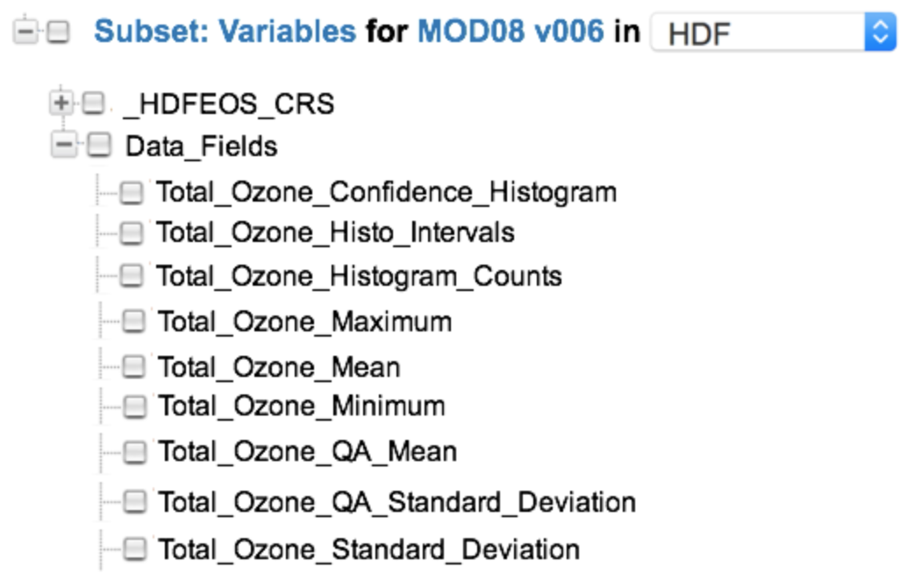​
Figure 47: Subset variable choices for the MOD08 collection

we can group the variables which pertain to 'Total Ozone' in the following way:

Variable: {"Name": "Total_Ozone_Confidence_Histogram",
...
"Sets": [
{"Name": "Total Ozone","Type": "Data_Field","Size": 9 ,"Index": 0}
],
...
}
Variable: ("Name": "Total_Ozone_Histo_Intervals",
...
"Sets": [
{"Name": "Total Ozone","Type": "Data_Field","Size": 9 ,"Index": 1}
],
...
}
Variable: ("Name": "Total_Ozone_Histogram_Counts",
...
"Sets": [
{"Name": "Total Ozone","Type": "Data_Field","Size": 9 ,"Index": 2}
],
...
}
Variable: ("Name": "Total_Ozone_Maximum",
...
"Sets": [
{"Name": "Total Ozone","Type": "Data_Field","Size": 9 ,"Index": 3}
],
...
}
Variable: ("Name": "Total_Ozone_Mean",
...
"Sets": [
{"Name": "Total Ozone","Type": "Data_Field","Size": 9 ,"Index": 4}
],
...
}
Variable: ("Name": "Total_Ozone_Minimum",
...
"Sets": [
{"Name": "Total Ozone","Type": "Data_Field","Size": 9 ,"Index": 5}
],
...
}
Variable: ("Name": "Total_Ozone_QA_Mean",
...
"Sets": [
{"Name": "Total Ozone","Type": "Data_Field","Size": 9 ,"Index": 6}
],
...
}
Variable: ("Name": "Total_Ozone_QA_Standard_Deviation",
...
"Sets": [
{"Name": "Total Ozone","Type": "Data_Field","Size": 9 ,"Index": 7}
],
...
}
Variable: ("Name": "Total_Ozone_Standard_Deviation",
...
"Sets": [
{"Name": "Total Ozone","Type": "Data_Field","Size": 9 ,"Index": 8}
],
...
}

In general, Variables are organized in a specific way within the structure of a data set. The examples shown above are for HDF4 structures. The arrangement of these structures varies considerably between HDF4, HDF5 and NetCDF-4, and NetCDF-CF.

In the following HDF5 example, the Variables for this SMAP_L3_SM_P data set are organized into two sets. The first set contains the variables representing the morning (AM) crossing and the second set contains variables representing the afternoon (PM) crossing.

​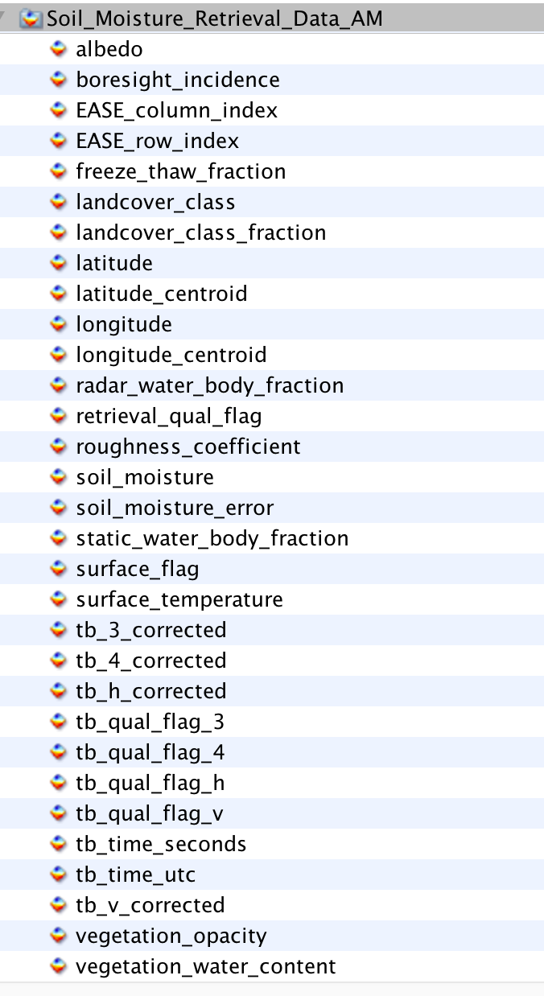​
Figure 48: SMAP_L3_SM_P variables representing the morning (AM) crossing

The second set represents the variables containing the afternoon (PM) crossing.
​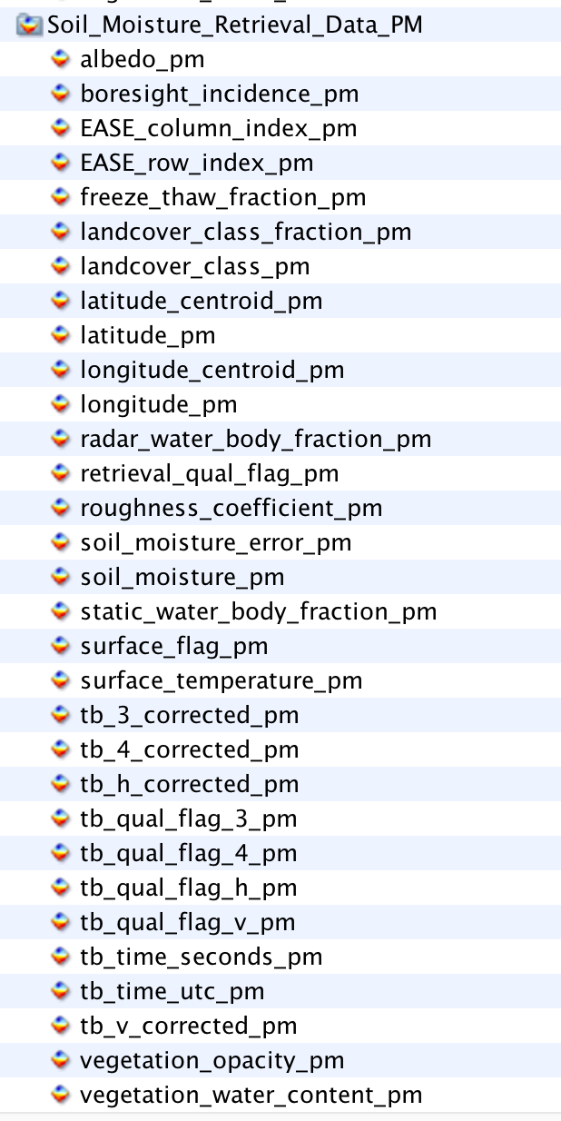​
Figure 49: SMAP_L3_SM_P variables representing the afternoon (PM) crossing

The benefit of using the Set class is to enable the CMR to preserve the order of the variables within the structure of the granule file.

Tags
Recommended

Name [R]
Element Specification
Sets/Name (1)

Description
This element enables specification of set name. For example, 'Data_Fields'.

Sample Value
"Data_Fields".

Tags
Required

Sample Mappings
ISO 19115-1:
/mdb:MD_Metadata/mdb:identificationInfo/mri:MD_DataIdentification/mri:citation/cit:CI_Citation/cit:identifier/mcc:MD_Identifier[mcc:description/gco:CharacterString[.='Sets']]/mcc:code/gco:CharacterString = Name:

Type [R]
Element Specification
Sets/Type (1)

Description
This element enables specification of set type. For example, if the variables have been grouped together based on a particular theme, such as wavelength, then the type should be set to that theme, otherwise it should be set to 'General'.

Sample Value
"SWIR Bands"

Tags
Required

Sample Mappings
ISO 19115-1:
/mdb:MD_Metadata/mdb:identificationInfo/mri:MD_DataIdentification/mri:citation/cit:CI_Citation/cit:identifier/mcc:MD_Identifier[mcc:description/gco:CharacterString[.='Sets']]/mcc:code/gco:CharacterString = Type:

Size [R]
Element Specification
Sets/Size (1)

Description
This element specifies the number of variables in the set. For example, if the number of variables in the set is fifteen, the size should be recorded as '15'.

Sample Value
"15"

Tags
Required

Sample Mappings
ISO 19115-1:
/mdb:MD_Metadata/mdb:identificationInfo/mri:MD_DataIdentification/mri:citation/cit:CI_Citation/cit:identifier/mcc:MD_Identifier[mcc:description/gco:CharacterString[.='Sets']]/mcc:code/gco:CharacterString = Size:

Index [R]
Element Specification
Sets/Index (1)

Description
This element specifies the index value within the set for this variable. For example, if this variable is the third variable in the set, the index value should be '3'.

Sample Value
"3"

Tags
Required

Sample Mappings
ISO 19115-1:
/mdb:MD_Metadata/mdb:identificationInfo/mri:MD_DataIdentification/mri:citation/cit:CI_Citation/cit:identifier/mcc:MD_Identifier[mcc:description/gco:CharacterString[.='Sets']]/mcc:code/gco:CharacterString = Index:

Sampling
Elements
Sampling (0..*)
Sampling/SamplingMethod [R]
Sampling/MeasurementConditions
Sampling/ReportingConditions

Description
Elements in this category are used for capturing information associated with sampling, including the method of sampling and the conditions at the time of measurement and reporting. MeasurementConditions and ReportingConditions are useful metadata for field campaign data sets.

Tags
Recommended

Sample Mappings
ISO 19115-1:
mrl:LI_Lineage/mrl:LE_ProcessStep/mrl:description/gco:CharacterString
and
mrl:LI_Lineage/mrl:LE_ProcessStep/mrl:rationale/gco:CharacterString

SamplingMethod [R]
Element Specification
Sampling/SamplingMethod (1)

Description
The name of the sampling method used for the measurement. For example, 'radiometric detection within the visible and infra-red ranges of the electromagnetic spectrum'.

Tags
Required

Sample Mappings
ISO 19115-1:
TBD

MeasurementCondition
Element Specification
Sampling/MeasurementCondition (0..1)

Description
Conditions at the time the observation or measurement was recorded. For example, 'Sampled Particle Size Range: 90 - 600 nm'.

Tags
Recommended

Sample Mappings
ISO 19115-1:
/mdb:MD_Metadata/mdb:contentInfo/mrc:MD_CoverageDescription/mrc:attributeGroup/mrc:MD_AttributeGroup/mrc:attribute/mrc:MD_SampleDimension/mrc:otherProperty:MeasurementCondition/gco:CharacterString

ReportingCondition
Element Specification
Sampling/ReportingCondition (0..1)

Description
Conditions over which the observation or measurement are valid. For example, 'STP: 1013 mb and 273 K'.

Tags
Recommended

Sample Mappings
ISO 19115-1:
/mdb:MD_Metadata/mdb:contentInfo/mrc:MD_CoverageDescription/mrc:attributeGroup/mrc:MD_AttributeGroup/mrc:attribute/mrc:MD_SampleDimension/mrc:otherProperty:ReportingCondition/gco:CharacterString

- Tags Glossary

The following table lists all tags used in this model and provides a description of the tags' usage.

Table 7: Tags Glossary
Tag Name | Description
Required | This element is required.
Free Text Search | This element will be indexed by the CMR as part of the Free Text Search.
Controlled Vocabulary | This element will have a vocabulary that will be used to validate the value. This will most likely be done via a vocabulary management service.
Recommended | This element is recommended.

- Inputs
- Discussions with Kathleen Baynes, Jon Pals (ECS Science Office), Dan Pilone (EED Chief Technologist), Abe Taaheri (HDF-EOS Lead Developer), Christopher Lynnes (NASA/ESDIS), Mahabal Hegde (NASA/GSFC)
- Inputs from Kathleen Baynes
• Original Appfriendly EOSDIS Science Information Retriever (AESIR)
proposal: https://docs.google.com/document/d/1H0EAPV3Iv3WtheOAVZrJ1eY89NneyiweCcHAz5eI9a0/edit#heading=h.8r4j53o9wk3j
• Variable data use case: http://giovanni.gsfc.nasa.gov/giovanni/
• Variable response from AESIR: AESIRresponse.xml file
• ODISEES tool link: http://odisees.larc.nasa.gov/
(Point of Contact for this is Beth Huffer: https://wiki.earthdata.nasa.gov/display/~bhuffer)
• More information about the GIBS API: https://wiki.earthdata.nasa.gov/display/GIBS/GIBS+API+for+Developers
• Existing/Preliminary UMM-V Model: https://docs.google.com/spreadsheets/d/1Zm5i_Mln0jGGHDS9wC8vzNZAqZ034bu5aSk58Bn77Ig/edit#gid=0 (to be refined by the GIBS Technical Working Group)
• GIBS TWG Wiki Space: https://wiki.earthdata.nasa.gov/display/GIBS/GIBS+Technical+Working+Group
• Current Status of UMM-V: https://wiki.earthdata.nasa.gov/display/GIBS/Visualization+Metadata
- Inputs from Edward Seiler regarding AESIR questions and content
• Giovanni application: http://giovanni.gsfc.nasa.gov/giovanni/
• The information for each variable is populated via an editor named EDDA at
http://dev-ts1.gesdisc.eosdis.nasa.gov/EDDA/index.html
• The help page for EDDA at
http://dev-ts1.gesdisc.eosdis.nasa.gov/EDDA/EDDA_help.html
- SMAP Data – sample 'Freeze Thaw' variable data from Abe Taaheri: SMAP_L3_FT_A_20140122_R11160_001.h5
- CF Conventions and CF Standard Variable Names: http://cfconventions.org/Data/cf-standard-names/27/build/cf-standard-name-table.html
- CSDMS Standard Variable Names: http://csdms.colordo.edu/wiki/CSN_Examples
- The CSDMS Standard Names: Cross-Domain Naming Conventions for Describing Process Models, Data Sets Their Associated Variables, S.D. Peckham, University of Colorado, INSTAAR, 1560 30th Street, Boulder, CO (Scott.Peckham@colorado.edu) http://www.iemss.org/sites/iemss2014/papers/iemss2014_submission_263.pdf
- CMR Data Partner User Guide: https://wiki.earthdata.nasa.gov/display/CMR/CMR+Data+Partner+User+Guide
- Towards Unifying NASA Earth Science Enterprise-Wide Metadata Around International Standards: Study Results and Recommendations, S.J.S. Khalsa, CIRES, University of Colorado, Boulder, CO 80309 USA – sjsk@nsidc.org, S.F. Browdy, OMS Tech, Orlando, Florida, USA – steveb@omstech.com, B.H. Weiss, Jet Propulsion Laboratory, Pasadena, CA – Barry.h.weiss@jpl.nasa.gov http://www.isprs.org/proceedings/2011/ISRSE-34/211104015Final00852.pdf
- The Dataset Interoperatbility WG https://wiki.earthdata.nasa.gov/display/ESDSWG/Dataset+Interoperability+Working+Group
- The Unified Modeling Language Reference, Rumbaugh, Jacobson, I, Booch, G, 199, Addison Wesley
- Summary of British Oceanographic Data Centre Holdings: https://www.bodc.ac.uk/resources/inventories/holdings/search/

- Keywords and Measurements Governance Structure

The Governance Structure shown in Figure 50 is recommended for the selection of keywords and measurements. ESDIS chairs each of the measurement or keyword selection councils and provides overall science guidance, and the DAAC/Data Providers serve as the decision authority for the metadata associated with data sets sourced from their DAAC/Project.

​
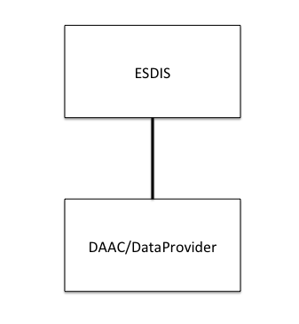

​Figure 50: Suggested Governance Structure

Adding Keywords or Measurements are expect to be done by the Metadata Curator, via a GUI. Keywords are to be sourced from the GCMD Keywords and are controlled. What is being proposed here is not too different from the existing method used in the EDSC UI, with the exception being that the Keyword will be used for discovery at the Variable level, as opposed to the Collection or Granule level, which is currently the case. The challenge with Measurements is that they are uncontrolled. The concept is to start with a pre-seeded list of suggested measurements and, over time an alphabetically ordered list can be collected, by certain users, and by their use of a metadata management tool, e.g., MMT. The guidelines for adding keywords or measurements can be achieved by following the suggested steps below.

Keywords
Keywords may be selected from the GCMD Keywords set.
The GCMD Keywords are already subject to a strict governance process:
- Review the controlled keyword/guidelines located at: http://gcmd.nasa.gov/learn/rules.html
- Verify that the keyword does not already exist.
- Map these to the appropriate variables.
- Include a definition of the controlled keyword.

Measurements
Measurements may be selected from an array of standard sources, e.g. CSDMS, CF Conventions, etc.
The process by which measurements may be selected is simple.
- Determine level: i.e. Atmosphere, Oceans, Land (highest) or Atmosphere Air Temperature (mid), or Atmosphere Air Temperature Saturated Adiabatic Lapse Rate (lowest), etc.
- Determine whether the measurement is missing, and a new one is needed. For example, if we have Atmosphere Air Column Water Vapor and the next tag is Atmosphere Air Flow Azimuth Angle of Bolus Velocity, then Atmosphere Air Carbon Dioxide (and its derivatives) are missing.
- Select the most appropriate measurement to suit the need. If the measurement does not exist, apply crosswalk to another standard, i.e. CSDMS to CF convention Standard Names.
- Add to the measurements list stored in the CMR so that all future users can use this measurement.
- Map these to the appropriate variables.
- Include a definition of the uncontrolled measurement.

- Analysis of CSDMS and CF Standard Names as a Source of Tagging
Analysis of CSDMS Standard Names as a source of tagging
The CSDMS (Community Surface Dynamics Modeling System) modeling framework provides mechanisms that allow models and data sets from different contributors (i.e. from different geoscience domains: hydrology, oceanography, meteorology, seismology). The framework defines an approach to the semantic mediation problem. It offers a unique approach to solving this problem by offering a set of standardized and precise descriptions of each variable. It provides a holistic approach to solve the semantic mediation problem by giving a number of options to resolving which names and abbreviations are to be used for a variable.
The naming conventions of the CSDMS Standard Names are based on object-oriented principles.
CSDMS Standard Names are grouped, i.e. by Variables Names for: the Atmosphere, Atoms, Automobiles, Basins, Bedrock, Channel, Chocolate, Compounds and Mixtures, Earthquakes, Glaciers, Materials, Models, Molecules, Oceans, Planets, Projectiles, Radiation, River Deltas, Sea Ice, Snow, Soil, Sea Floor Debris, Topography and Water Tank.
Only a subset of these are groups are suitable for EOS: Variables Names for: the Atmosphere, Oceans, Radiation, Sea Ice, Soil, Snow, Topography.
Potentially, other groups are suitable for EOS: Variable Names for: Basins, Channel, Earthquakes, Glaciers, Planets, River Deltas, Sea Floor Debris.
These Standard Names can be chosen as the primary source of tagging, since each group is highly relevant to the science domains which are covered by the EOS data sets and those likely to be covered in the future.
The CSDMS Standard Names exhibit the Object Name + Model Name Pattern structure to the name.
An example of an Object Name is:atmosphere_water
Examples of the corresponding Model Name Patterns are: domain time integral of precipitation leq volume flux, icefall mass per volume density, precipitation duration, precipitation leq volume flux, precipitation mass flux.
The first example of combining Object Name + Model Name yields the resultant standard name: atmosphere water domain time integral of precipitation leq volume flux.
An example of a missing name would be: atmosphere water precipitation, or the more common term, precipitation.

Analysis of CF Standard Names as a source of tagging
CF conventions for climate and forecast metadata are designed to promote the processing and sharing of files created with the netCDF Application Programmer Interface. The CF conventions generalize and extend the COARDS conventions.
Most of the CF standard names have been derived from guidelines which have drawn on ECMWF, and NCEP GRIB tables, the PCMDI and GCMD.
CF standard names consist of lower-letters, digits and underscores, and begin with a letter. Upper case is not used.
US spelling is used, e.g. vapor, sulfur.
The CF Standard Names can be chosen as a source of tagging supplementary to CSDMS.
Examples of CF Standard Names are: precipitation amount, and precipitation flux, and precipitation flux onto canopy are included in the CF Standard Names and not in the CSDMS Standard Names.
In this simple example, both CSDMS and CF Standard Names may be used as a source of tagging for search terms to locate all variables associated with the measurement: precipitation.

- Abbreviations and Acronym List
Table 8: Abbreviations and Acronyms
ACL | Access Control List
AESIR | Application friendly EOSDIS Science Information Retriever
CF | Climate and Forecast metadata
CMR | Common Metadata Repository
COARDS | Cooperative Ocean/Atmosphere Research Data Service
DAAC | Distributed Active Archive Center
DOI | Digital Object Identifier
ECHO | Earth Observing System (EOS) Clearing House
ECMWF | The European Center for Medium-Range Weather Forecasts
ECS | EOSDIS Core System
EDSC | Earthdata Search Client
EED | EOSDIS Evolution and Development
EOS | Earth Observing System
EOSDIS | Earth Observing System Data and Information System
ESDIS | Earth Science Data and Information System
ESI | ​EOSDIS Service Interface
ESO | Earth Science Office
GCMD | Global Change Master Directory
GIBS | Global Imagery Browse Services
GRIB | GRIdded Binary file format
ISO | International Organization for Standardization
KMS | Keyword Management System
MAS | Metadata Architecture Studies
NASA | National Aeronautics and Space Administration
NCEP | National Centers for Environmental Prediction
NOAA | National Oceanic and Atmospheric Administration
PCMDI | Program for Climate Model Diagnosis and Intercomparison
SERF | Service Entry Resource Format
SSW | Simple Subset Wizard
TBS | To Be Supplied
UML | Unified Modeling Language
UMM | Unified Metadata Model
UMM-C | Unified Metadata Model - Collections
UMM-Common | Unified Metadata Model - Common Elements
UMM-G | Unified Metadata Model - Granules
UMM-S | Unified Metadata Model - Services
UMM-Var | Unified Metadata Model - Variables
UMM-Vis | Unified Metadata Model - Visualization
URI | Uniform Resource Identifier
URL | Uniform Resource Locator
URS | User Registration System
XML | Extensible Markup Language
XPath | XML Path Language

