5/14/2020
Released

National Aeronautics and
Space Administration
Goddard Space Flight Center
Greenbelt, Maryland
Earth Science Data and Information Systems (ESDIS) Project, Code 423

appendex F. Metadata requirements base reference for Unified Metadata Model - Tool (UMM-T)

Signature/Approval Page

Prepared by:
Name |  | Date
Title/Role
Organization
Reviewed by:
Name |  | Date
Title/Role
Organization
Approved by:
Name |  | Date
Title/Role
Organization
Concurred by:
Name |  | Date
Title/Role
Organization

[Electronic] Signatures available in B32 Room E148
online at: / https://ops1-cm.ems.eosdis.nasa.gov/cm2/
Preface
This document is under ESDIS Project configuration control. Once this document is approved, ESDIS approved changes are handled in accordance with Class I and Class II change control requirements described in the ESDIS Configuration Management Procedures, and changes to this document shall be made by change bars or by complete revision.

Any questions should be addressed to: esdis-esmo-cmo@lists.nasa.gov
ESDIS Configuration Management Office (CMO)
NASA/GSFC
Code 423
Greenbelt, Md. 20771

Abstract

This document describes the Unified Metadata Model (UMM) for Tool (UMM-T) to be used by the National Aeronautics and Space Administration (NASA) Earth Science community and addresses the need for describing tools available for data which is managed by repositories contributing their metadata to Common Metadata Repository (CMR). This community needs tools that manipulate structured data into a form that is convenient to the end user. Developers, engineers and architects should reference this document and the UMM as a guide while implementing CMR components, CMR clients or services that make use of the CMR or CMR clients.

This version of the tool model focuses on what tool metadata is needed to support the User Interface/User Experience (UI/UX) leading to an improved user experience. The tool model has been extended to include tool metadata needed to support downloadable tools and tools accessible via a web user interface. In general, the UMM covers both data and services. While the UMM-C (Collection), UMM-G (Granule) and UMM-Var (Variables) consider data, the UMM-S (Service) considers only services, and the UMM-T considers tools.

Keywords:
Change History Log

Revision | Effective Date | Description of Changes  (Reference the CCR & CCB Approval Date)
CCR 423-ESDIS-XXX; CCB Approved
Pages:

Table of Contents
F.1 Introduction 1
F.1.1 Purpose 1
F.1.2 Scope 1
F.1.3 Related Documentation 2
F.1.3.1 Applicable Documents 2
F.1.3.2 Reference Documents 2
F.1.4 Impact 2
F.1.5 Copyright Notice 3
F.1.6 Feedback 3
F.1.7 Document Conventions 3
F.2 Tools Metadata Conceptual Model 4
F.2.1 Use Cases 4
F.2.1.1 Web User Interface 4
F.2.1.2 Downloadable Tools 7
F.2.2 UMM-T Metadata Model 9
F.2.2.1 Name [R] 10
F.2.2.2 LongName [R] 11
F.2.2.3 Type [R] 11
F.2.2.4 Version [R] 12
F.2.2.5 Description [R] 12
F.2.2.6 ToolKeyword [R] 13
F.2.2.7 Organizations [R] 14
F.2.2.8 URL [R] 14
F.2.2.9 DOI 15
F.2.2.10 SupportedOutputFormats 15
F.2.2.11 SupportedInputFormats 16
F.2.2.12 SupportedOperatingSystem 16
F.2.2.13 SupportedBrowsers 17
F.2.2.14 SupportedSoftwareLanguage 17
F.2.2.15 Quality 18
F.2.2.16 AccessConstraints 18
F.2.2.17 UseConstraints 19
F.2.2.18 AncillaryKeywords 19
F.2.2.19 ContactPersons 20
F.2.2.20 ContactGroups 21
F.2.2.21 RelatedURLs 22
F.2.2.22 SearchAction 22
Appendix A Deprecated Elements 24
Appendix B Tags Glossary 25
Appendix C Definitions of Terms 26
Appendix D Examples 27
Appendix E Abbreviations and Acronyms 31

List of Figures
Figure 1. Web User interface Use Case 5
Figure 2. Web User Interface Activity Diagram 6
Figure 3. Web User Interface Sequence Diagram 7
Figure 4. Downloadable Tools Use Case 8
Figure 5. Downloadable Tools Activity Diagram 8
Figure 6. Downloadable Tools Sequence Diagram 9
Figure 7. Overall Tool Model 10

List of Tables
Table 1. Applicable Documents 2
Table 2. Reference Documents 2
Table 3. Cardinality 3

Introduction

Earth Observing System Data and Information System (EOSDIS) generates, archives, and distributes enormous amounts of Earth Science data via its Distributed Active Archive Centers (DAACs). These data are accessed and employed by a broad user community. It is therefore imperative that reliable, consistent, and high-quality metadata be maintained in order to enable accurate cataloging, discovery, accessibility, and interpretation. To increase the level of quality and consistency among its metadata holdings, EOSDIS has developed a model for various metadata concepts that it archives and maintains. This model aims to document vital elements that may be represented across various metadata formats and standards and unify them through core fields useful for data discovery and service invocations. This unified model, aptly named the Unified Metadata Model (UMM), has been developed as part of the EOSDIS Metadata Architecture Studies (MAS) I and II conducted between 2012 and 2013.

The UMM will be used by the CMR and will drive search and retrieval of metadata cataloged within that system.

This document describes a UMM reference model, referred to as the UMM-T, where 'T' stands for tools. The new UMM-T provides metadata to support the User Interface/User Experience (UI/UX)-driven approach to Tools. Specifically, when a user wants to know the tools available for a specific collection and makes selections via the UI, what operating systems or languages are supported. The UMM-T enables the population of the tool options which are surfaced in the UI to support these selections. Each tool record contains the identification of the tool, i.e., name, type, version, description, supported input and output formats, languages and operating systems. An important consideration of how the capabilities of the tool are captured in UMM-T is to ensure that the tool can be downloaded or accessed via a web interface.

Purpose

The purpose of UMM-T is to express a tools model applicable to CMR that (1) stores tool metadata, and (2) permits user selection of tools for data manipulation which are provided by the tool(s) for any given collection. The UMM-T model is related to the other CMR metadata models, e.g., UMM-C, which supports the specification of collections which have associated tools.

This document provides information to the NASA Earth Science community. Distribution is unlimited.

Scope

This document describes the UMM Tools (UMM-T) model version 1.0.

Related Documentation

The latest versions of all documents below should be used. The latest ESDIS Project documents can be obtained from Uniform Resource Locator (URL): https://ops1-cm.ems.eosdis.nasa.gov. ESDIS documents have a document number starting with either 423 or 505. Other documents are available for reference in the ESDIS project library website at: http://esdisfmp01.gsfc.nasa.gov/esdis_lib/default.php unless indicated otherwise.

Applicable Documents

The following documents are referenced within, are directly applicable, or contain policies or other directive matters that are binding upon the content of this document.

Table 1. Applicable Documents
Document Number | Document Title
N/A | CMR Life Cycle  https://wiki.earthdata.nasa.gov/display/CMR/CMR+Documents
N/A | SERF  https://git.earthdata.nasa.gov/projects/EMFD/repos/serf-schemas/browse
N/A | CMR End-To-End Services Study (Task 25) EED2-TP-025  https://wiki.earthdata.nasa.gov/download/attachments/83624411/EED2-TP-025_CMR%20End-To-End%20Services%20Study.pdf?api=v2

Reference Documents

The following documents are not binding on the content but referenced herein and, amplify or clarify the information presented in this document.

Table 2. Reference Documents
Document Number | Document Title
N/A | Tags  http://en.wikipedia.org/wiki/Tag_%28metadata%29
N/A | XPath  XPath is a language for addressing parts of an XML document, designed for use with XSLT.

Impact

This document outlines a profile intended to be backward compatible with existing NASA Earth Science metadata implementations. It will impact providers from NASA DAAC[s], CMR client developers, metadata catalog developers, and users.

Copyright Notice

The contents of this document are not protected by copyright in the United States and may be used without obtaining permission from NASA.

Feedback

Questions, comments and recommendations on the contents of this document should be directed to support@earthdata.nasa.gov.

Document Conventions

There are two main sections to the rest of this document: the use cases and the detailed description of the metadata model. The use case section describes the use cases used to create the metadata model. Each use case section contains the following information:
- Scenarios: One or more related scenarios are described in this section.
- Outcomes: A description of what the system provides the user as a result of the scenarios.
- Use Case Diagram: A diagram that highlights the actor's interaction with the system.
- Activity Diagram: A diagram that shows the flow of data in terms of the user experience.
- Sequence Diagram: A diagram which shows the key components of the system and the sequences of actions within the system.

The detailed description of the metadata model section of this document describes each element within the model. Elements of the Service model are documented in the following way:
- Element Name: Specifies the element name.
- Element Specification: Provides the sub-elements, cardinality of the sub-elements within (), any valid values within <>, applicable comments and notes within {}, and any other major factors that make up the element.
- Description: Provides background information on the purpose of the element and how it should be used. Any notes about the current usage of this element are documented here as well as any recommendations for usage or unresolved issues.
- Tags: Provides specific, related categorical values associated with this element, which are defined in Appendix B Tags Glossary.

With the exception of Element Name each of the element's sections are that are included are listed in bold to make it easier for the reader to distinguish between the element's section headings and the descriptions.

Table 3. Cardinality
Value | Description
1 | Exactly one of this element is required
0..N | This element is optional; up to and including N number of this element may be present
0..* | Optionally, many of this element may be present
1..* | At least one of this element is required, many may be present

The [R] after an element name indicates that the element is required.

Tools Metadata Conceptual Model

Use Cases

This section provides information about use cases identified for the UMM-T. In keeping with the UML methodology, we provide several diagrams that describe different information. A use case diagram shows the actor's interaction with the system. An activity diagram shows the flow of data in terms of the user experience. A sequence diagram shows the sequences of actions within the system and the key components of the system.

Web User Interface

As a user of the Earthdata Search (EDSC), I can search for collections, locate applicable web applications, add spatial and/or temporal constraints and pass the results into Giovanni without losing context, so I can continue to plot and visualize the data.

Scenario [a]: As a user of the EDSC, I can search for collections.

Scenario [b]: As a user of the EDSC, I can search for applicable web user interfaces.

Scenario [c]: As a user of the EDSC, I can search for collections with spatial and/or temporal constraints.

Scenario [d]: As a user of the EDSC, I can pass the collection results into Giovanni without losing context so I can continue to plot and visualize the data.

Outcomes: As an EDSC user, I can plot and visualize the data using an appropriate web application following a collection search, and optionally pass the collection results to Giovanni to continue to plot and visualize the data,

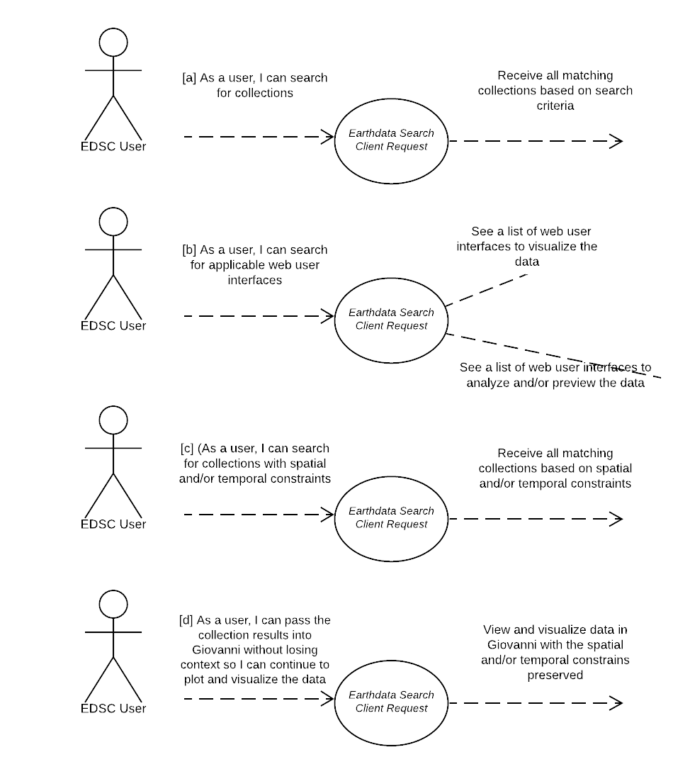
Figure 1. Web User interface Use Case

User Experience: See the activity diagram below.

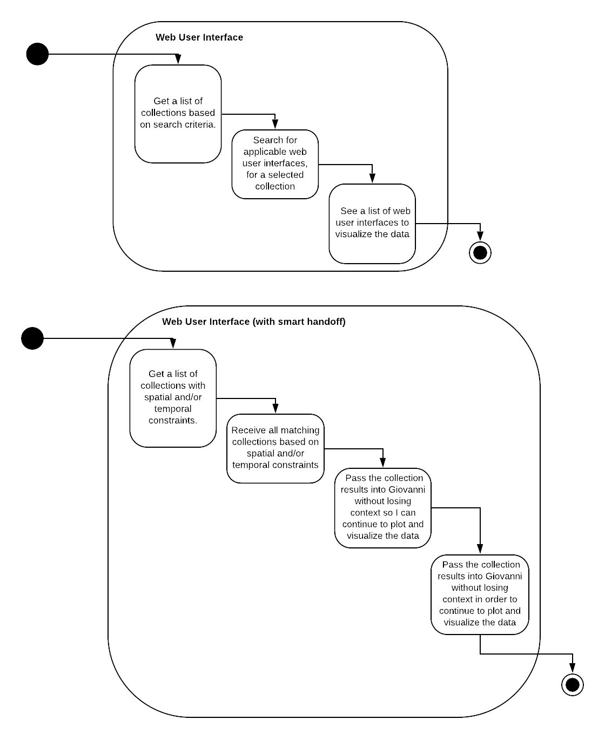
Figure 2. Web User Interface Activity Diagram

Workflow: See the sequence diagram below.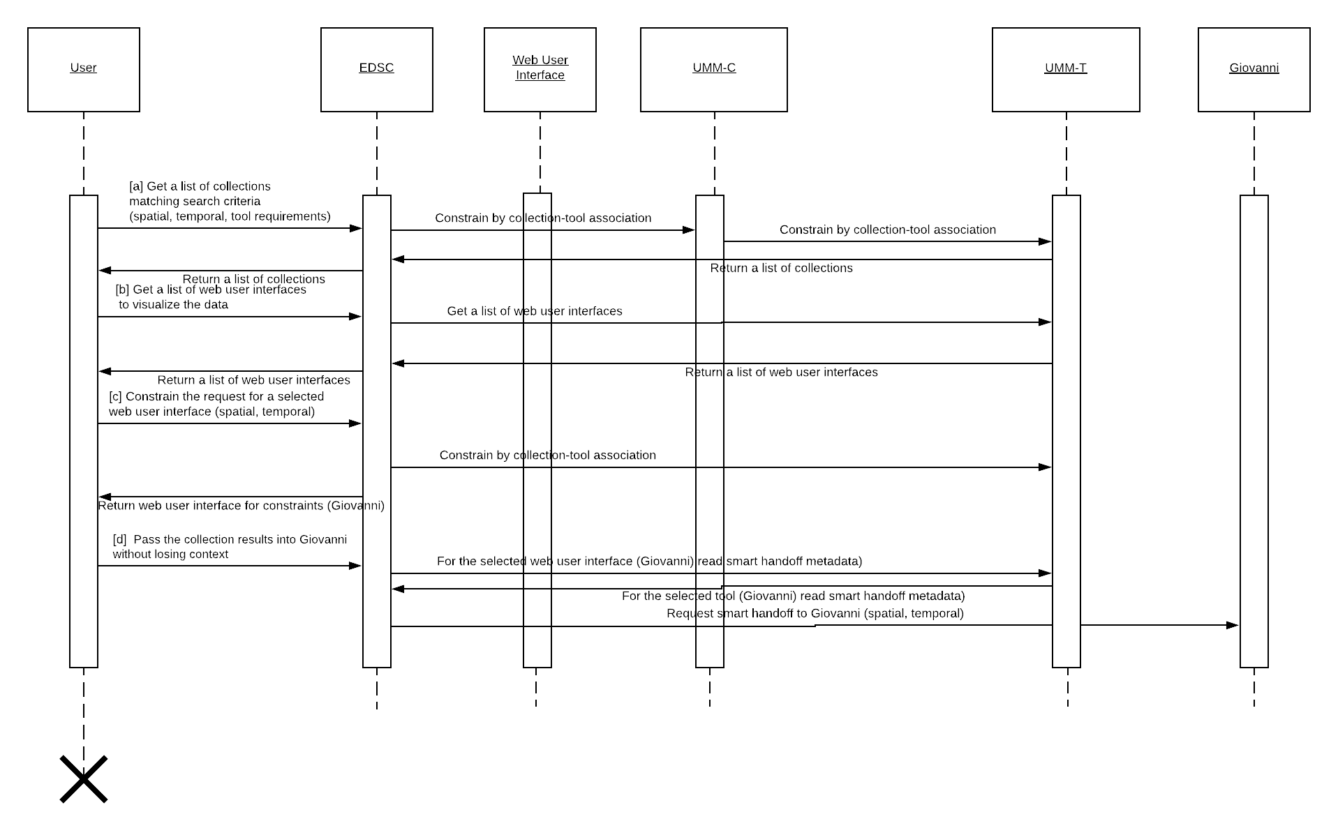
Figure 3. Web User Interface Sequence Diagram

Downloadable Tools

As a user of the Earthdata Search (EDSC), I can search for collections, locate downloadable tools, so I can plot and visualize the data.

Scenario [a]: As a user of the EDSC, I can search for collections.

Scenario [b]: As a user of the EDSC, I can search for applicable downloadable tools.

Outcomes: As an EDSC user, I can plot and visualize the data using a downloadable tool following a collection search.

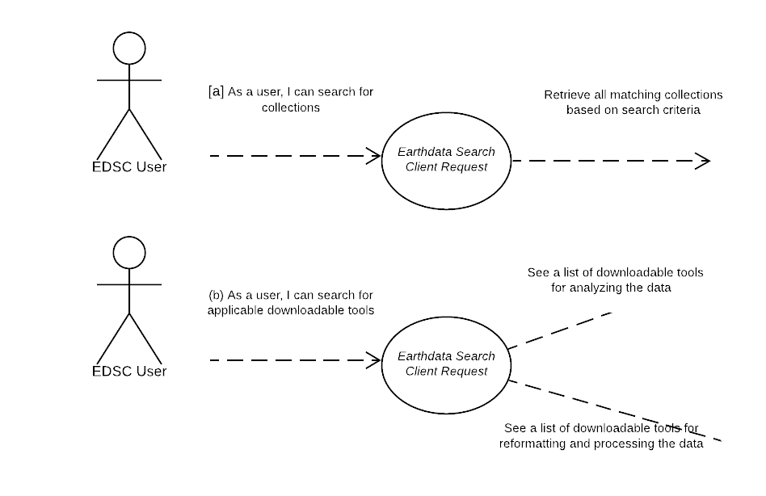
Figure 4. Downloadable Tools Use Case

User Experience: See the activity diagram below.

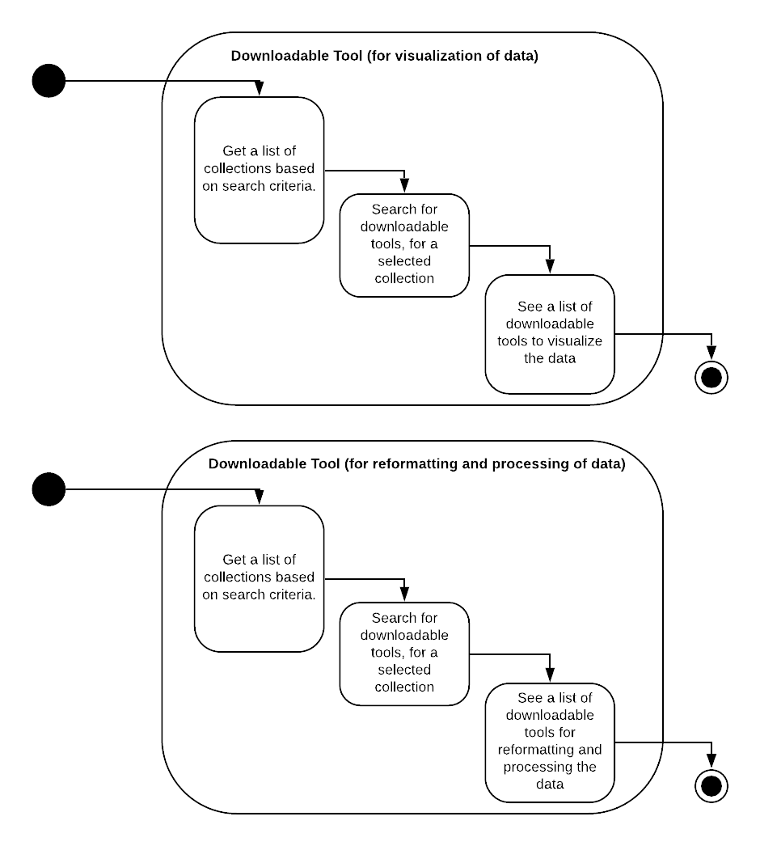
Figure 5. Downloadable Tools Activity Diagram

Workflow: See the sequence diagram below.

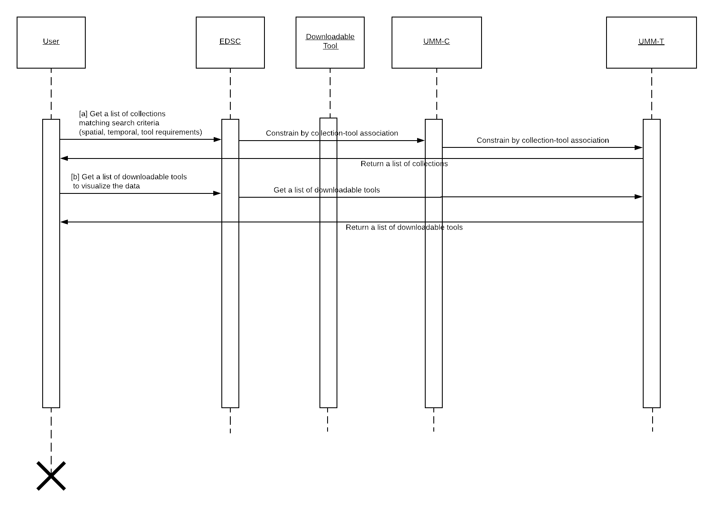
Figure 6. Downloadable Tools Sequence Diagram

UMM-T Metadata Model

The tool metadata conceptual model shown in Figure 8 shows the model broken down into one major class for Tools: Tool. There are also some minor classes: Organizations, URL, SupportedOperatingSystem, SupportedBrowsers, SupportedSoftwareLanguage, Quality, RelatedURLs, UseConstraints, SearchAction, ContactGroups and ContactPersons, which capture other important information about the tool. The Collection (UMM-C), Granule (UMM-G), Service (UMM-S) and Variable (UMM-Var) models are represented here to highlight these important relationships with the Tool class. Each aspect is described in more detail in the subsequent sections of this document.

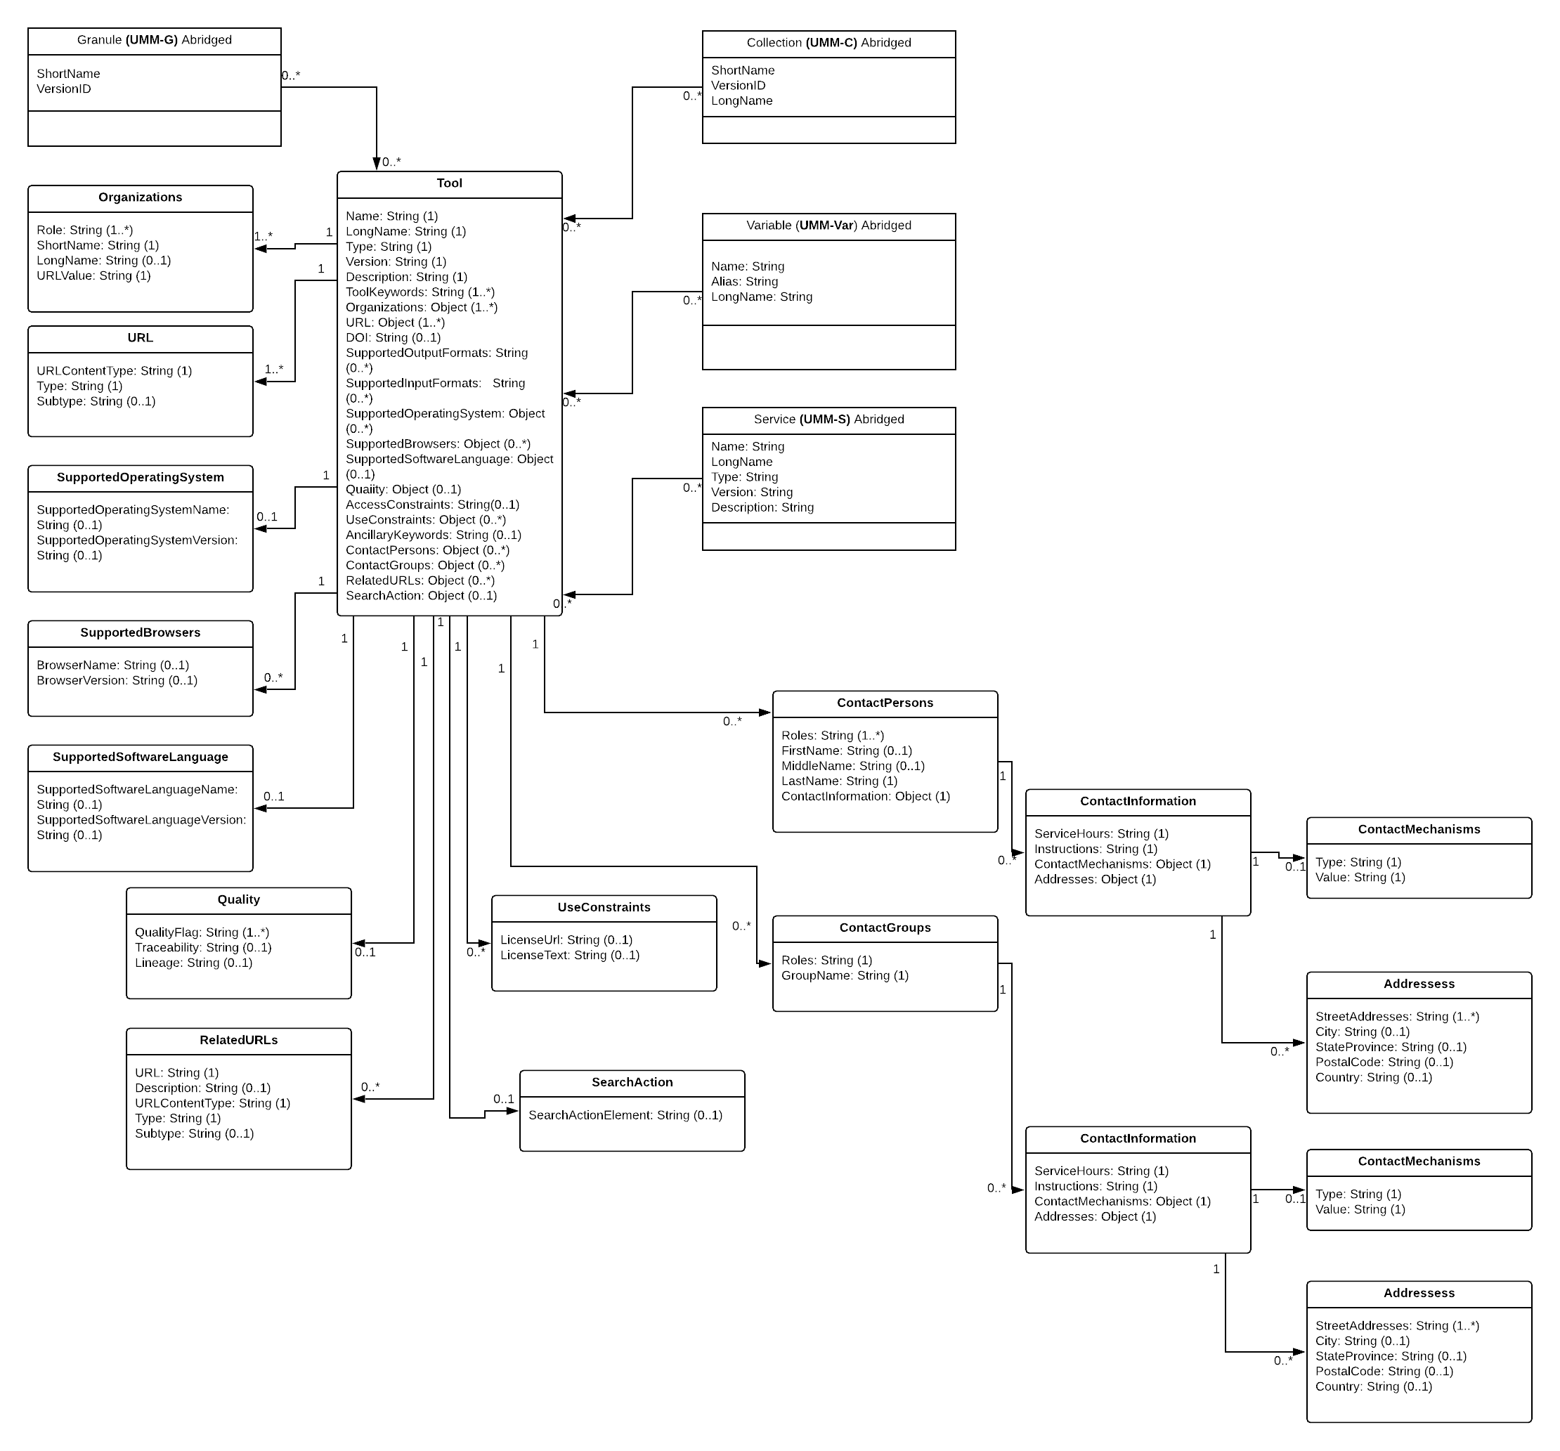
Figure 7. Overall Tool Model

The function of the Tool class is to enable the tool to be specified by its unique tool metadata. Each tool will be identified in terms of its name, long name, type, version, and description.

Name [R]

Element Specification

Name (1)

Description

The name of the downloadable tool or web user interface.

Sample Values:
- CIESIN_SEDAC_HAZARDS_MAPPER
- SOTO
- NASA_GISS_Panoply
- WCT

Tags

Required

LongName [R]

Element Specification

LongName (1)

Description

The long name of the downloadable tool or web user interface.

Sample Values:
- SEDAC Hazards Mapper
- State Of The Ocean
- Panoply netCDF, HDF and GRIB Data Viewer
- Weather and Climate Toolkit

Tags

Required

Type [R]

Element Specification

Type (1) <Downloadable Tool, Web User Interface, Web Portal, Model>

Description

The type of tool.

Sample Values
- Downloadable Tool
- Web User Interface
- Model

Tags

Required, Controlled Vocabulary

Version [R]

Element Specification

Version (1)

Description

The edition or version of the web user interface or downloadable tool. A value of 'NOT PROVIDED' may be used if the version is not available or unknown.

Sample Values
- 1.0
- 4.3
- NOT PROVIDED

Tags

Required

Description [R]

Element Specification

Description (1)

Description

A brief description of the web user interface or downloadable tool. Note: This field allows lightweight markup language with plain text formatting syntax. Line breaks within the text are preserved.

Sample Values:
- The SEDAC Hazards Mapper enables users to visualize data and map layers related to Socioeconomic, Infrastructure, Natural Disasters, and Environment and analyze potential impacts and exposure. The web app mashups layers from various sources including SEDAC, NASA LANCE, NASA GIBS, USGS, NOAA, ESRI, and others.
- The State of the Ocean (SOTO) is a web browser visualization service that provides access to a broad range of satellite-derived products and key parameters of interest to the oceanographic community. SOTO facilitates visual exploration and comparative quantitative analysis of physical oceanographic data, enabling scientific oceanographic, climate, and related research.
- Panoply plots geo-referenced and other arrays from netCDF, HDF, GRIB, and other datasets. With Panoply 4 you can: (1) Slice and plot geo-referenced latitude-longitude, latitude-vertical, longitude-vertical, time-latitude or time-vertical arrays from larger multidimensional variables; (2) Slice and plot "generic" 2D arrays from larger multidimensional variables; (3) Slice 1D arrays from larger multidimensional variables and create line plots; (4) Combine two geo-referenced arrays in one plot by differencing, summing or averaging; (5) Plot lon-lat data on a global or regional map using any of over 100 map projections or make a zonal average line plot; (6) Overlay continent outlines or masks on lon-lat map plots; (7) Use any of numerous color tables for the scale colorbar, or apply your own custom ACT, CPT, or RGB color table; and (8) Save plots to disk GIF, JPEG, PNG or TIFF bitmap images or as PDF or PostScript graphics files.
- NOAA's Weather and Climate Toolkit (WCT) is free, platform independent software distributed from NOAA's National Centers for Environmental Information (NCEI). The WCT allows the visualization and data export of weather and climate data, including Radar, Satellite and Model data. The WCT also provides access to weather/climate web services provided from NCEI and other organizations. The WCT provides tools for background maps, animations and basic filtering. The export of images and movies is provided in multiple formats. The data export feature supports conversion of data to a variety of common formats including GeoJSON, KMZ, Shapefile, Well-Known Text, GeoTIFF, ESRI Grid and Gridded NetCDF. These data export features promote the interoperability of weather and climate information with various scientific communities and common software packages such as ArcGIS, Google Earth, MatLAB, QGIS, R and many more.

Tags

Required

ToolKeyword [R]

Element Specification

ToolKeywords (1..*)

ToolKeywords/ToolCategory (1)

ToolKeywords/ToolTopic (1)

ToolKeywords/ToolTerm (0..1)

ToolKeywords/ToolSpecificTerm (0..1)

Description

Keywords used to describe the classification and functions of the web user interface or downloadable tool.

Sample Values
- EARTH SCIENCE SERVICES > DATA ANALYSIS AND VISUALIZATION > STATISTICAL APPLICATION
- EARTH SCIENCE SERVICES > DATA ANALYSIS AND VISUALIZATION > VISUALIZATION/IMAGE PROCESSING
- EARTH SCIENCE SERVICES > DATA ANALYSIS AND VISUALIZATION > GEOGRAPHIC INFORMATION SYSTEMS
- EARTH SCIENCE SERVICES > DATA MANAGEMENT/DATA HANDLING > DATA INTEROPERABILITY > DATA REFORMATTING
- EARTH SCIENCE SERVICES > DATA MANAGEMENT/DATA HANDLING > TRANSFORMATION/CONVERSION

Tags

Required, Controlled Vocabulary

Organizations [R]

Element Specification

Organizations (1..*)

Organizations/Role (1..*) <ISO Role Code List>

Organizations/ShortName (1)

Organizations/LongName (0..1)

Organizations/URLValue (1)

Description

The organization or institution responsible for developing, archiving, and/or hosting the web user interface or downloadable tool.

Sample Values
- Role: PROVIDER
- ShortName: SEDAC
- LongName: Socioeconomic Data and Applications Center
- URLValue:http://sedac.ciesin.columbia.edu/https://sedac.ciesin.columbia.edu/

- Role: DEVELOPER
- ShortName: NASA/GSFC/SED/ESD/GISS
- LongName: Goddard Institute for Space Studies, Earth Sciences Division, Science and Exploration Directorate, Goddard Space Flight Center, NASA
- URLValue:https://www.giss.nasa.gov/

Tags

Required, Controlled Vocabulary

URL [R]

Element Specification

URL (1)

URL/URLContentType (1) <DistributionURL>

URL/Type (1) <GOTO WEB TOOL, DOWNLOAD SOFTWARE>

URL/Subtype (0..1) {see KMS values}

URL/URLValue (1) {enter online resource locator}

Description

The URL where you can directly access the web user interface or downloadable tool.

Sample Values
- URLContentType: DistributionURL
- Type: GoTo Web Tool
- Subtype: Map Viewer
- URLValue:http://sedac.ciesin.columbia.edu/mapping/hazards/

- URLContentType: DistributionURL
- Type: Download Software
- Subtype: Map Viewer
- URLValue:https://www.giss.nasa.gov/tools/panoply/download/

Tags

Required, Controlled Vocabulary

DOI

Element Specification

DOI (0..1)

Description

The Digital Object Identifier (DOI) of the web user interface or downloadable tool.

Sample Values
- 10.5440/1237353
- 10.3334/ORNLDAAC/1388

Tags

Recommended

SupportedOutputFormats

Element Specification

SupportedOutputFormats (0..*)

Description

The output data format (s) supported by the web user interface or downloadable tool.

Sample Values
- GIF
- JPEG
- PNG
- MVT
- TIFF

Tags

Recommended, Controlled Vocabulary

SupportedInputFormats

Element Specification

SupportedInputFormats (0..*)

Description

The input data format (s) supported by the downloadable tool.

Sample Values
- netCDF
- HDF
- GRIB

Tags

Recommended, Controlled Vocabulary

SupportedOperatingSystem

Element Specification

SupportedOperatingSystem (0..*)

SupportedOperatingSystem/OperatingSystemName (0..1)

SupportedOperatingSystem/OperatingSystemVersion (0..1)

Description

The operating system(s) and associated version supported by the downloadable tool.

Sample Values
- Operating System Name: Microsoft Windows
- Operating System Version: 10
- Operating System Name: Apple macOS
- Operating System Version: 10.14
- Operating System Name: Ubuntu
- Operating System Version: 19

Tags

Recommended, Controlled Vocabulary

SupportedBrowsers

Element Specification

SupportedBrowsers (0..*)

SupportedBrowsers/BrowserName (0..1)

SupportedBrowsers/BrowserVersion (0..1)

Description

The browser(s) and associated version supported by the web user interface.

Sample Values
- Browser Name: Firefox
- Browser Version: 67

- Browser Name: Chrome
- Browser Version: 74

- Browser Name: Safari
- Browser Version: 12

- Browser Name: Internet Explorer
- BrowserVersion: 11.4

Tags

Recommended, Controlled Vocabulary

SupportedSoftwareLanguage

Element Specification

SupportedSoftwareLanguage (0..*)

SupportedSoftwareLanguageVersion (0..*)

Description

The programming language (s) and associated version supported by the downloadable tool.

Sample Values
- Software Language: Python
- Software Language Version: 3
- Software Language: Java
- Software Language Version: 8.0
- Software Language: C++
- Software Language Version: 14
- Software Language: Ruby
- Software Language Version: 2.7

Tags

Recommended, Controlled Vocabulary

Quality

Element Specification

Quality (0..1)

Quality/QualityFlag (1..*) <"Available", "Unavailable", "Reviewed", "Not Reviewed", "Other">

Quality/Traceability (0..1)

Quality/Lineage (0..1)

Description

Information about the quality of the web user interface or downloadable tool. This would include information about any quality assurance procedures followed in development. Note: This field allows lightweight markup language with plain text formatting syntax. Line breaks within the text are preserved.

Sample Values
- QualityFlag: "Reviewed"
- Lineage: "This web viewer has been reviewed for quality and no errors have been found".

Tags

Recommended, Controlled Vocabulary

AccessConstraints

Element Specification

AccessConstraints (0..1)

Description

Information about any constraints for accessing the web user interface or downloadable tool. Note: This field allows lightweight markup language with plain text formatting syntax. Line breaks within the text are preserved.

Sample Values

Registration is required to access the map viewer.
Registration is required to download this software.
None

Tags

Recommended

UseConstraints

Element Specification

UseConstraints/LicenseUrl (0..1)

UseConstraints/LicenseText (0..1)

Description

Designed to protect privacy and/or intellectual property by allowing the author to specify how the web user interface or downloadable tool may or may not be used after access is granted. This includes any special restrictions, legal prerequisites, terms and conditions, and/or limitations. Providers may request acknowledgement of the item from users and claim no responsibility for quality and completeness. UseConstraints describes how the item may be used once access has been granted; and is distinct from AccessConstraints, which refers to any constraints in access. A provider may also add a license URL or license text. Note: This field allows lightweight markup language with plain text formatting syntax. Line breaks within the text are preserved.

Sample Values
- LicenseText:
- "Subject to all the terms and conditions of this license and of the individual licenses of any third-party libraries, NASA Goddard Institute for Space Studies grants the user royalty-free, nonexclusive, non transferable, and worldwide rights to reproduce, modify, reverse engineer, and distribute the Panoply software package, herein referred to as the Product.:
- THIS SOFTWARE AND ITS DOCUMENTATION ARE CONSIDERED TO BE IN THE PUBLIC DOMAIN AND THUS ARE AVAILABLE FOR UNRESTRICTED PUBLIC USE. THEY ARE FURNISHED "AS IS." THE AUTHORS, THE UNITED STATES GOVERNMENT, ITS INSTRUMENTALITIES, OFFICERS, EMPLOYEES, AND AGENTS MAKE NO WARRANTY, EXPRESS OR IMPLIED, AS TO THE USEFULNESS OF THE SOFTWARE AND DOCUMENTATION FOR ANY PURPOSE. THEY ASSUME NO RESPONSIBILITY (1) FOR THE USE OF THE SOFTWARE AND DOCUMENTATION; OR (2) TO PROVIDE TECHNICAL SUPPORT TO USERS.
- Conditions and Limitations of Use. Neither the U.S. Government, nor any agency or employee thereof, makes any warranties, expressed or implied, with respect to the Product provided under this License."
- LicenseUrl:
- http://www.cerc.co.uk/environmental-software/prices.php

Tags

Recommended

AncillaryKeywords

Element Specification

AncillaryKeywords (0..1)

Description

Words or phrases to further describe the web user interface or downloadable tool.

Sample Values
- Calibration and Validation (Cal/Val)
- Committee on Earth Observing Satellites
- EPA Superfund
- Climate

Tags

Recommended

ContactPersons

Element Specification

ContactPersons (0..*)

ContactPersons/Roles (1..*) <ISO Role Code List>

ContactPersons/FirstName (0..1)

ContactPersons/MiddleName (0..1)

ContactPersons/LastName (1)

ContactPersons/ContactInformation (0..1)

ContactPersons/ContactInformation/ServiceHours (0..1)

ContactPersons/ContactInformation/ContactInstructions (0..1)

ContactPersons/ContactInformation/ContactMechanisms (0..*)

ContactPersons/ContactInformation/ContactMechanisms/Type (1) <Direct Line, Email, Facebook, Fax, Mobile, Modem, Primary, TDD/TTY Phone, Telephone, Twitter, U.S. toll free, Other>

ContactPersons/ContactInformation/ContactMechanisms/Value (1)

ContactPersons/ContactInformation/Addresses (0..*)

ContactPersons/ContactInformation/Addresses/StreetAddresses (0..*)

ContactPersons/ContactInformation/Addresses/City (0..1)

ContactPersons/ContactInformation/Addresses/StateProvince (0..1)

ContactPersons/ContactInformation/Addresses/PostalCode (0..1)

ContactPersons/ContactInformation/Addresses/Country (0..1)

Description

Person (s) to contact at an organization to get information about the web user interface or downloadable tool, including how the person may be contacted.

Sample Value

Role: PROVIDER

BRIAN KILLOUGH

Brian.D.Killough@nasa.gov

757-864-7047

Mail Stop 431

NASA Langley Research Center

Hampton, VA, 23681-2199

Role: TECHNICAL SUPPORT

ROBERT SCHMUNK

Robert.B.Schmunk@nasa.gov

212-678-5535

NASA Goddard Institute for Space Studies

2880 Broadway

New York, NY 10025

Tags

Recommended, Controlled Vocabulary

ContactGroups

Element Specification

ContactGroups (0..*)

ContactGroups/Roles (1..*) <ISO Role Code List>

ContactGroups/GroupName (1)

ContactGroups/ContactInformation (0..1)

ContactGroups/ContactInformation/ServiceHours (0..1)

ContactGroups/ContactInformation/ContactInstructions (0..1)

ContactGroups/ContactInformation/ContactMechanisms (0..*)

ContactGroups/ContactInformation/ContactMechanisms/Type (1) <Direct Line, Email, Facebook, Fax, Mobile, Modem, Primary, TDD/TTY Phone, Telephone, Twitter, U.S. toll free, Other>

ContactGroups/ContactInformation/ContactMechanisms/Value (1)

ContactGroups/ContactInformation/Addresses (0..*)

ContactGroups/ContactInformation/Addresses/StreetAddresses (0..*)

ContactGroups/ContactInformation/Addresses/City (0..1)

ContactGroups/ContactInformation/Addresses/StateProvince (0..1)

ContactGroups/ContactInformation/Addresses/PostalCode (0..1)

ContactGroups/ContactInformation/Addresses/Country (0..1)

Description

Group (s) to contact at an organization to get information about the web user interface or downloadable tool, including how the group may be contacted.

Sample Value

Role: TECHNICAL SUPPORT

LP DAAC User Services

605-594-6116

LPDAAC@usgs.gov

Tags

Recommended, Controlled Vocabulary

RelatedURLs

Element Specification

RelatedURLs (0..*)

RelatedURLs/URL (1)

RelatedURLs/Description (0..1)

RelatedURLs/URLContentType (1) <CollectionURL, PublicationURL, VisualizationURL>

RelatedURLs/Type (1) {see KMS values}

RelatedURLs/Subtype (0..1) {see KMS values}

Description

Any resource-related URLs that include a project home pages, resource information pages, how-to documentation, example code snippets, thumbnail image, or other relevant information about the web user interface or downloadable tool.

Sample Values

Web User Interface Example:

URL:http://superfund.ciesin.columbia.edu/sfmapper/map_intro.htmhttps://sedac.ciesin.columbia.edu/downloads/maps/superfund/superfund-atsdr-hazardous-waste-site-v2/superfund-atsdr-hazardous-waste-site-v2.png

Description: Thumbnail image of Superfund ATSDR Hazardous Waste Sites.

URLContentType: VisualizationURL

Type: Get Related Visualization

Subtype: Map

Downloadable Tool Example:

URL:https://www.giss.nasa.gov/tools/panoply/help/

Description: Access Panoply help and how-to documentation.

URLContentType: PublicationURL

Type: View Related Information

Subtype: User's Guide

Tags

Required, Controlled Vocabulary

SearchAction

Element Specification

SearchAction/SearchActionElement (0..1)

Description

Information about a smart handoff from one web user interface to another. This includes information about the back-end API of the web user interface. Smart handoffs enable the transferal of search results and/or context to another tool without losing that specific context.

Sample Values

Provided here are JSON-LD search action examples.

EDSC → Giovanni

Giovanni

EDSC → SOTO

SOTO

Tool → EDSC

Earthdata Search

The basic concept is that the JSON-LD search action string is embedded in the UMM-T record, using the SearchActionElement field. The direction of the search action is implicit in each case of the record. The URI of the SearchAction should follow the standard for URI templates.

Tags

Recommended

Appendix A Deprecated Elements

This page is intentionally left blank.

Appendix B Tags Glossary
Tag Name | Description
Required | This element is required.
Controlled Vocabulary | This element will have a vocabulary that will be used to validate the value. This will most likely be done via a vocabulary management service.
Recommended | This element is recommended.

Appendix C Definitions of Terms

This section contains definitions for new concepts introduced in the UMM-T model, i.e. downloadable tool, web user interface, smart handoff, search action, etc.

Downloadable tool are those which must be downloaded to the user’s processing platform in order to use them. examples of these include local GUI tools like Panoply and command line tools such as NCO.

Web user interfaces provide the ability for users to interact with the data, but lacking a robust, well-advertised API. An example of this class is the State of the Ocean tool.

Smart handoffs enable users to perform searches on one tool, or web interface and, without losing context, pass the search results and constraints across to another user tool. Examples of smart handoffs are, Earthdata Search -> Giovanni, or Earthdata Search -> the State of the Ocean tool.

Search action is a web concept which captures all the necessary context of a search in a structured format, e.g. XML, or JSON-LD. In this model, the search action string is embedded in the UMM-T record and contains information about a smart handoff from one web user interface to another.

Appendix D Examples

This section contains some tool metadata worked examples.

The following two distinct types are represented: Downloadable Tool, Web User Interface.

These two tool types are envisaged to be the most commonly used tools and hence warrant a worked example for each type.

Downloadable Tool example:

The NOAA/NCDC Weather and Climate Toolkit is an example of a downloadable tool. It can enable the visualization of NOAA Weather Products (which may consumed by the tool) and enables the export of these data products into a preferred export format.

{
"Name": "USGS_TOOLS_LATLONG",
"LongName": "WRS-2 Path/Row to Latitude/Longitude Converter",
"Type": "Downloadable Tool",
"Version": "1.0",
"Description": "The USGS WRS-2 Path/Row to Latitude/Longitude Converter allows users to enter any Landsat path and row to get the nearest scene center latitude and longitude coordinates.",
"URL": {
"URLContentType": "DistributionURL",
"Type": "DOWNLOAD SOFTWARE",
"Description": "Access the WRS-2 Path/Row to Latitude/Longitude Converter.",
"URLValue": "http://www.scp.byu.edu/software/slice_response/Xshape_temp.html"
},
"ToolKeywords" : [{
"ToolCategory": "EARTH SCIENCE SERVICES",
"ToolTopic": "DATA MANAGEMENT/DATA HANDLING",
"ToolTerm": "DATA INTEROPERABILITY",
"ToolSpecificTerm": "DATA REFORMATTING"
}],
"Organizations" : [
{
"Roles": ["SERVICE PROVIDER"],
"ShortName": "USGS/EROS",
"LongName": "US GEOLOGICAL SURVEY EARTH RESOURCE OBSERVATION AND SCIENCE (EROS) LANDSAT CUSTOMER SERVICES",
"URLValue": "http://www.usgs.gov"
}
],
"ContactPersons": [{
"Roles" : [ "SERVICE PROVIDER"],
"ContactInformation" : {
"ContactMechanisms" : [ {
"Type" : "Email",
"Value" : "custserv at usgs.gov"
}, {
"Type" : "Fax",
"Value" : "605-594-6589"
}, {
"Type" : "Telephone",
"Value" : "605-594-6151"
} ],
"Addresses" : [ {
"StreetAddresses" : [ "47914 252nd Street" ],
"City" : "Sioux Falls",
"StateProvince" : "SD",
"Country" : "USA",
"PostalCode" : "57198-0001"
} ]
},
"FirstName" : "Service Provider Personnel First Name",
"MiddleName" : "Service Provider Personnel Middle Name",
"LastName" : "Service Provider Personnel Last Name"
}],
"MetadataSpecification": {
"URL": "https://cdn.earthdata.nasa.gov/umm/tool/v1.0",
"Name": "UMM-T",
"Version": "1.0"
}
}

The second of these two tool records is for the Web User Interface type. This is the landing page for the online AppEEARS tool.

{
"Name": "AppEEARS",
"LongName": "Application for Extracting and Exploring Analysis Ready Samples",
"Type": "Web User Interface",
"Version": "2.9",
"Description": "The Application for Extracting and Exploring Analysis Ready Samples (AρρEEARS) offers a simple and efficient way to access and transform geospatial data from a variety of federal data archives. AρρEEARS enables users to subset geospatial datasets using spatial, temporal, and band/layer parameters. Two types of sample requests are available: point samples for geographic coordinates and area samples for spatial areas via vector polygons. Sample requests submitted to AρρEEARS provide users not only with data values, but also associated quality data values. Interactive visualizations with summary statistics are provided for each sample within the application, which allow users to preview and interact with their samples before downloading their data. Get started with a sample request using the Extract option above, or visit the Help page to learn more.",
"URL": {
"URLContentType": "DistributionURL",
"Type": "GOTO WEB TOOL",
"Description": "AppEEARS Landing Page.",
"URLValue": "https://lpdaacsvc.cr.usgs.gov/appeears/"
},
"ToolKeywords" : [{
"ToolCategory": "EARTH SCIENCE SERVICES",
"ToolTopic": "DATA MANAGEMENT/DATA HANDLING",
"ToolTerm": "DATA INTEROPERABILITY",
"ToolSpecificTerm": "DATA REFORMATTING"
}],
"Organizations" : [
{
"Roles": ["SERVICE PROVIDER"],
"ShortName": "LP DAAC",
"LongName": "Land Processes Distributed Active Archive Center",
"URLValue": "https://lpdaac.usgs.gov/"
}
],
"ContactGroups": [{
"Roles" : [ "SERVICE PROVIDER"],
"ContactInformation" : {
"ContactMechanisms" : [ {
"Type" : "Email",
"Value" : "lpdaac@usgs.gov"
}, {
"Type" : "U.S. toll free",
"Value" : "866-573-3222"
}, {
"Type" : "Telephone",
"Value" : "605-594-6116"
} ],
"Addresses" : [ {
"StreetAddresses" : [ "U.S. Geological Survey, Earth Resources Observation and Science (EROS) Center" ],
"City" : "Sioux Falls",
"StateProvince" : "SD",
"Country" : "USA",
"PostalCode" : "57198"
} ]
},
"GroupName" : "LP DAAC User Services"
}],
"MetadataSpecification": {
"URL": "https://cdn.earthdata.nasa.gov/umm/tool/v1.0",
"Name": "UMM-T",
"Version": "1.0"
}
}

Appendix E Abbreviations and Acronyms
API | Application Programming Interface
AppEEARS | Application for Extracting and Exploring Analysis Ready Samples
CMR | Common Metadata Repository
CSV | Comma-Separated Values
DAAC | Distributed Active Archive Center
DOI | Digital Object Identifier
ECHO | Earth Observing System (EOS) Clearing House
EDSC | Earthdata Search
EOS | Earth Observing System
EOSDIS | Earth Observing System Data and Information System
ESDIS | Earth Science Data and Information System
ESO | ESDIS Standards Office
GCMD | Global Change Master Directory
GES DISC | Goddard Earth Sciences Data and Information Services Center
ISO | International Organization for Standardization
KB | Kilobyte
KMS | Keyword Management System
MAS | Metadata Architecture Studies
MB | Megabyte
MMT | Metadata Management Tool
NASA | National Aeronautics and Space Administration
NOAA | National Oceanic and Atmospheric Administration
NODC | National Oceanographic Data Center
SERF | Service Entry Resource Format
UI | User Interface
UML | Unified Modeling Language
UMM | Unified Metadata Model
UMM-C | Unified Metadata Model - Collections
UMM-G | Unified Metadata Model - Granules
UMM-S | Unified Metadata Model - Services
UMM-T | Unified Metadata Model - Tools
UMM-Var | Unified Metadata Model - Variables
URL | Uniform Resource Locator
USGS | United States Geological Survey
UI/UX | User Interface/User Experience
XML | Extensible Markup Language
XPath | XML Path Language
XSLT | Extensible Stylesheet Language Transformations

