GSFC ESDIS CMO
October 31, 2018
Released
National Aeronautics and
Space Administration
Goddard Space Flight Center
Greenbelt, Maryland

423-RQMT-003-C, Original, Revision -
Earth Science Data and Information Systems (ESDIS) Project, Code 423

Appendix C. Metadata Requirements Base Reference Unified Metadata Model Granules (UMM-G)

Appendix C. Metadata Requirements Base Reference Unified Metadata Model Granules (UMM-G)
Signature/Approval Page

Prepared by:
Signature obtained on file |  | 10/30/2018
Valerie Dixon |  | Date
ESDIS CMR Manager
GSFC Code 586
Reviewed by:
Signature obtained on file |  | 11/05/2018
Karen Michael |  | Date
EOSDIS System Manager
NASA GSFC Code 423
Signature obtained on file |  | 10/30/2018
Jeanne Behnke |  | Date
ESDIS Deputy Manager for Science Operations
NASA GSFC Code 423
Approved by:
Signature obtained on file |  | 10/31/2018
Andrew Mitchell |  | Date
ESDIS Project Manager
GSFC Code 423

[Electronic] Signatures available in B32 Room E148
online at: / https://ops1-cm.ems.eosdis.nasa.gov/cm2/
Preface
This document is under ESDIS Project configuration control. Once this document is approved, ESDIS approved changes are handled in accordance with Class I and Class II change control requirements described in the ESDIS Configuration Management Procedures. Changes to this document shall be verified by a document change notice (DCN) and implemented by change bars or by complete revision.

Any questions should be addressed to: esdis-esmo-cmo@lists.nasa.gov
ESDIS Configuration Management Office (CMO)
NASA/GSFC
Code 423
Greenbelt, Md. 20771

Abstract
This document describes the Unified Metadata Model for Granules (UMM-G) to be used by the NASA Earth Science community. This model takes into account standards and specifications (Earth Observing System (EOS) Clearing House (ECHO) 10, ISO 19115-2, and ISO 19115-1) used by this community. Implementers of Earth Science Data and Information System's (ESDIS) CMR, its clients, and data providers should reference this document and the Unified Metadata Model (UMM) as a guide while implementing the system, its clients, or generating metadata.

Keywords: UMM-S, UMM-Common, UMM-C, UMM-G, UMM-Var, Granules, NASA Earthdata Search, Tools, EOSDIS, ESDIS, CMR
Change History Log

Revision | Effective Date | Description of Changes  (Reference the CCR & CCB Approval Date)
V1.0 | June 2014 | - Provisional Release.
Baseline/ Original, Rev- | 10/31/2018 | CCR 423-ESDIS-193; approved 10/10/2018  - Baseline in COMET as stand-alone Appendix C to the Metadata Requirements Base Reference as Revision B. Pages: C-1 through C-83

Table of Contents
C.1. Introduction C-9
C.1.1 Purpose C-9
C.1.2 Scope C-9
C.1.3 Impact C-9
C.1.4 Copyright Notice C-10
C.1.5 Feedback C-10
C.1.6 Document Conventions C-10
C.1.7 Related Documentation C-11
C.1.7.1 Applicable Documents C-12
C.1.7.2 Reference Documents C-12
C.2. Granule Metadata Conceptual Model C-13
C.2.1 Metadata Information C-13
C.2.1.1 Metadata Language C-13
C.2.1.2 Metadata Dates C-14
C.2.2 Data Identification C-14
C.2.2.1 Data Dates [R] C-14
C.2.2.2 Universal Reference Identifier [R] C-15
C.2.2.3 Producer Identifier C-16
C.2.2.4 Local Version Identifier C-17
C.2.2.5 Reprocessing Plan Note C-18
C.2.2.6 Browse Graphic C-19
C.2.2.7 Data Format C-20
C.2.2.8 Additional Attributes - Descriptive Keywords C-21
C.2.2.9 Spatial Locality C-21
C.2.2.10 Access Constraint Value C-23
C.2.2.11 Parent Collection Identifier [R] C-24
C.2.2.12 Parent Collection Identifier Option 1 - Entry Id (Short Name + Version) C-24
C.2.2.13 Parent Collection Identifier Option 2 - Entry Title (Dataset Id) C-26
C.2.3 Spatial Information C-29
C.2.3.1 Spatial Extent C-29
C.2.3.2 VerticalSpatialDomain C-29
C.2.3.3 ZoneIdentifier C-31
C.2.3.4 Spatial Option 1- Point C-32
C.2.3.5 Spatial Option 2 - Line C-33
C.2.3.6 Spatial Option 3 - Polygon C-34
C.2.3.7 Spatial Option 4 – Bounding Box C-34
C.2.3.8 Spatial Option 5 – Bounding Box with Center Point C-35
C.2.3.9 Spatial Option 6 – Polygon with Center Point C-36
C.2.3.10 Spatial Option 7 – Polygon with Holes C-36
C.2.3.11 Spatial Option 8 – Platform Orbit Information C-37
C.2.3.12 Additional Attributes - Geographic Identifier C-43
C.2.3.13 Tiling Identification System C-44
C.2.4 Temporal Information C-45
C.2.4.1 Temporal Extent C-45
C.2.5 Coverage Description C-46
C.2.5.1 Additional Attributes - Content Information C-46
C.2.5.2 Day Night Flag C-47
C.2.5.3 Cloud Cover C-48
C.2.6 Distribution Information C-50
C.2.6.1 Distribution C-50
C.2.6.2 Data Format C-50
C.2.6.3 File Size C-50
C.2.6.4 Related URL C-51
C.2.7 Data Quality Information C-52
C.2.7.1 Additional Attributes - Quality Information C-53
C.2.7.2 Reprocessing Lineage C-55
C.2.7.3 Production Date Time C-56
C.2.7.4 Product Generation Executive (PGE) Information C-57
C.2.7.5 Input Granules C-59
C.2.8 Acquisition Information C-61
C.2.8.1 Platform C-61
C.2.8.2 Instrument C-62
C.2.8.3 Sensor C-62
C.2.8.4 Project C-63
Appendix C-1. Deprecated Fields C-64
C-1.1 Measured Parameters C-64
C-1.2 Price C-64
C-1.3 Orderable C-64
C-1.4 Visible C-64
Appendix C-2. Tags Glossary C-65
Appendix C-3. Tag Index C-66
Appendix C-4. Tiling Identification Systems C-69
Appendix C-5. Additional Attributes Categorization C-70
Appendix C-6. Field Summary C-71
Appendix C-7. NASA ESDIS Echo 10 Granule Elements To UMM Mapping (Cross-Walk) C-73
Appendix C-8. NASA ESDIS Granule Profile Of ISO 19115 Compatible With ECHO 10 Granule Information Content (Cross-Walk) C-76
Appendix C-9. Abbreviations And Acronyms C-82

List of Figures
Figure C.1. Overall Granule Model C-13
Figure C.2. Metadata Information C-13
Figure C.3. Data Identification C-14
Figure C.4. Collection - Granule Relationship C-24
Figure C.5. Spatial Information C-29
Figure C.6. Temporal Information C-45
Figure C.7. Coverage Description C-46
Figure C.8. Distribution Information C-50
Figure C.9. Data Quality Information C-52
Figure C.10. Acquisition Information C-61

List of Tables
Table C.1. Cardinality 11

Introduction

Purpose
Earth Observing System Data and Information System (EOSDIS) generates, archives, and distributes enormous amounts of Earth Science data via its Distributed Active Archive Centers (DAACs). These data are accessed and employed by a broad user community. It is therefore imperative that reliable, consistent, and high-quality metadata be maintained in order to enable accurate cataloging, discovery, accessibility, and interpretation. To increase the level of quality and consistency among its metadata holdings, EOSDIS has developed a model for various metadata concepts that it archives and maintains. This model aims to document vital elements that may be represented across various metadata formats and standards and unify them through core fields useful for data discovery and service invocations. This unified model, aptly named the Unified Metadata Model (UMM), has been developed as part of the EOSDIS Metadata Architecture Studies (MAS I and II) conducted between 2012 and 2013.

The UMM will be used by the Common Metadata Repository (CMR) and will drive search and retrieval of metadata cataloged within that system.

This document is intended to serve as a reference profile – a part of the UMM model - for geospatial science metadata for individual granules that are part of a larger data collection. This reference profile is referred to as the UMM-G, where 'G' indicates that this is the granule profile. The UMM-G attempts to unify several metadata specifications (ECHO 10, International Organization for Standardization (ISO) 19115-2:2009, and ISO 19115-1:2014). The profile breaks down granules into elements or classes closely aligned to the ISO 19115-* Geographic Information Metadata schemas. Links to more information about the standards and specifications used in this document can be found in Related Documents section.

For each element, this document provides: a description, analysis, and set of associated tags; specification of any conflicts that were identified by the unification process; and a discussion of applicable recommendations. The set of associated tags can be used to understand various aspects of the field. Some fields are identified as being part of a controlled vocabulary providing a uniform way of classifying and describing all EOSDIS metadata. A reconciliation process will be developed to handle any conflicts specified by the unification process and the details will be developed on a provider-by-provider basis.

This document provides information to the National Aeronautics and Space Administration (NASA) Earth Science community. Distribution is unlimited.

Scope
This document describes the UMM Granule (UMM-G) model.

Impact
This document outlines a profile intended to be backward compatible with existing NASA Earth Science metadata implementations. It will impact providers from NASA DAAC[s], CMR client developers, metadata catalog developers, and users.

Copyright Notice
The contents of this document are not protected by copyright in the United States.

Feedback
Questions, comments and recommendations on this model should be directed to support@earthdata.nasa.gov

Document Conventions
Unified Modeling Language (UML) diagrams and element lists are provided for each subcomponent of the model. The [R] after a field name indicates that the field is required. Elements that have commonality across multiple models are fully documented in the UMM-Common model. These elements are documented here, with references to the UMM-Common model as appropriate. If the element is documented fully in the UMM-Common document, only Tags and Sample Mappings are included here.

Each section of this document describes an element of the model. Many elements in this model are used in other metadata models. For example, several metadata models contain the Science Keywords element. Elements that have commonality across multiple models are fully documented in the UMM-Common model. These elements are documented here, with references to the UMM-Common model as appropriate. If the element is documented fully in the UMM-Common document, only Tags and Sample Mappings are included here. Elements that are unique to the Collection model are documented in the following way:

- Element Specification: Identifies the individual fields for the element
- Description: Provides background information on the purpose of the element and how it should be used. Any notes about the current usage of this element are documented here as well as any recommendations for usage or unresolved issues.
- Cardinality: Indicates the expectation of counts for this element, summarized in the following table:
- Tags: Provides related keywords associated with this element. Tags have specific valid values, which are documented and described in Appendix B: Tags Glossary.
- Sample Mappings: Gives an XPath for this element in DIF 9, DIF 10.x, ECHO, EMS, ISO-1911-2 and ISO 19115-1 metadata XML representations. This can be seen as the "crosswalk" for this element. Note: Not all elements have mappings in all formats and sometimes elements may have multiple mappings.
- Examples: XML snippets from "crosswalked" data formats documenting sample values for the element. Whenever possible, a URL to the specific collection used for the metadata snippet is provided. ISO 19115-2 snippets were developed using the file ECHOtoISO.xsl. ISO 19115-1 snippets were developed using ECHOtoISO-1.xsl. Current versions of these transformations can be found at https://cdn.earthdata.nasa.gov/iso/resources/transforms/

Table C.1. Cardinality
Value | Description
1 | Exactly one of this element is required
0..1 | Optionally, one of this element may be present
0..* | Optionally, many of this element may be present
1..* | At least one of this element is required, many may be present

granule

The smallest aggregation of data independently described, inventoried, and managed. Granules can be managed as logical granules and/or physical granules.

These are metadata elements that describe a single instance of a data product. Values of granule metadata apply to all of the data in that one granule. Typical metadata in this category describe spatial and temporal extent of the data as well as the quality and lineage of the data.

Source: http://edhs1.gsfc.nasa.gov/waisdata/docsw/pdf/tp1520303.pdf

UML diagrams and element lists are provided for each subcomponent of the model. The [R] after an element name indicates that the element is required.

Some elements are marked via tags as 'Required (with Option)'. These elements are similar to the xml scheme <choice> element: one of the options is required, but there is a choice with regards to which option is utilized. For more information about the various tags used throughout this document, refer to Appendix B: Tags Glossary of this document.

Related Documentation
There is a document that fully describes metadata elements that are used in multiple models. This document, the UMM-Common (https://wiki.earthdata.nasa.gov/display/CMR/CMR+Documents) is documented separately. The Granule model makes multiple references to the UMM-Common throughout.

The ISO 19115-2 and ISO 19115-1 mapping paths and extracts of XML encoding of this standard used in this document are derived from the NASA Best Practices ISO translation from ECHO to 19115-2 and a similar ECHO to ISO 19115-1 translation. The translation files can be found online at this site: https://cdn.earthdata.nasa.gov/iso/resources/transforms. These translations resulted from efforts of the group assembled for the Metadata Evolution for NASA Data Systems (MENDS). More information on the Base Metadata Requirements established by the MENDS group can be found online at: https://wiki.earthdata.nasa.gov/display/NASAISO/NASA+Base+Metadata+Requirements.

The latest versions of all documents below should be used. The latest ESDIS Project documents can be obtained from URL: https://ops1-cm.ems.eosdis.nasa.gov. ESDIS documents have a document number starting with either 423 or 505. Other documents are available for reference in the ESDIS project library website at: http://esdisfmp01.gsfc.nasa.gov/esdis_lib/default.php unless indicated otherwise.

Applicable Documents
The following documents are referenced within or are directly applicable, or contain policies or other directive matters that are binding upon the content of this document.
423-RQMT-003 | Metadata Requirements Base Reference Document
CMR Life Cycle | https://wiki.earthdata.nasa.gov/display/CMR/CMR+Documents
423-RQMT-003-A  UMM-Common | Metadata Requirements Base Reference Appendix A UMM-Common  https://wiki.earthdata.nasa.gov/display/CMR/CMR+Documents
ECHO 10 | https://wiki.earthdata.nasa.gov/display/echo/Earth+Observing+System+Clearing+House+-+ECHO
ISO 19115-2 (MENDS) | ISO 19115-2 Geographic Information - Metadata. http://www.iso.org/iso/catalogue_detail.htm?csnumber=39229  https://cdn.earthdata.nasa.gov/iso/
ISO 19115-1 | ISO 19115-1 Geographic Information - Metadata  https://github.com/ISO-TC211/XML

Reference Documents
The following documents are not binding on the content but referenced herein and, amplify or clarify the information presented in this document.
Tags | http://en.wikipedia.org/wiki/Tag_%28metadata%29
Translators | Translators to ISO can be found at https://cdn.earthdata.nasa.gov/iso/resources/transforms/
XPath | XPath is a language for addressing parts of an XML document, designed for use with XSLT.
XLinks | http://en.wikipedia.org/wiki/XLink
MENDS | More information on the Base Metadata Requirements established by the MENDS group: https://wiki.earthdata.nasa.gov/display/NASAISO/NASA+Base+Metadata+Requirements  http://www.w3schools.com/schema/el_choice.asp

Granule Metadata Conceptual Model
As shown in Figure C.1, the model has been organized into seven subsections that group related model elements. Each of these subsections and its constituent elements is documented individually.
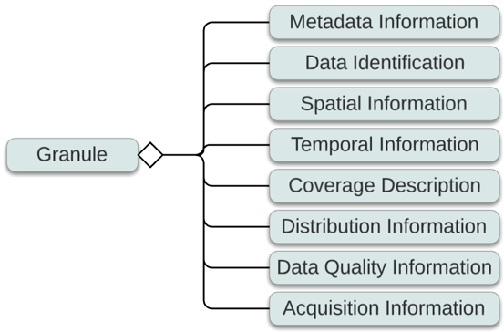
Figure C.1. Overall Granule Model

Metadata Information
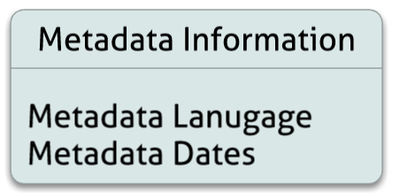
Figure C.2. Metadata Information

Metadata Language
This field is only part of ISO 19115. See UMM-Common Metadata Language element for full documentation and examples.

Tags
Controlled Vocabulary, Faceted, Recommended

Sample Mappings
ISO 19115-2 | /gmi:MI_Metadata[gmd:characterSet/gmd:MD_CharacterSetCode[@codeList='  http://www.ngdc.noaa.gov/metadata/published/xsd/schema/resources/Codelist/  gmxCodelists.xml#MD_CharacterSetCode'][@codeListValue='utf8']]  /gmd:language/gco:CharacterString
ISO 19115-1 | /mdb:MD_Metadata/mdb:defaultLocale/lan:PT_Locale[lan:characterEncoding  /lan:MD_CharacterSetCode[@codeList='codeListLocation#MD_CharacterSetCode']  [@codeListValue='anyValidURI']]/lan:language/lan:LanguageCode
ECHO 10 Granule | N/A

Metadata Dates
This includes any metadata related dates. All metadata dates will have a Lineage/Scope of 'metadata'. See UMM-Common Lineage and Metadata Dates element for full documentation and examples.

Sample Mappings
ISO 19115-2 | /gmi:MI_Metadata/gmd:datestamp/gco:DateTime – metadata creation date
ISO 19115-1 | /mdb:MD_Metadata/mdb:dateInfo/cit:CI_Date[cit:dateType/cit:CI_DateTypeCode[@codeList = 'codeListLocation#CI_DateTypeCode'][@codeListValue = 'anyValidURI'][. = 'creation']]/cit:date/gco:DateTime
ECHO 10 Granule | /Granule/DataGranule/ProductionDateTime (cardinality [0..1])

Data Identification
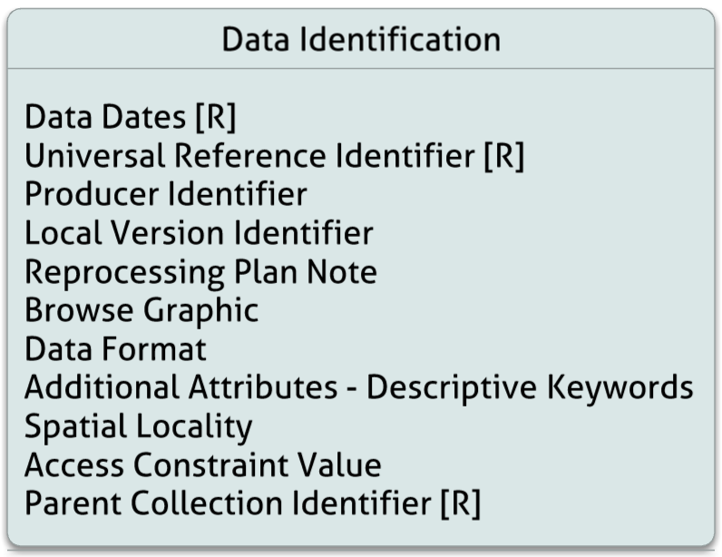
Figure C.3. Data Identification

Data Dates [R]
This includes any data related dates. All of these dates will have a Lineage/Scope of 'data'. See UMM-Common Lineage and Data Dates elements for full documentationand examples.

Tags
Required (as specified in sample mappings)

Sample Mappings
ISO 19115-2 | /gmi:MI_Metadata/gmd:identificationInfo/gmd:MD_DataIdentification/gmd:citation  /gmd:CI_Citation/gmd:date/gmd:CI_Date[gmd:dateType/gmd:CI_DateTypeCode  [@codeList = 'http://www.ngdc.noaa.gov/metadata/published/xsd/schema/resources/Codelist  /gmxCodelists.xml#CI_DateTypeCode'][@codeListValue='creation']]/gmd:date/gco:DateTime  Note: @codeListValue varies – InsertTime -> 'creation', LastUpdate -> 'revision',  DeleteTime -> 'expiry'
ISO 19115-1 | /mdb:MD_Metadata/mdb:identificationInfo/mri:MD_DataIdentification  /mri:citation/cit:CI_Citation/cit:date/cit:CI_Date[cit:dateType/  cit:CI_DateTypeCode[@codeList = 'codeListLocation#CI_DateTypeCode']  [@codeListValue = 'anyValidURI'][. = 'creation']]/cit:date/gco:DateTime  Note: @codeListValue varies – InsertTime -> 'creation', LastUpdate -> 'revision', DeleteTime -> 'expiry'
ECHO 10 Granule | /Granule/InsertTime [R]  /Granule/LastUpdate [R]  /Granule/DeleteTime(cardinality [0..1])

Universal Reference Identifier [R]

Element Specification
GranuleUR

Description
The Universal Reference (UR) ID of the granule referred to by the data provider. This ID is unique per data provider.

Cardinality
1

Tags
Required, Free Text Search, Parameter Search

Mappings
ISO 19115-2 | As data identifier: /gmi:MI_Metadata/gmd:identificationInfo/gmd:MD_DataIdentification  /gmd:citation  /gmd:CI_Citation/gmd:identifier/gmd:MD_Identifier/gmd:code/gco:CharacterString  As data title:  /gmi:MI_Metadata/gmd:identificationInfo/gmd:MD_DataIdentification/gmd:citation  /gmd:CI_Citation/gmd:title/gco:CharacterString
ISO 19115-1 | As data identifier: /mdb:MD_Metadata/mdb:identificationInfo  /mri:MD_DataIdentification/mri:citation  /cit:CI_Citation/cit:identifier/mcc:MD_Identifier[mcc:description/gco:CharacterString  [. = 'GranuleUR']]/mcc:code/gco:CharacterString  As data title:  /mdb:MD_Metadata/mdb:identificationInfo/mri:MD_DataIdentification/mri:citation  /cit:CI_Citation/cit:title/gco:CharacterString
ECHO 10 Granule | /Granule/GranuleUR [R]

Producer Identifier
Element Specification
Lineage/Reprocessing/DataDates[Type = 'creation']/Date

Description
Unique identifier assigned to a granule by the data producer.

Cardinality
0..1

Tags
Optional, Free Text Search, Parameter Search

Sample Mappings
ISO 19115-2 | /gmi:MI_Metadata/gmd:identificationInfo/gmd:MD_DataIdentification/gmd:citation  /gmd:CI_Citation/gmd:identifier/gmd:MD_Identifier/gmd:code/gco:CharacterString
ISO 19115-1 | /mdb:MD_Metadata/mdb:identificationInfo/mri:MD_DataIdentification/mri:citation  /cit:CI_Citation/cit:identifier/mcc:MD_Identifier/mcc:code/gco:CharacterString
ECHO 10 Granule | /Granule/DataGranule/ProducerGranuleId

Examples
ECHO
<ProducerGranuleId>AIRS.2002.08.31.100.L1B.AIRS_QaSub.v5.0.0.0.G07071151057.hdf
</ProducerGranuleId>

ISO 19115-2
<gmd:identifier>
<gmd:MD_Identifier>
<gmd:code>
<gco:CharacterString>AIRS.2002.08.31.100.L1B.AIRS_QaSub.v5.0.0.0.G07071151057.hdf
</gco:CharacterString>
</gmd:code>
<gmd:description>
<gco:CharacterString>ProducerGranuleId</gco:CharacterString>
</gmd:description>
</gmd:MD_Identifier>
</gmd:identifier>

ISO 19115-1
<cit:identifier>
<mcc:MD_Identifier>
<mcc:code>
<gco:CharacterString>MCD43C1.A2000057.005.2006264133654.hdf</gco:CharacterString>
</mcc:code>
<mcc:description>
<gco:CharacterString>ProducerGranuleId</gco:CharacterString>
</mcc:description>
</mcc:MD_Identifier>
</cit:identifier>

ECHO Granule Source:
https://api.echo.nasa.gov:443/catalog-rest/echo_catalog/granules/G185415387-GSFCS4PA

Local Version Identifier
Element Specification
Lineage/Reprocessing/EntryId/Version

Description
PGE-defined granule version as assigned by the data producer. See note for more information
Note: This field is used inconsistently within ECHO. Some providers use this for more granule-specific lineage information. Usage needs to be normalized.
Cardinality
0..1

Tags
Optional, Deprecate, Normalize
Sample Mappings
ISO 19115-2 | /gmi:MI_Metadata/gmd:identificationInfo/gmd:MD_DataIdentification/gmd:citation  /gmd:CI_Citation/gmd:identifier/gmd:MD_Identifier[gmd:description  /gco:CharacterString[. = 'LocalVersionId']]/gmd:code/gco:CharacterString
ISO 19115-1 | /mdb:MD_Metadata/mdb:identificationInfo/mri:MD_DataIdentification/mri:citation  /cit:CI_Citation/cit:identifier/mcc:MD_Identifier[mcc:description/gco:CharacterString[. = 'LocalVersionId']]/mcc:code/gco:CharacterString
ECHO 10 Granule | /Granule/DataGranule/LocalVersionId

Examples
ECHO
<LocalVersionId>1</LocalVersionId>

ISO 19115-2
<gmd:identifier>
<gmd:MD_Identifier>
<gmd:code>
<gco:CharacterString>1</gco:CharacterString>
</gmd:code>
<gmd:description>
<gco:CharacterString>LocalVersionId</gco:CharacterString>
</gmd:description>
</gmd:MD_Identifier>
</gmd:identifier>

ISO 19115-1
<cit:identifier>
<mcc:MD_Identifier>
<mcc:code>
<gco:CharacterString>3.0.0</gco:CharacterString>
</mcc:code>
<mcc:description>
<gco:CharacterString>LocalVersionId</gco:CharacterString>
</mcc:description>
</mcc:MD_Identifier>
</cit:identifier>

ECHO Granule Source:
https://api.echo.nasa.gov:443/catalog-rest/echo_catalog/granules/G202006-PODAAC

Reprocessing Plan Note
Description
Note stating what reprocessing may be performed on this granule.

Cardinality
0..1

Tags
Optional, Deprecate

Sample Mappings
ISO 19115-2 | /gmi:MI_Metadata/gmd:identificationInfo/gmd:MD_DataIdentification  /gmd:resourceMaintenance/gmd:MD_MaintenanceInformation/gmd:maintenanceNote  /gco:CharacterString
ISO 19115-1 | /mdb:MD_Metadata/mdb:identificationInfo/mri:MD_DataIdentification  /mri:resourceMaintenance/mmi:MD_MaintenanceInformation/mmi:maintenanceNote  /gco:CharacterString
ECHO 10 Granule | /Granule/DataGranule/ReprocessingPlanned

Examples
ECHO
<ReprocessingPlanned>further update is anticipated</ReprocessingPlanned>

ISO 19115-2
<gmd:resourceMaintenance>
<gmd:MD_MaintenanceInformation>
<gmd:maintenanceAndUpdateFrequency gco:nilReason="missing"/>
<gmd:maintenanceNote>
<gco:CharacterString>further update is anticipated</gco:CharacterString>
</gmd:maintenanceNote>
</gmd:MD_MaintenanceInformation>
</gmd:resourceMaintenance>

ISO 19115-1
<mri:resourceMaintenance>
<mmi:MD_MaintenanceInformation>
<mmi:maintenanceAndUpdateFrequency gco:nilReason="missing"/>
<mmi:maintenanceNote>
<gco:CharacterString>further update is anticipated</gco:CharacterString>
</mmi:maintenanceNote>
</mmi:MD_MaintenanceInformation>
</mri:resourceMaintenance>

ECHO Granule Source:
https://api.echo.nasa.gov:443/catalog-rest/echo_catalog/granules/G29633887-LPDAAC_ECS

Browse Graphic
Description
The list of browse image urls and descriptions associated with this granule. In the future this may be deprecated in favor of visualization metadata linkage.
In ISO 19115-2 the URL is included as an attribute and the description and file size are descriptive elements. The mime type for the browse graphic is included under a file type element.

The Browse Graphic details can be found in Related URL element of the UMM Common document.

Cardinality
0..*

Tags
Optional

Sample Mappings
ISO 19115-2 | URL -> /gmi:MI_Metadata/gmd:identificationInfo/gmd:MD_DataIdentification  /gmd:graphicOverview  /gmd:MD_BrowseGraphic/gmd:fileName/gmx:FileName/@src  FileSize & Description -> /gmi:MI_Metadata/gmd:identificationInfo/gmd:MD_DataIdentification  /gmd:graphicOverview/gmd:MD_BrowseGraphic/gmd:fileDescription  MimeType -> /gmi:MI_Metadata/gmd:identificationInfo/gmd:MD_DataIdentification  /gmd:graphicOverview/gmd:MD_BrowseGraphic/gmd:fileType/gco:CharacterString
ISO 19115-1 | URL -> /mdb:MD_Metadata/mdb:identificationInfo/mri:MD_DataIdentification  /mri:graphicOverview/mcc:MD_BrowseGraphic/mcc:fileName/gcx:FileName/@src  FileSize & Description -> /mdb:MD_Metadata/mdb:identificationInfo/mri:MD_DataIdentification  /mri:graphicOverview/mcc:MD_BrowseGraphic/mcc:fileDescription/gco:CharacterString  MimeType -> /mdb:MD_Metadata/mdb:identificationInfo/mri:MD_DataIdentification  /mri:graphicOverview/mcc:MD_BrowseGraphic/mcc:fileType/gco:CharacterString
ECHO 10 Granule | /Granule/AssociatedBrowseImageUrls/ProviderBrowseUrl/URL  /Granule/AssociatedBrowseImageUrls/ProviderBrowseUrl/FileSize  /Granule/AssociatedBrowseImageUrls/ProviderBrowseUrl/Description  /Granule/AssociatedBrowseImageUrls/ProviderBrowseUrl/MimeType

Data Format
Description
This attribute contains the file format of the raw data (such as HDF) for this granule

Cardinality
0..*

Tags
Optional, Controlled Vocabulary, Normalize, Multiple ISO Mappings

Sample Mappings
ISO 19115-2 | /gmi:MI_Metadata/gmd:identificationInfo/gmd:MD_DataIdentification  /gmd:resourceFormat/gmd:MD_Format/gmd:name/gco:CharacterString
ISO 19115-1 | /mdb:MD_Metadata/mdb:identificationInfo/mri:MD_DataIdentification  /mri:resourceFormat/mrd:MD_Format/mrd:formatSpecificationCitation  /cit:CI_Citation/cit:title/gco:CharacterString
ECHO 10 Granule | /Granule/DataFormat

Additional Attributes - Descriptive Keywords
Description
This entity stores the product specific attributes that are descriptive in nature. For more information on how attributes are mapped, please refer Appendix E: Additional Attributes Categorization.

The Additional Attributes details can be found in the UMM Common document.

Cardinality
0..*

Relationships
This field is validated against the parent collection field ProductSpecificAttribute of the UMM-C to ensure that it contains an attribute of the same name.

Tags
Optional, Free Text Search, Parameter Search, Validated

Sample Mappings
ISO 19115-2 | /gmi:MI_Metadata/gmd:identificationInfo/gmd:MD_DataIdentification  /gmd:descriptiveKeywords/gmd:MD_Keywords/gmd:keyword/gco:CharacterString
ISO 19115-1 | /mdb:MD_Metadata/mdb:identificationInfo/mri:MD_DataIdentification  \/mri:descriptiveKeywords/mri:MD_Keywords/mri:keyword/gco:CharacterString
ECHO 10 Granule | /Granule/AdditionalAttributes/AdditionalAttribute/Name: /Granule  /AdditionalAttributes/AdditionalAttribute/Values/Value

Spatial Locality
Description
This field needs a re-evaluation and subsequent clarification of the usage criteria. Typical Values are
'Global'
'Limb'
'Land'

Cardinality
0..*

Tags
Optional, Free Text Search, Deprecate, Normalize

Sample Mappings
ISO 19115-2 | /gmi:MI_Metadata/gmd:identificationInfo/gmd:MD_DataIdentification  /gmd:descriptiveKeywords/gmd:MD_Keywords[gmd:type  /gmd:MD_KeywordTypeCode[@codeList='http://www.ngdc.noaa.gov  /metadata/published/xsd/schema/resources/Codelist/gmxCodelists.xm  l#MD_KeywordTypeCode'][@codeListValue='place']]/gmd:keyword/gco:CharacterString
ISO 19115-1 | /mdb:MD_Metadata/mdb:identificationInfo/mri:MD_DataIdentification  /mri:descriptiveKeywords/mri:MD_Keywords [mri:type/mri:MD_KeywordTypeCode[@codeList=codeListLocation  #MD_KeywordTypeCode'][@codeListValue='place']]/mri:keyword/gco:CharacterString
ECHO 10 Granule | /Granule/Spatial/GranuleLocality/LocalityValue

Examples
ECHO
<LocalityValue>Limb</LocalityValue>

ISO 19115-2
<gmd:descriptiveKeywords>
<gmd:MD_Keywords>
<gmd:keyword>
<gco:CharacterString>Limb</gco:CharacterString>
</gmd:keyword>
<gmd:type>
<gmd:MD_KeywordTypeCode codeList="http://www.ngdc.noaa.gov/metadata/published/xsd/schema/resources/Codelist
/gmxCodelists.xml#MD_KeywordTypeCode"
codeListValue="place">place</gmd:MD_KeywordTypeCode>
</gmd:type>
</gmd:MD_Keywords>
</gmd:descriptiveKeywords>

ISO 19115-1
<mri:descriptiveKeywords>
<mri:MD_Keywords>
<mri:keyword>
<gco:CharacterString>Global</gco:CharacterString>
</mri:keyword>
<mri:type>
<mri:MD_KeywordTypeCode codeList="codeListLocation#MD_KeywordTypeCode"
codeListValue="place">place</mri:MD_KeywordTypeCode>
</mri:type>
</mri:MD_Keywords>
</mri:descriptiveKeywords>

ECHO Granule Source:
https://api.echo.nasa.gov:443/catalog-rest/echo_catalog/granules/G179134463-GSFCS4PA

Access Constraint Value
Description
The numerical value indicates the type of data access restriction that applies on the granule.

The Access Constraints details can be found in the UMM Common document. UMM element specification AccessConstraints/Description[. = 'RestrictionComment Value']/Value[. = 'RestrictionFlag Value']

Tags
Optional

Sample Mappings
ISO 19115-2 | /gmi:MI_Metadata/gmd:identificationInfo/gmd:MD_DataIdentification  /gmd:resourceConstraints/gmd:MD_LegalConstraints[gmd:otherConstraints  /gco:CharacterString[. =concat( 'Restriction Comment:',RestrictionComment) ]]  /gmd:otherConstraints/gco:CharacterString[. =concat( 'Restriction Flag:',RestrictionFlag) ]
ISO 19115-1 | /mdb:MD_Metadata/mdb:identificationInfo/mri:MD_DataIdentification  /mri:resourceConstraints/mco:MD_LegalConstraints[mco:otherConstraints  /gco:CharacterString[. =concat( 'Restriction Comment:',RestrictionComment) ]]/mco:otherConstraints[2]/gco:CharacterString[. =concat( 'Restriction Flag:',RestrictionFlag) ]
ECHO 10 Granule | /Granule/RestrictionFlag

Parent Collection Identifier [R]
Description
Each granule has an associated parent collection as shown in Figure C.4. The relationship between the granule and its parent can be specified in a number of ways. The following fields provide options for specifying the parent relationship.
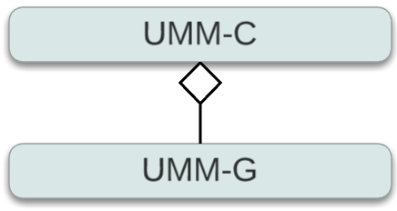
Figure C.4. Collection - Granule Relationship

Parent Collection Identifier Option 1 - Entry Id (Short Name + Version)
Description
This element defines the association of a granule with its parent collection. The collection short name and version can be used.

Cardinality
0..1

Relationships
This field is validated against the parent collection field ShortName and Version of the UMM-C to ensure that it contains an id of the same name.

Tags
Required (with option), Free Text Search, Parameter Search, Addition, Validated

Sample Mappings
ISO 19115-2 | /gmi:MI_Metadata/gmd:identificationInfo/gmd:MD_DataIdentification  /gmd:aggregationInfo/gmd:MD_AggregateInformation/gmd:aggregateDataSetName  /gmd:CI_Citation[gmd:edition/gco:CharacterString[. = 'VersionId']]/gmd:title  /gco:CharacterString[. = 'ShortName']  and  /gmi:MI_Metadata/gmd:identificationInfo/gmd:MD_DataIdentification  /gmd:aggregationInfo/gmd:MD_AggregateInformation/gmd:aggregateDataSetName  /gmd:CI_Citation/gmd:identifier/gmd:MD_Identifier/gmd:code/gco:CharacterString  [. = concat(ShortName, VersionId)]  with  DS_AssociationTypeCode[@codeListValue="LargerWorkCitation"]
ISO 19115-1 | /mdb:MD_Metadata/mdb:identificationInfo/mri:MD_DataIdentification  /mri:associatedResource/mri:MD_AsociatedResource/mri:name  /cit:CI_Citation[cit:edition/gco:CharacterString[. = 'VersionId']]/cit:title  /gco:CharacterString[. = 'ShortName']  and  /mdb:MD_Metadata/mdb:identificationInfo/mri:MD_DataIdentification  /mri:associatedResource/mri:MD_AsociatedResource/mri:name/cit:CI_Citation  /cit:identifier/mcc:MD_Identifier/mcc:code/gco:CharacterString[. = concat(ShortName, VersionId)]  with  DS_AssociationTypeCode[@codeListValue="LargerWorkCitation"]
ECHO 10 Granule | /Granule/Collection/ShortName with /Granule/Collection/VersionId  or  /Granule/Collection/DataSetId (Proposed addition to ECHO Granule schema)

Examples
ECHO
<Collection>
<ShortName>AIRS2CCF</ShortName>
<VersionId>005</VersionId>
</Collection>

ISO 19115-2
<gmd:aggregationInfo>
<gmd:MD_AggregateInformation>
<gmd:aggregateDataSetName>
<gmd:CI_Citation>
<gmd:title>
<gco:CharacterString>AIRS2CCF</gco:CharacterString>
</gmd:title>
<gmd:date gco:nilReason="unknown"/>
<gmd:edition>
<gco:CharacterString>005</gco:CharacterString>
</gmd:edition>
</gmd:CI_Citation>
</gmd:aggregateDataSetName>
<gmd:aggregateDataSetIdentifier>
<gmd:MD_Identifier>
<gmd:code>
<gco:CharacterString>AIRS2CCF</gco:CharacterString>
</gmd:code>
</gmd:MD_Identifier>
</gmd:aggregateDataSetIdentifier>
<gmd:associationType>
<gmd:DS_AssociationTypeCode codeList="http://www.ngdc.noaa.gov/metadata/published/xsd/schema/resources
/Codelist/gmxCodelists.xml#DS_AssociationTypeCode"
codeListValue="LargerWorkCitation">LargerWorkCitation
</gmd:DS_AssociationTypeCode>
</gmd:associationType>
</gmd:MD_AggregateInformation>
</gmd:aggregationInfo>

ISO 19115-1
<mri:associatedResource>
<mri:MD_AssociatedResource>
<mri:name>
<cit:CI_Citation>
<cit:title>
<gco:CharacterString>AIRS2CCF</gco:CharacterString>
</cit:title>
<cit:date gco:nilReason="unknown"/>
<cit:edition>
<gco:CharacterString>005</gco:CharacterString>
</cit:edition>
</cit:CI_Citation>
</mri:name>
<mri:associationType>
<mri:DS_AssociationTypeCode codeList="codeListLocation#DS_AssociationTypeCode"
codeListValue="LargerWorkCitation">LargerWorkCitation
</mri:DS_AssociationTypeCode>
</mri:associationType>
</mri:MD_AssociatedResource>
</mri:associatedResource>

ECHO Granule Source:
https://api.echo.nasa.gov:443/catalog-rest/echo_catalog/granules/G187566519-GSFCS4PA

Parent Collection Identifier Option 2 - Entry Title (Dataset Id)
Description
This element defines the association of a granule with its parent collection. The collection entry title can be used.

Note: Need Name Changes to align with UMM-C (Entry Title)

Cardinality
0..1

Relationships
This field is validated against the parent collection field Entry Title of the UMM-C to ensure that it contains a title of the same name.

Tags
Required (with option), Free Text Search, Parameter Search, Validated

Sample Mappings
ISO 19115-2 | /gmi:MI_Metadata/gmd:identificationInfo/gmd:MD_DataIdentification  /gmd:aggregationInfo/gmd:MD_AggregateInformation/gmd:aggregateDataSetName  /gmd:CI_Citation/gmd:identifier/gmd:MD_Identifier/gmd:code/gco:CharacterString  and  /gmi:MI_Metadata/gmd:identificationInfo/gmd:MD_DataIdentification  /gmd:aggregationInfo/gmd:MD_AggregateInformation[gmd:associationType  /gmd:DS_AssociationTypeCode[@codeList="http://www.ngdc.noaa.gov/metadata  /published/xsd/schema/resources/Codelist/gmxCodelists.xml#DS_AssociationTypeCode"]  [@codeListValue="LargerWorkCitation"]][gmd:initiativeType/gmd:DS_InitiativeTypeCode  [@codeList="http://www.ngdc.noaa.gov/metadata/published/xsd/schema/resources  /Codelist/gmxCodelists.xml#DS_InitiativeTypeCode"][@codeListValue="collection"]]  /gmd:aggregateDataSetName/gmd:CI_Citation/gmd:title/gco:CharacterString
ISO 19115-1 | /mdb:MD_Metadata/mdb:identificationInfo/mri:MD_DataIdentification  /mri:associatedResource/mri:MD_AsociatedResource/mri:name/cit:CI_Citation  /cit:identifier/mcc:MD_Identifier/mcc:code/gco:CharacterString  and  /mdb:MD_Metadata/mdb:identificationInfo/mri:MD_DataIdentification  /mri:associatedResource/mri:MD_AsociatedResource[mri:associationType  /mri:DS_AssociationTypeCode[@codeList="codeListLocation  #DS_AssociationTypeCode"][@codeListValue="LargerWorkCitation"]]  [mri:initiativeType/mri:DS_InitiativeTypeCode[@codeList=  "codeListLocation#DS_InitiativeTypeCode"][@codeListValue="collection"]]  /mri:name/cit:CI_Citation/cit:title/gco:CharacterString
ECHO 10 Granule | /Granule/Collection/DataSetId

Examples
ECHO
<Collection>
<DataSetId>
AMSR-E/Aqua Daily L3 12.5 km Tb, Sea Ice Conc., &amp; Snow Depth Polar Grids V003
</DataSetId>
</Collection>

ISO 19115-2
<gmd:aggregationInfo>
<gmd:MD_AggregateInformation>
<gmd:aggregateDataSetName>
<gmd:CI_Citation>
<gmd:title>
<gco:CharacterString>AMSR-E/Aqua Daily L3 12.5 km Tb, Sea Ice Conc., &amp;
Snow Depth Polar Grids V003</gco:CharacterString>
</gmd:title>
<gmd:date gco:nilReason="unknown"/>
</gmd:CI_Citation>
</gmd:aggregateDataSetName>
<gmd:aggregateDataSetIdentifier>
<gmd:MD_Identifier>
<gmd:code>
<gco:CharacterString>AMSR-E/Aqua Daily L3 12.5 km Tb, Sea Ice Conc., &amp; Snow
Depth Polar Grids V003</gco:CharacterString>
</gmd:code>
</gmd:MD_Identifier>
</gmd:aggregateDataSetIdentifier>
<gmd:associationType>
<gmd:DS_AssociationTypeCode codeList="http://www.ngdc.noaa.gov/metadata/published/xsd/schema/resources/Codelist
/gmxCodelists.xml#DS_AssociationTypeCode"
codeListValue="LargerWorkCitation">LargerWorkCitation
</gmd:DS_AssociationTypeCode>
</gmd:associationType>
</gmd:MD_AggregateInformation>
</gmd:aggregationInfo>

ISO 19115-1
<mri:associatedResource>
<mri:MD_AssociatedResource>
<mri:name>
<cit:CI_Citation>
<cit:title>
<gco:CharacterString>MODIS/Terra+Aqua BRDF/Albedo Parameters 16-Day L3
Global 0.05Deg CMG V005</gco:CharacterString>
</cit:title>
<cit:date gco:nilReason="unknown"/>
</cit:CI_Citation>
</mri:name>
<mri:associationType>
<mri:DS_AssociationTypeCode codeList="codeListLocation#DS_AssociationTypeCode"
codeListValue="LargerWorkCitation">LargerWorkCitation
</mri:DS_AssociationTypeCode>
</mri:associationType>
</mri:MD_AssociatedResource>
</mri:associatedResource>

ECHO Granule Source:
https://api.echo.nasa.gov:443/catalog-rest/echo_catalog/granules/G1000849409-NSIDC_ECS

Spatial Information
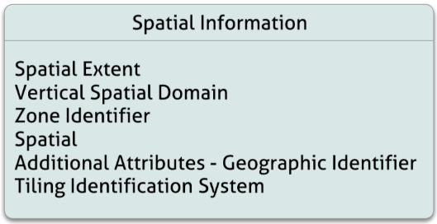
Figure C.5. Spatial Information
Spatial Relationships
This field is validated against the parent collection field Spatial Extent of the UMM-C to ensure that the parent collection allows for the extent described in the granule.

NASA Best Practices ISO 19115 and Spatial Metadata
The MENDS effort has produced extensive documentation related to the use of spatial extents in the ISO metadata.

More information can be found at the following link: https://wiki.earthdata.nasa.gov/display/NASAISO/Extents

Spatial Extent
See UMM-Common Spatial Extent element for full documentation and examples.

VerticalSpatialDomain
Description
This entity contains the domain value and type for the granule's vertical spatial domain - i.e., reference frame or system from which altitude or depths are measured. The term 'altitude' is used instead of the common term 'elevation' to conform to terminology in Federal Information Processing Standards 70-1 and 173. The information contains the datum name, distance units and encoding method, which provide the definition for the system.

Note: This field will hold both the type and value fields of the existing ECHO 10 Granule schema.

See UMM-Common VerticalSpatialDomain element for full documentation and examples.

Tags
Optional, Controlled Vocabulary, Normalize

Sample Mappings
ISO 19115-2 | /gmi:MI_Metadata/gmd:identificationInfo/gmd:MD_DataIdentification/gmd:extent  /gmd:EX_Extent/gmd:description/gco:CharacterString[. = 'VerticalSpatialDomainType  =Atmosphere Layer, VerticalSpatialDomainValue=Atmosphere Profile']
ISO 19115-1 | /mdb:MD_Metadata/mdb:identificationInfo/mri:MD_DataIdentification/mri:extent  /gex:EX_Extent/gex:description/gco:CharacterString[. = 'VerticalSpatialDomainType=Atmosphere Layer, VerticalSpatialDomainValue=Atmosphere Profile']
ECHO 10 Granule | /Granule/Spatial/VerticalSpatialDomains/VerticalSpatialDomain/Type  /Granule/Spatial/VerticalSpatialDomains/VerticalSpatialDomain/Value

Examples
ECHO
<VerticalSpatialDomains>
<VerticalSpatialDomain>
<Type>Atmosphere Layer</Type>
<Value>Atmosphere Profile</Value>
</VerticalSpatialDomain>
</VerticalSpatialDomains>

ISO 19115-2
<gmd:extent>
<gmd:EX_Extent id="boundingExtent">
<gmd:description>
<gco:CharacterString>VerticalSpatialDomainType=Atmosphere Layer, VerticalSpatialDomainValue=Atmosphere Profile</gco:CharacterString>
</gmd:description>
...
</gmd:EX_Extent>
</gmd:extent>

ISO 19115-1
<mri:extent>
<gex:EX_Extent>
<gex:description>
<gco:CharacterString>VerticalSpatialDomainType=Atmosphere Layer, VerticalSpatialDomainValue=Atmosphere Profile</gco:CharacterString>
</gex:description>
...
</gex:EX_Extent>
</mri:extent>

ZoneIdentifier
Description
The appropriate numeric or alpha code used to identify the various zones in this grid coordinate system. See domain values of coordinate system for constraints on the zone numbers.

See UMM-Common ZoneIdentifier element for full documentation and examples.

Tags
Optional, Controlled Vocabulary

Sample Mappings
ISO 19115-2 | /gmi:MI_Metadata/gmd:identificationInfo/gmd:MD_DataIdentification/gmd:extent  /gmd:EX_Extent/gmd:geographicElement[2]/gmd:EX_GeographicDescription  /gmd:geographicIdentifier/gmd:MD_Identifier[gmd:description/gco:CharacterString  ='ZoneIdentifier']/gmd:code/gco:CharacterString
ISO 19115-1 | /mdb:MD_Metadata/mdb:identificationInfo/mri:MD_DataIdentification/mri:extent  /EX_Extent[@id='boundingExtent']/gex:geographicElement  /gex:EX_GeographicDescription/gex:geographicIdentifier/mcc:MD_Identifier  [gex:description/gco:CharacterString='ZoneIdentifier']/gex:code/gco:CharacterString
ECHO 10 Granule | /Granule/Spatial/HorizontalSpatialDomain/ZoneIdentifier
Examples
ECHO
<Spatial>
...
<HorizontalSpatialDomain>
<ZoneIdentifier>Universal Transverse Mercator (UTM)</ZoneIdentifier>
</HorizontalSpatialDomain>
...
</Spatial>

ISO 19115-2
<gmd:geographicElement>
<gmd:EX_GeographicDescription>
<gmd:geographicIdentifier>
<gmd:MD_Identifier>
<gmd:code>
<gco:CharacterString>Universal Transverse Mercator (UTM)</gco:CharacterString>
</gmd:code>
<gmd:description>
<gco:CharacterString>ZoneIdentifier</gco:CharacterString>
</gmd:description>
</gmd:MD_Identifier>
</gmd:geographicIdentifier>
</gmd:EX_GeographicDescription>
</gmd:geographicElement>

ISO 19115-1
<gex:geographicElement>
<gex:EX_GeographicDescription>
<gex:geographicIdentifier>
<mcc:MD_Identifier>
<gex:code>
<gco:CharacterString>Universal Transverse Mercator (UTM)</gco:CharacterString>
</gex:code>
<gex:description>
<gco:CharacterString>ZoneIdentifier</gco:CharacterString>
</gex:description>
</mcc:MD_Identifier>
</gex:geographicIdentifier>
</gex:EX_GeographicDescription>
</gex:geographicElement>

Spatial Option 1- Point
Description
A point represents a single geodetic latitudinal, longitudinal value.

See UMM-Common for full documentation and examples.

Tags
Optional, Parameter Search, Validated

Sample Mappings
ISO 19115-2 | /gmi:MI_Metadata/gmd:identificationInfo/gmd:MD_DataIdentification/gmd:extent  /gmd:EX_Extent/gmd:geographicElement/gmd:EX_GeographicBoundingBox  [gmd:westBoundLongitude/gco:Decimal ][gmd:eastBoundLongitude/gco:Decimal]  [gmd:southBoundLatitude/gco:Decimal][gmd:northBoundLatitude/gco:Decimal]  and  /gmi:MI_Metadata/gmd:identificationInfo/gmd:MD_DataIdentification/gmd:extent  /gmd:EX_Extent/gmd:geographicElement[2]/gmd:EX_BoundingPolygon/gmd:polygon  /gml:Point/gml:pos[@srsName='http://www.opengis.net/def/crs/EPSG/4326']@  [srsDimension='2']
ISO 19115-1 | /mdb:MD_Metadata/mdb:identificationInfo/mri:MD_DataIdentification/mri:extent  /gex:EX_Extent/gex:geographicElement/gex:EX_GeographicBoundingBox  [gex:westBoundLongitude/gco:Decimal ][gex:eastBoundLongitude/gco:Decimal]  [gex:southBoundLatitude/gco:Decimal][gex:northBoundLatitude/gco:Decimal]  and  /mdb:MD_Metadata/mdb:identificationInfo/mri:MD_DataIdentification/mri:extent  /gex:EX_Extent/gex:geographicElement[2]/gex:EX_BoundingPolygon/gex:polygon  /gml:Point/gml:pos[@srsName='http://www.opengis.net/def/crs/EPSG/4326']  [@srsDimension='2']
ECHO 10 Granule | /Granule/Spatial/HorizontalSpatialDomain/Geometry/Point/PointLongitude  /Granule/Spatial/HorizontalSpatialDomain/Geometry/Point/PointLatitude

Spatial Option 2 - Line
Description
This entity contains the granule's spatial coverage information. The ISO mapping includes two elements for ease of use in a variety of tools

See UMM-Common for full documentation and examples.

Tags
Optional, Parameter Search, Validated

Sample Mappings
ISO 19115-2 | /gmi:MI_Metadata/gmd:identificationInfo/gmd:MD_DataIdentification/gmd:extent  /gmd:EX_Extent/gmd:geographicElement/gmd:EX_GeographicBoundingBox  [gmd:westBoundLongitude/gco:Decimal ][gmd:eastBoundLongitude/gco:Decimal]  [gmd:southBoundLatitude/gco:Decimal][gmd:northBoundLatitude/gco:Decimal]  and  /gmi:MI_Metadata/gmd:identificationInfo/gmd:MD_DataIdentification/gmd:extent  /gmd:EX_Extent/gmd:geographicElement[2]/gmd:EX_BoundingPolygon/gmd:polygon  /gml:LineString/gml:posList[@srsName='http://www.opengis.net/def/crs/EPSG/4326']  [@srsDimension='2']
ISO 19115-1 | /mdb:MD_Metadata/mdb:identificationInfo/mri:MD_DataIdentification/mri:extent  /gex:EX_Extent/gex:geographicElement/gex:EX_GeographicBoundingBox  [gex:westBoundLongitude/gco:Decimal ][gex:eastBoundLongitude/gco:Decimal]  [gex:southBoundLatitude/gco:Decimal][gex:northBoundLatitude/gco:Decimal]  and  /mdb:MD_Metadata/mdb:identificationInfo/mri:MD_DataIdentification/mri:extent  /gex:EX_Extent/gex:geographicElement[2]/gex:EX_BoundingPolygon/gex:polygon  /gml:LineString/gml:posList[@srsName='http://www.opengis.net/def/crs/EPSG/4326']  [@srsDimension='2']
ECHO 10 Granule | /Granule/Spatial/HorizontalSpatialDomain/Geometry/Line/Point/PointLongitude  /Granule/Spatial/HorizontalSpatialDomain/Geometry/Line/Point/PointLatitude

Spatial Option 3 - Polygon
Description
This entity contains the granule's spatial coverage information. Need a minimum of 3 points to define a polygon.

See UMM-Common for full documentation and examples.

Tags
Optional, Parameter Search, Validated

Sample Mappings
ISO 19115-2 | /gmi:MI_Metadata/gmd:identificationInfo/gmd:MD_DataIdentification/gmd:extent  /gmd:EX_Extent/gmd:geographicElement/gmd:EX_BoundingPolygon/gmd:polygon  /gml:Polygon/gml:exterior/gml:LinearRing/gml:posList[@srsName="  http://www.opengis.net/def/crs/EPSG/4326"][@srsDimension="2"]
ISO 19115-1 | /mdb:MD_Metadata/mdb:identificationInfo/mri:MD_DataIdentification/mri:extent  /gex:EX_Extent/gex:geographicElement[2]/gex:EX_BoundingPolygon/gex:polygon  /gml:Polygon/gml:exterior/gml:LinearRing/gml:posList[@srsName=  "http://www.opengis.net/def/crs/EPSG/4326"][@srsDimension="2"]
ECHO 10 Granule | /Granule/Spatial/HorizontalSpatialDomain/Geometry/Gpolygon/Boundary/Point (min 3 points)

Spatial Option 4 – Bounding Box
Description
This entity contains the granule's spatial coverage information.

See UMM-Common for full documentation and examples.

Tags
Optional, Parameter Search, Validated

Sample Mappings
ISO 19115-2 | /gmi:MI_Metadata/gmd:identificationInfo/gmd:MD_DataIdentification/gmd:exten  t/gmd:EX_Extent/gmd:geographicElement/gmd:EX_GeographicBoundingBox  [gmd:westBoundLongitude/gco:Decimal ][gmd:eastBoundLongitude/gco:Decimal][gmd:southBoundLatitude/gco:Decimal]  [gmd:northBoundLatitude/gco:Decimal]
ISO 19115-1 | /mdb:MD_Metadata/mdb:identificationInfo/mri:MD_DataIdentification/mri:extent  /gex:EX_Extent/gex:geographicElement/gex:EX_GeographicBoundingBox  [gex:westBoundLongitude/gco:Decimal ][gex:eastBoundLongitude/gco:Decimal][gex:southBoundLatitude/gco:Decimal]  [gex:northBoundLatitude/gco:Decimal]
ECHO 10 Granule | /Granule/Spatial/HorizontalSpatialDomain/Geometry/BoundingRectangle  /WestBoundingCoordinate  /Granule/Spatial/HorizontalSpatialDomain/Geometry/BoundingRectangle  /NorthBoundingCoordinate  /Granule/Spatial/HorizontalSpatialDomain/Geometry/BoundingRectangle  /EastBoundingCoordinate  /Granule/Spatial/HorizontalSpatialDomain/Geometry/BoundingRectangle  /SouthBoundingCoordinate

Spatial Option 5 – Bounding Box with Center Point
Description
This entity contains the granule's spatial coverage information and represents the center point of the bounding rectangle.

See UMM-Common for full documentation and examples.

Tags
Optional, Parameter Search, Validated

Sample Mappings
ISO 19115-2 | TBD
ISO 19115-1 | TBD
ECHO 10 Granule | /Granule/Spatial/HorizontalSpatialDomain/Geometry/BoundingRectangle  /WestBoundingCoordinate  /Granule/Spatial/HorizontalSpatialDomain/Geometry/BoundingRectangle  /NorthBoundingCoordinate  /Granule/Spatial/HorizontalSpatialDomain/Geometry/BoundingRectangle  /EastBoundingCoordinate  /Granule/Spatial/HorizontalSpatialDomain/Geometry/BoundingRectangle  /SouthBoundingCoordinate  /Granule/Spatial/HorizontalSpatialDomain/Geometry/BoundingRectangle  /CenterPoint/PointLongitude  /Granule/Spatial/HorizontalSpatialDomain/Geometry/BoundingRectangle  /CenterPoint/PointLatitude

Spatial Option 6 – Polygon with Center Point
Description
This entity contains the granule's spatial coverage information and represents the center point of the polygon.

See UMM-Common for full documentation and examples.

Tags
Optional, Parameter Search, Validated

Sample Mappings
ISO 19115-2 | TBD
ISO 19115-1 | TBD
ECHO 10 Granule | /Granule/Spatial/HorizontalSpatialDomain/Geometry/Gpolygon/Boundary/Point (a minimum of 3 points)  /Granule/Spatial/HorizontalSpatialDomain/Geometry/Gpolygon/CenterPoint

Spatial Option 7 – Polygon with Holes
Description
This entity contains the granule's spatial coverage information.

See UMM-Common for full documentation and examples.

Tags
Optional, Parameter Search, Validated

Sample Mappings
ISO 19115-2 | Exterior ->  /gmi:MI_Metadata/gmd:identificationInfo/gmd:MD_DataIdentification/gmd:extent  /gmd:EX_Extent/gmd:geographicElement/gmd:EX_BoundingPolygon/gmd:polygon  /gml:Polygon/gml:exterior/gml:LinearRing/gml:posList[@srsName="  http://www.opengis.net/def/crs/EPSG/4326"][@srsDimension="2"]  Interior ->  /gmi:MI_Metadata/gmd:identificationInfo/gmd:MD_DataIdentification/gmd:extent  /gmd:EX_Extent/gmd:geographicElement/gmd:EX_BoundingPolygon/gmd:polygon  /gml:Polygon/gml:interior/gml:LinearRing/gml:posList[@srsName="  http://www.opengis.net/def/crs/EPSG/4326"][@srsDimension="2"]
ISO 19115-1 | Exterior ->  /gmi:MI_Metadata/gmd:identificationInfo/gmd:MD_DataIdentification/gmd:extent  /gmd:EX_Extent/gmd:geographicElement/gmd:EX_BoundingPolygon/gmd:polygon/  gml:Polygon/gml:exterior/gml:LinearRing/gml:posList[@srsName="  http://www.opengis.net/def/crs/EPSG/4326"][@srsDimension="2"]  Interior ->  /mdb:MD_Metadata/mdb:identificationInfo/mri:MD_DataIdentification/mri:extent  /gex:EX_Extent/gex:geographicElement[2]/gex:EX_BoundingPolygon/gex:polygon  /gml:Polygon/gml:interior/gml:LinearRing/gml:posList[@srsName="  http://www.opengis.net/def/crs/EPSG/4326"][@srsDimension="2"]
ECHO 10 Granule | /Granule/Spatial/HorizontalSpatialDomain/Geometry/Gpolygon/Boundary/Point (a minimum of 3 points)  /Granule/Spatial/HorizontalSpatialDomain/Geometry/Gpolygon/ExclusiveZone/Boundary  /Point (a minimum of 3 points)

Spatial Option 8 – Platform Orbit Information
Element Specification
PlatformOrbitInfo/OrbitalModelName
PlatformOrbitInfo/OrbitNumber
PlatformOrbitInfo/StartOrbitNumber
PlatformOrbitInfo/StopOrbitNumber
PlatformOrbitInfo/EquatorCrossingLongitude
PlatformOrbitInfo/EquatorCrossingDateTime

Description
This entity is used to store the characteristics of the orbit calculated spatial domain, which includes: the model name, orbit number, start and stop orbit number, equator crossing date and time, and equator crossing longitude.

Cardinality
0..1

Tags
Optional

Sample Mappings
ISO 19115-2 | /gmi:MI_Metadata/gmi:acquisitionInformation/gmi:MI_AcquisitionInformation  /gmi:platform/eos:EOS_Platform/eos:otherProperty/gco:Record/eos:AdditionalAttributes  /eos:AdditionalAttribute[3][eos:reference/eos:EOS_AdditionalAttributeDescription[eos:type  /eos:EOS_AdditionalAttributeTypeCode[@codeList='http://earthdata.nasa.gov  /metadata/resources/Codelists.xml#EOS_AdditionalAttributeTypeCode']  [@codeListValue='platformInformation'][. = 'platformInformation']]  [eos:name/gco:CharacterString[.='orbitSpecNameXXX']]]/eos:value/gco:CharacterString  with  orbitSpecNameXXX = OrbitalModelName | OrbitNumber | StartOrbitNumber | StopOrbitNumber | EquatorCrossingLongitude | EquatorCrossingDateTime
ISO 19115-1 | /mdb:MD_Metadata/mdb:acquisitionInformation/mac:MI_AcquisitionInformation  /mac:platform/eos:EOS_Platform/eos:otherProperty/gco:Record  /eos:AdditionalAttributes/eos:AdditionalAttribute[eos:reference  /eos:EOS_AdditionalAttributeDescription[eos:type  /eos:EOS_AdditionalAttributeTypeCode[@codeList='http://earthdata.nasa.gov  /metadata/resources/Codelists.xml#EOS_AdditionalAttributeTypeCode']  [@codeListValue='platformInformation'][. = 'platformInformation']][eos:name/gco:CharacterString[.='OrbitalModelName']]]  /eos:value/gco:CharacterString  with  orbitSpecNameXXX = OrbitalModelName | OrbitNumber | StartOrbitNumber | StopOrbitNumber | EquatorCrossingLongitude | EquatorCrossingDateTime
ECHO 10 Granule | /Granule/OrbitCalculatedSpatialDomains/OrbitCalculatedSpatialDomain/[OrbitalModelName | OrbitNumber | StartOrbitNumber | StopOrbitNumber | EquatorCrossingLongitude | EquatorCrossingDateTime]

Examples
ECHO
<OrbitCalculatedSpatialDomains>
<OrbitCalculatedSpatialDomain>
<OrbitalModelName>WRS-2</OrbitalModelName>
<StartOrbitNumber>667</StartOrbitNumber>
<StopOrbitNumber>667</StopOrbitNumber>
<EquatorCrossingLongitude>9.54</EquatorCrossingLongitude>
<EquatorCrossingDateTime>2002-06-19T00:56:48.48Z</EquatorCrossingDateTime>
</OrbitCalculatedSpatialDomain>
</OrbitCalculatedSpatialDomains>

ISO 19115-2
<gmi:acquisitionInformation>
<gmi:MI_AcquisitionInformation>
<gmi:platform>
<eos:EOS_Platform>
<gmi:identifier gco:nilReason="missing"/>
<gmi:description gco:nilReason="missing"/>
<gmi:instrument gco:nilReason="missing"/>
<eos:otherPropertyType>
<gco:RecordType xlink:href="http://earthdata.nasa.gov/metadata/schema/eos
/1.0/eos.xsd#xpointer(
//element[@name='AdditionalAttributes'])">Echo Additional Attributes</gco:RecordType>
</eos:otherPropertyType>
<eos:otherProperty>
<gco:Record>
<eos:AdditionalAttributes><!--OrbitCalculatedSpatialDomains-->
<eos:AdditionalAttribute>
<eos:reference>
<eos:EOS_AdditionalAttributeDescription>
<eos:type>
<eos:EOS_AdditionalAttributeTypeCode codeList=
"http://earthdata.nasa.gov/metadata/resources/Codelists.xml
#EOS_AdditionalAttributeTypeCode"
codeListValue="platformInformation">platformInformation</eos:EOS_AdditionalAttributeTypeCode>
</eos:type>
<eos:name>
<gco:CharacterString>OrbitalModelName</gco:CharacterString>
</eos:name>
</eos:EOS_AdditionalAttributeDescription>
</eos:reference>
<eos:value>
<gco:CharacterString>WRS-2</gco:CharacterString>
</eos:value>
</eos:AdditionalAttribute>
<eos:AdditionalAttribute>
<eos:reference>
<eos:EOS_AdditionalAttributeDescription>
<eos:type>
<eos:EOS_AdditionalAttributeTypeCode codeList="http://earthdata.nasa.gov/metadata/resources/Codelists.xml
#EOS_AdditionalAttributeTypeCode" codeListValue="platformInformation">platformInformation</eos:EOS_AdditionalAttributeTypeCode>
</eos:type>
<eos:name>
<gco:CharacterString>StartOrbitNumber</gco:CharacterString>
</eos:name>
</eos:EOS_AdditionalAttributeDescription>
</eos:reference>
<eos:value>
<gco:CharacterString>667</gco:CharacterString>
</eos:value>
</eos:AdditionalAttribute>
<eos:AdditionalAttribute>
<eos:reference>
<eos:EOS_AdditionalAttributeDescription>
<eos:type>
<eos:EOS_AdditionalAttributeTypeCode codeList="http://earthdata.nasa.gov/metadata/resources/Codelists.xml
#EOS_AdditionalAttributeTypeCode" codeListValue="platformInformation">platformInformation</eos:EOS_AdditionalAttributeTypeCode>
</eos:type>
<eos:name>
<gco:CharacterString>StopOrbitNumber</gco:CharacterString>
</eos:name>
</eos:EOS_AdditionalAttributeDescription>
</eos:reference>
<eos:value>
<gco:CharacterString>667</gco:CharacterString>
</eos:value>
</eos:AdditionalAttribute>
<eos:AdditionalAttribute>
<eos:reference>
<eos:EOS_AdditionalAttributeDescription>
<eos:type>
<eos:EOS_AdditionalAttributeTypeCode codeList="http://earthdata.nasa.gov/metadata/resources/Codelists.xm
l#EOS_AdditionalAttributeTypeCode" codeListValue="platformInformation">platformInformation</eos:EOS_AdditionalAttributeTypeCode>
</eos:type>
<eos:name>
<gco:CharacterString>EquatorCrossingLongitude</gco:CharacterString>
</eos:name>
</eos:EOS_AdditionalAttributeDescription>
</eos:reference>
<eos:value>
<gco:CharacterString>9.54</gco:CharacterString>
</eos:value>
</eos:AdditionalAttribute>
<eos:AdditionalAttribute>
<eos:reference>
<eos:EOS_AdditionalAttributeDescription>
<eos:type>
<eos:EOS_AdditionalAttributeTypeCode codeList="http://earthdata.nasa.gov/metadata/resources/Codelists.xml
#EOS_AdditionalAttributeTypeCode" codeListValue="platformInformation">platformInformation</eos:EOS_AdditionalAttributeTypeCode>
</eos:type>
<eos:name>
<gco:CharacterString>EquatorCrossingDateTime</gco:CharacterString>
</eos:name>
</eos:EOS_AdditionalAttributeDescription>
</eos:reference>
<eos:value>
<gco:CharacterString>2002-06-19T00:56:48.48Z</gco:CharacterString>
</eos:value>
</eos:AdditionalAttribute>
<!--HorizontalSpatialDomain/Orbit-->
<eos:AdditionalAttribute>
<eos:reference>
<eos:EOS_AdditionalAttributeDescription>
<eos:type>
<eos:EOS_AdditionalAttributeTypeCode codeList="http://earthdata.nasa.gov/metadata/resources/Codelists.xml
#EOS_AdditionalAttributeTypeCode" codeListValue="platformInformation">platformInformation</eos:EOS_AdditionalAttributeTypeCode>
</eos:type>
<eos:name>
<gco:CharacterString>AscendingCrossing</gco:CharacterString>
</eos:name>
</eos:EOS_AdditionalAttributeDescription>
</eos:reference>
<eos:value>
<gco:CharacterString>-158.10</gco:CharacterString>
</eos:value>
</eos:AdditionalAttribute>
<eos:AdditionalAttribute>
<eos:reference>
<eos:EOS_AdditionalAttributeDescription>
<eos:type>
<eos:EOS_AdditionalAttributeTypeCode codeList="http://earthdata.nasa.gov/metadata/resources/Codelists.xml
#EOS_AdditionalAttributeTypeCode" codeListValue="platformInformation">platformInformation</eos:EOS_AdditionalAttributeTypeCode>
</eos:type>
<eos:name>
<gco:CharacterString>StartLat</gco:CharacterString>
</eos:name>
</eos:EOS_AdditionalAttributeDescription>
</eos:reference>
<eos:value>
<gco:CharacterString>81.8</gco:CharacterString>
</eos:value>
</eos:AdditionalAttribute>
<eos:AdditionalAttribute>
<eos:reference>
<eos:EOS_AdditionalAttributeDescription>
<eos:type>
<eos:EOS_AdditionalAttributeTypeCode codeList="http://earthdata.nasa.gov/metadata/resources/Codelists.xml
#EOS_AdditionalAttributeTypeCode" codeListValue="platformInformation">platformInformation</eos:EOS_AdditionalAttributeTypeCode>
</eos:type>
<eos:name>
<gco:CharacterString>StartDirection</gco:CharacterString>
</eos:name>
</eos:EOS_AdditionalAttributeDescription>
</eos:reference>
<eos:value>
<gco:CharacterString>D</gco:CharacterString>
</eos:value>
</eos:AdditionalAttribute>
<eos:AdditionalAttribute>
<eos:reference>
<eos:EOS_AdditionalAttributeDescription>
<eos:type>
<eos:EOS_AdditionalAttributeTypeCode codeList="http://earthdata.nasa.gov/metadata/resources/Codelists.xml
#EOS_AdditionalAttributeTypeCode" codeListValue="platformInformation">platformInformation</eos:EOS_AdditionalAttributeTypeCode>
</eos:type>
<eos:name>
<gco:CharacterString>EndLat</gco:CharacterString>
</eos:name>
</eos:EOS_AdditionalAttributeDescription>
</eos:reference>
<eos:value>
<gco:CharacterString>-81.8</gco:CharacterString>
</eos:value>
</eos:AdditionalAttribute>
<eos:AdditionalAttribute>
<eos:reference>
<eos:EOS_AdditionalAttributeDescription>
<eos:type>
<eos:EOS_AdditionalAttributeTypeCode codeList="http://earthdata.nasa.gov/metadata/resources/Codelists.xml
#EOS_AdditionalAttributeTypeCode" codeListValue="platformInformation">platformInformation</eos:EOS_AdditionalAttributeTypeCode>
</eos:type>
<eos:name>
<gco:CharacterString>EndDirection</gco:CharacterString>
</eos:name>
</eos:EOS_AdditionalAttributeDescription>
</eos:reference>
<eos:value>
<gco:CharacterString>D</gco:CharacterString>
</eos:value>
</eos:AdditionalAttribute>
<eos:AdditionalAttribute>
<eos:reference>
<eos:EOS_AdditionalAttributeDescription>
<eos:type>
<eos:EOS_AdditionalAttributeTypeCode codeList="http://earthdata.nasa.gov/metadata/resources/Codelists.xml
#EOS_AdditionalAttributeTypeCode" codeListValue="platformInformation">platformInformation</eos:EOS_AdditionalAttributeTypeCode>
</eos:type>
<eos:name>
<gco:CharacterString>CenterPoint</gco:CharacterString>
</eos:name>
</eos:EOS_AdditionalAttributeDescription>
</eos:reference>
<eos:value>
<gco:CharacterString>-80.118772.5477</gco:CharacterString>
</eos:value>
</eos:AdditionalAttribute>
</eos:AdditionalAttributes>
</gco:Record>
</eos:otherProperty>
</eos:EOS_Platform>
</gmi:platform>
</gmi:MI_AcquisitionInformation>

ISO 19115-1
TBD

Additional Attributes - Geographic Identifier
Description
This entity stores the product specific attributes that are geographic in nature. For more information on how attributes are mapped, please refer Appendix E: Additional Attributes Categorization.

See UMM-Common for full documentation and examples.

Relationships
This field is validated against the parent collection field ProductSpecificAttribute of the UMM-C to ensure that it contains an attribute of the same name.

Tags
Optional, Free Text Search, Parameter Search, Validated

Sample Mappings
ISO 19115-2 | map AdditionalAttribute/Name -> /gmi:MI_Metadata/gmd:identificationInfo/gmd:MD_DataIdentification  /gmd:extent/gmd:EX_Extent/gmd:geographicElement[5]  /gmd:EX_GeographicDescription/gmd:geographicIdentifier  /gmd:MD_Identifier/gmd:description/gco:CharacterString  map AdditionalAttribute/Value -> /gmi:MI_Metadata/gmd:identificationInfo  /gmd:MD_DataIdentification  /gmd:extent/gmd:EX_Extent/gmd:geographicElement[5]  /gmd:EX_GeographicDescription/gmd:geographicIdentifier  /gmd:MD_Identifier[gmd:codeSpace/gco:CharacterString[. = 'gov.nasa.echo']]  /gmd:code/gco:CharacterString
ISO 19115-1 | map AdditionalAttribute/Name -> /mdb:MD_Metadata/mdb:identificationInfo  /mri:MD_DataIdentification/mri:extent  /gex:EX_Extent/gex:geographicElement[5]/gex:EX_GeographicDescription  /gex:geographicIdentifier/mcc:MD_Identifier/mcc:description/gco:CharacterString  map AdditionalAttribute/Value -> /mdb:MD_Metadata/mdb:identificationInfo  /mri:MD_DataIdentification  /mri:extent/gex:EX_Extent/gex:geographicElement[5]/gex:EX_GeographicDescription  /gex:geographicIdentifier/mcc:MD_Identifier[mcc:codeSpace/gco:CharacterString[. = 'gov.nasa.echo']]/mcc:code/gco:CharacterString
ECHO 10 Granule | /Granule/AdditionalAttributes/AdditionalAttribute/Name  /Granule/AdditionalAttributes/AdditionalAttribute/Values/Value

Tiling Identification System
Description
This entity stores the two-dimensional coordinate system information for the granule, which is an alternative way to express granule's spatial coverage based on a tiling system defined by the providers.
The following discussion on Landsat's PATH/ROW is an example of grid information. The Path is the longitudinal center-line of a Landsat scene corresponding to the center of an orbital track that is represented by grid Y lines.
The Row is the Latitudinal center line of a Landsat scene corresponding to grid X lines. The indication of the two dimensional coordinate system type is "WRS-2". The two-dimensional coordinate system information can be used to designate a geographic search for a nominal scene center.
More information related to this topic exists as part of the MENDS documentation and can be found at the following URL (URS login required) https://wiki.earthdata.nasa.gov/display/MEN/Two+Dimensional+Coordinate+Systems

Note: See the Tiling Identification System Appendix for more information about specific coordinate system translations. Formerly Two Dimensional Coordinate System.

Cardinality
0..1

Tags
Optional, Controlled Vocabulary, Parameter Search, Normalize, Validated

Sample Mappings
ECHO 10 Granule | /Granule/TwoDCoordinateSystem/StartCoordinate1  /Granule/TwoDCoordinateSystem/EndCoordinate1 /Granule/TwoDCoordinateSystem/StartCoordinate2  /Granule/TwoDCoordinateSystem/EndCoordinate2  /Granule/TwoDCoordinateSystem/TwoDCoordinateSystemName
ISO 19115-2 | /gmi:MI_Metadata/gmd:identificationInfo/gmd:MD_DataIdentification  /gmd:extent/gmd:EX_Extent/gmd:geographicElement[6]/gmd:EX_GeographicDescription  /gmd:geographicIdentifier/gmd:MD_Identifier[gmd:description  /gco:CharacterString[. = 'TwoDCoordinateSystemName']]  /gmd:code/gco:CharacterString[. = 'h19-29v11-21']
ISO 19115-1 | /mdb:MD_Metadata/mdb:identificationInfo/mri:MD_DataIdentification/mri:extent  /gex:EX_Extent/gex:geographicElement[6]/gex:EX_GeographicDescription  /gex:geographicIdentifier/mcc:MD_Identifier[mcc:description/gco:CharacterString[. = 'TwoDCoordinateSystemName']]/mcc:code/gco:CharacterString[. = 'h19-29v11-21']

Temporal Information
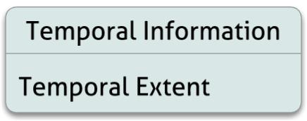
Figure C.6. Temporal Information

Temporal Extent
Description
This field is validated against the parent collection field Temporal Extent of the UMM-C to ensure that the parent collection allows for the extent described in the granule.

See UMM-Common Temporal Extent element for full documentation and examples.

Tags
Required (with option), Parameter Search, Validated

Sample Mappings
ISO 19115-2 | - /gmi:MI_Metadata/gmd:identificationInfo/gmd:MD_DataIdentification/gmd:extent  - /gmd:EX_Extent/gmd:temporalElement/gmd:EX_TemporalExtent/gmd:extent  - /gml:TimePeriod/gml:beginPosition  /gmi:MI_Metadata/gmd:identificationInfo/gmd:MD_DataIdentification/gmd:extent  /gmd:EX_Extent/gmd:temporalElement/gmd:EX_TemporalExtent/gmd:extent  /gml:TimePeriod/gml:endPosition  2/gmi:MI_Metadata/gmd:identificationInfo/gmd:MD_DataIdentification/gmd:extent  /gmd:EX_Extent/gmd:temporalElement/gmd:EX_TemporalExtent/gmd:extent  /gml:TimeInstant/gml:timePosition
ISO 19115-1 | 1)/mdb:MD_Metadata/mdb:identificationInfo/mri:MD_DataIdentification/mri:extent  /gex:EX_Extent/gex:temporalElement/gex:EX_TemporalExtent/gex:extent/gml:TimePeriod  /gml:beginPosition  /mdb:MD_Metadata/mdb:identificationInfo/mri:MD_DataIdentification/mri:extent  /gex:EX_Extent/gex:temporalElement/gex:EX_TemporalExtent/gex:extent/gml:TimePeriod  /gml:endPosition  2)/mdb:MD_Metadata/mdb:identificationInfo/mri:MD_DataIdentification/mri:extent  /gex:EX_Extent/gex:temporalElement/gex:EX_TemporalExtent/gex:extent  /gml:TimeInstant/gml:timePosition
ECHO 10 Granule | {Choice of one}  1)/Granule/Temporal/RangeDateTime/BeginningDateTime  /Granule/Temporal/RangeDateTime/EndingDateTime  2)/Granule/Temporal/SingleDateTime

Coverage Description

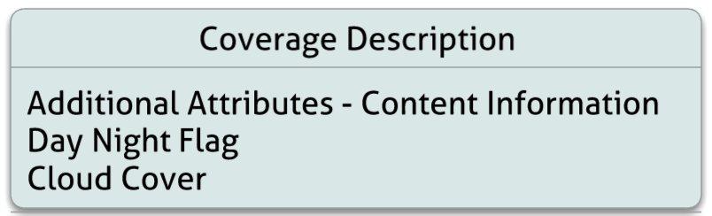
Figure C.7. Coverage Description

Additional Attributes - Content Information
Description
This entity stores the product specific attributes that are related to granule content. For more information on how attributes are mapped, please refer Appendix E: Additional Attributes Categorization.

See UMM-Common Additional Attribute elements for full documentation and examples.

Tags
Optional, Free Text Search, Parameter Search, Validated

Day Night Flag
Element Specification
DayNightFlag (0..1)

Description
Possible values for the day night flag. If no day night flag information is available, the unspecified value should be used.

Cardinality
0..1

Tags
Optional, Controlled Vocabulary, Parameter Search

Sample Mappings
ISO 19115-2 | /gmi:MI_Metadata/gmd:contentInfo/gmd:MD_CoverageDescription/gmd:dimension  /gmd:MD_Band/gmd:otherProperty/gco:Record/eos:AdditionalAttributes  /eos:AdditionalAttribute[eos:reference/eos:EOS_AdditionalAttributeDescription  [eos:type/eos:EOS_AdditionalAttributeTypeCode[@codeListValue = 'contentInformation']]  [eos:name/gco:CharacterString[. = 'DayNightFlag']]]/eos:value/gco:CharacterString
ISO 19115-1 | /mdb:MD_Metadata/mdb:contentInfo/mrc:MD_CoverageDescription/mrc:attributeGroup  /mrc:MD_AttributeGroup/mrc:attribute/mrc:MD_SampleDimension/mrc:otherProperty  /gco:Record/*[namespace-uri()='http://www.echo.nasa.gov/ingest/schemas/operations'  and local-name()='AdditionalAttributes']/eos:AdditionalAttribute[eos:reference  /eos:EOS_AdditionalAttributeDescription[eos:type/eos:EOS_AdditionalAttributeTypeCode  [@codeListValue = 'contentInformation']][eos:name/gco:CharacterString[. = 'DayNightFlag']]]/eos:value/gco:CharacterString
ECHO 10 Granule | /Granule/DataGranule/DayNightFlag

Examples
ECHO
<DayNightFlag>DAY</DayNightFlag>

ISO 19115-2
<eos:AdditionalAttributes>
<eos:AdditionalAttribute>
<eos:reference>
<eos:EOS_AdditionalAttributeDescription>
<eos:type>
<eos:EOS_AdditionalAttributeTypeCode codeList="http://earthdata.nasa.gov/metadata/resources/Codelists.xml
#EOS_AdditionalAttributeTypeCode" codeListValue="contentInformation">contentInformation</eos:EOS_AdditionalAttributeTypeCode>
</eos:type>
<eos:name>
<gco:CharacterString>DayNightFlag</gco:CharacterString>
</eos:name>
</eos:EOS_AdditionalAttributeDescription>
</eos:reference>
<eos:value>
<gco:CharacterString>DAY</gco:CharacterString>
</eos:value>
</eos:AdditionalAttribute>
</eos:AdditionalAttributes>

ISO 19115-1
<mrc:AdditionalAttribute>
<mrc:reference>
<mrc:EOS_AdditionalAttributeDescription>
<mrc:type>
<mrc:EOS_AdditionalAttributeTypeCode
codeList="http://earthdata.nasa.gov/metadata/resources/Codelists.xm
l#EOS_AdditionalAttributeTypeCode"
codeListValue="contentInformation">
contentInformation
</mrc:EOS_AdditionalAttributeTypeCode>
</mrc:type>
<mrc:name>
<gco:CharacterString>DayNightFlag</gco:CharacterString>
</mrc:name>
</mrc:EOS_AdditionalAttributeDescription>
</mrc:reference>
<mrc:value>
<gco:CharacterString>DAY</gco:CharacterString>
</mrc:value>
</mrc:AdditionalAttribute>

ECHO Granule Source:
https://api.echo.nasa.gov:443/catalog-rest/echo_catalog/granules/G7052933-LARC_ASDC

Cloud Cover
Element Specification
CloudCover (0..1)

Description
This element is a percentage value indicating how much of the area of a granule has been obscured by clouds. It is worth noting that there are many different measures of cloud cover across data holdings and that the cloud cover parameter that is represented is specific to the entire granule.

Cardinality
0..1

Tags
Optional, Parameter Search

Sample Mappings
ISO 19115-2 | /gmi:MI_Metadata/gmd:contentInfo/gmd:MD_ImageDescription  /gmd:cloudCoverPercentage/gco:Real
ISO 19115-1 | /mdb:MD_Metadata/mdb:contentInfo/mdb:MD_ImageDescription  /mdb:cloudCoverPercentage/gco:Real
ECHO 10 Granule | /Granule/CloudCover

Examples
ECHO
<CloudCover>3</CloudCover>

ISO 19115-2
<gmd:contentInfo>
<gmd:MD_ImageDescription>
<gmd:attributeDescription/>
<gmd:contentType/>
<gmd:cloudCoverPercentage>
<gco:Real>3</gco:Real>
</gmd:cloudCoverPercentage>
</gmd:MD_ImageDescription>
</gmd:contentInfo>

ISO 19115-1
<mdb:contentInfo>
<mdb:MD_ImageDescription>
<mdb:attributeDescription/>
<mdb:contentType/>
<mdb:cloudCoverPercentage>
<gco:Real>3</gco:Real>
</mdb:cloudCoverPercentage>
</mdb:MD_ImageDescription>
</mdb:contentInfo>
ECHO Granule Source:
https://api.echo.nasa.gov:443/catalog-rest/echo_catalog/granules/G133543732-NSIDC_ECS

Distribution Information
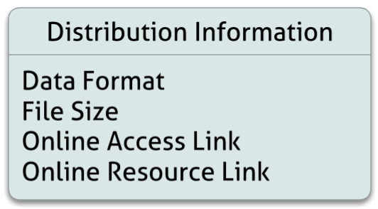
Figure C.8. Distribution Information

Distribution
The Distribution details can be found in the UMM Common document.

Data Format
Element Specification
Distribution/Format (0..1)

Description
This attribute contains the file format of the raw data (such as HDF) for a granule.
This attribute is tracked by Distribution/Format element of UMM Common.

Cardinality
0..*

Tags
Optional, Controlled Vocabulary, Normalize, Multiple ISO Mappings

Sample Mappings
ISO 19115-2 | /gmi:MI_Metadata/gmd:distributionInfo/gmd:MD_Distribution/gmd:distributor  \/gmd:MD_Distributor/gmd:distributorFormat/gmd:MD_Format/gmd:name  /gco:CharacterString
ISO 19115-1 | /mdb:MD_Metadata/mdb:distributionInfo/mrd:MD_Distribution/mrd:distributor  /mrd:MD_Distributor/mrd:distributorFormat/mrd:MD_Format  /mrd:formatSpecificationCitation/cit:CI_Citation/cit:title/gco:CharacterString
ECHO 10 Granule | /Granule/DataFormat

File Size
Element Specification
Distribution/Size (0..1)

Description
The size attribute will indicate the volume of data, in megabytes, contained in a granule.
This attribute is tracked by Distribution/Size element of UMM Common.

Note: The ISO Snippet for this field includes online access information for a granule in addition to the file size information to provide context

Cardinality
0..1

Tags
Optional

Sample Mappings
ISO 19115-2 | /gmi:MI_Metadata/gmd:distributionInfo/gmd:MD_Distribution/gmd:distributor  /gmd:MD_Distributor/gmd:distributorTransferOptions/gmd:MD_DigitalTransferOptions  /gmd:transferSize/gco:Real
ISO 19115-1 | /mdb:MD_Metadata/mdb:distributionInfo/mrd:MD_Distribution/mrd:distributor  /mrd:MD_Distributor/mrd:distributorTransferOptions/mrd:MD_DigitalTransferOptions  /mrd:transferSize/gco:Real
ECHO 10 Granule | /Granule/SizeMBDataGranule

Related URL
Description
This field specifies links to Internet sites that contain information related to the data, as well as related Internet sites such as project home pages, related data archives/servers, metadata extensions, online software packages, web mapping services, and calibration/validation data. Two fields from ECHO's granule schema have been consolidated into a single field. This field is related to the UMM-C field RelatedURL element.
The Related URL details can be found in the UMM Common document.

Cardinality
0..*

Tags
Optional

Sample Mappings
ISO 19115-2 | URL -> /gmi:MI_Metadata/gmd:distributionInfo/gmd:MD_Distribution/gmd:distributor  /gmd:MD_Distributor/gmd:distributorTransferOptions/gmd:MD_DigitalTransferOptions  /gmd:onLine/gmd:CI_OnlineResource[gmd:function/gmd:CI_OnLineFunctionCode  [@codeList = 'http://www.ngdc.noaa.gov/metadata/published/xsd/schema/resources  /Codelist/gmxCodelists.xml#CI_OnLineFunctionCode'][@codeListValue = 'download']]  /gmd:linkage/gmd:URL  Description -> /gmi:MI_Metadata/gmd:distributionInfo/gmd:MD_Distribution/gmd:distributor  /gmd:MD_Distributor/gmd:distributorTransferOptions/gmd:MD_DigitalTransferOptions  /gmd:onLine/gmd:CI_OnlineResource/gmd:description/gco:CharacterString  MimeType -> /gmi:MI_Metadata/gmd:distributionInfo/gmd:MD_Distribution/gmd:distributor  /gmd:MD_Distributor/gmd:distributorTransferOptions/gmd:MD_DigitalTransferOptions  /gmd:onLine/gmd:CI_OnlineResource/gmd:applicationProfile/gco:CharacterString
ISO 19115-1 | URL -> /mdb:MD_Metadata/mdb:distributionInfo/mrd:MD_Distribution  /mrd:distributor/mrd:MD_Distributor/mrd:distributorTransferOptions  /mrd:MD_DigitalTransferOptions/mrd:onLine/cit:CI_OnlineResource  /cit:linkage/gco:CharacterString  Description -> /mdb:MD_Metadata/mdb:distributionInfo/mrd:MD_Distribution  /mrd:distributor/mrd:MD_Distributor/mrd:distributorTransferOptions  /mrd:MD_DigitalTransferOptions/mrd:onLine/cit:CI_OnlineResource  /cit:description/gco:CharacterString  MimeType -> /mdb:MD_Metadata/mdb:distributionInfo/mrd:MD_Distribution  /mrd:distributor/mrd:MD_Distributor/mrd:distributorTransferOption  s/mrd:MD_DigitalTransferOptions/mrd:onLine/cit:CI_OnlineResource  /cit:applicationProfile/gco:CharacterString
ECHO 10 Granule | /Granule/OnlineAccessURLs/OnlineAccessURL/URL  or  /Granule/OnlineResources/OnlineResource/URL

Data Quality Information
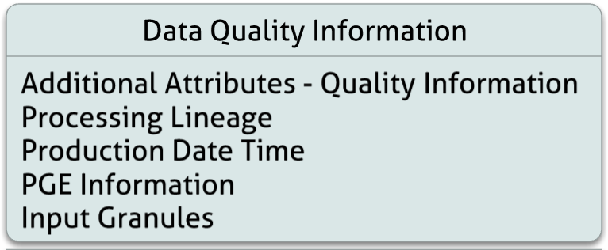
Figure C.9. Data Quality Information

Additional Attributes - Quality Information
Description
This entity stores the product specific attributes that are related to data quality. For more information on how attributes are mapped, please refer Appendix E: Additional Attributes Categorization.

See UMM-Common Additional Attributes section for full documentation and examples.

Cardinality
0..*

Relationships
This field is validated against the parent collection field ProductSpecificAttribute of the UMM-C to ensure that it contains an attribute of the same name.

Tags
Optional, Free Text Search, Parameter Search, Validated

Sample Mappings
ISO 19115-2 | /gmi:MI_Metadata/gmd:dataQualityInfo/gmd:DQ_DataQuality/gmd:report  /gmd:DQ_QuantitativeAttributeAccuracy/gmd:result/gmd:DQ_QuantitativeResult  /gmd:value/gco:Record/eos:AdditionalAttributes/eos:AdditionalAttribute/eos:reference  /eos:EOS_AdditionalAttributeDescription/eos:name/gco:CharacterString
ISO 19115-1 | BASE_XPATH=/mdb:MD_Metadata/mdb:contentInfo/mrc:MD_CoverageDescription  /mrc:attributeGroup/mrc:MD_AttributeGroup/mrc:attribute/mrc:MD_SampleDimension  /mrc:otherProperty/gco:Record/mrc:AdditionalAttributes/mrc:AdditionalAttribute  /BASE_XPATH/mrc:reference/mrc:EOS_AdditionalAttributeDescription/mrc:name  /gco:CharacterString  and  /BASE_XPATH/mrc:value/gco:CharacterString
ECHO 10 Granule | /Granule/AdditionalAttributes/AdditionalAttribute

Examples
ECHO
<AdditionalAttribute>
<Name>OrbitQuality</Name>
<Values>
<Value>6</Value>
</Values>
</AdditionalAttribute>

ISO 19115-2
<eos:AdditionalAttribute>
<eos:reference>
<eos:EOS_AdditionalAttributeDescription>
<eos:type>
<eos:EOS_AdditionalAttributeTypeCode
codeList="http://earthdata.nasa.gov/metadata/resources/Codelists.xml
#EOS_AdditionalAttributeTypeCode"
codeListValue="qualityInformation"
>qualityInformation</eos:EOS_AdditionalAttributeTypeCode>
</eos:type>
<eos:name>
<gco:CharacterString>OrbitQuality</gco:CharacterString>
</eos:name>
</eos:EOS_AdditionalAttributeDescription>
</eos:reference>
<eos:value>
<gco:CharacterString>6</gco:CharacterString>
</eos:value>
</eos:AdditionalAttribute>

ISO 19115-1
<mrc:AdditionalAttribute>
<mrc:reference>
<mrc:EOS_AdditionalAttributeDescription>
<mrc:type>
<mrc:EOS_AdditionalAttributeTypeCode
codeList="http://earthdata.nasa.gov/metadata/resources/Codelists.xml
#EOS_AdditionalAttributeTypeCode"
codeListValue="contentInformation">
contentInformation
</mrc:EOS_AdditionalAttributeTypeCode>
</mrc:type>
<mrc:name>
<gco:CharacterString>OrbitQuality</gco:CharacterString>
</mrc:name>
</mrc:EOS_AdditionalAttributeDescription>
</mrc:reference>
<mrc:value>
<gco:CharacterString>6</gco:CharacterString>
</mrc:value>
</mrc:AdditionalAttribute>
ECHO Granule Source:
https://api.echo.nasa.gov:443/catalog-rest/echo_catalog/granules/G190034442-NSIDC_ECS

Reprocessing Lineage
Element Specification
Lineage/Reprocessing/Description

Description
Granule level, stating what reprocessing has been performed on this granule.

Note: The ISO Snippet for this field includes PGE version information and production date time for the granule in addition to the reprocessing information to provide context

Cardinality
0..*

Tags
Optional

Sample Mappings
ISO 19115-2 | /gmi:MI_Metadata/gmd:dataQualityInfo/gmd:DQ_DataQuality/gmd:lineage  /gmd:LI_Lineage/gmd:processStep/gmi:LE_ProcessStep/gmd:description  /gco:CharacterString
ISO 19115-1 | /mdb:MD_Metadata/mdb:resourceLineage/mrl:LI_Lineage/mrl:processStep  /mrl:LE_ProcessStep/mrl:description/gco:CharacterString
ECHO 10 Granule | /Granule/DataGranule/ReprocessingActual

Examples
ECHO
<ReprocessingActual>reprocessed once</ReprocessingActual>

ISO 19115-2
<gmi:LE_ProcessStep>
<gmd:description>
<gco:CharacterString>reprocessed once</gco:CharacterString>
</gmd:description>
</gmi:LE_ProcessStep>

ISO 19115-1
<mrl:LE_ProcessStep>
<mrl:description>
<gco:CharacterString>reprocessed once</gco:CharacterString>
</mrl:description>
</mrl:LE_ProcessStep>
ECHO Granule Source:
https://api.echo.nasa.gov:443/catalog-rest/echo_catalog/granules/G186406262-NSIDC_ECS

Production Date Time
Element Specification
Lineage/Reprocessing/DataDates[Type = 'creation']/Date

Description
The date and time a specific granule was produced by a Product Generation Executive (PGE).

Cardinality
0..*

Tags
Optional

Sample Mappings
ISO 19115-2 | /gmi:MI_Metadata/gmd:dataQualityInfo/gmd:DQ_DataQuality/gmd:lineage  /gmd:LI_Lineage/gmd:processStep/gmi:LE_ProcessStep/gmd:dateTime/gco:DateTime
ISO 19115-1 | /mdb:MD_Metadata/mdb:resourceLineage/mrl:LI_Lineage/mrl:processStep  /mrl:LE_ProcessStep/mrl:stepDateTime/gml:TimeInstant/gml:timePosition
ECHO 10 Granule | /Granule/DataGranule/ProductionDateTime

Examples
ECHO
<ProductionDateTime>2007-03-12T20:17:30.000Z</ProductionDateTime>

ISO 19115-2
<gmd:lineage>
<gmd:LI_Lineage>
<gmd:processStep>
<gmi:LE_ProcessStep>
<gmd:description gco:nilReason="unknown"/>
<gmd:dateTime>
<gco:DateTime>2007-03-12T20:17:30.000Z</gco:DateTime>
</gmd:dateTime>
</gmi:LE_ProcessStep>
</gmd:processStep>
</gmd:LI_Lineage>
</gmd:lineage>

ISO 19115-1
<mrl:processStep>
<mrl:LE_ProcessStep>
<mrl:stepDateTime>
<gml:TimeInstant gml:id="d1e1116">
<gml:timePosition>2007-03-12T20:17:30.000Z</gml:timePosition>
</gml:TimeInstant>
</mrl:stepDateTime>
</mrl:LE_ProcessStep>
</mrl:processStep>

ECHO Granule Source:
https://api.echo.nasa.gov:443/catalog-rest/echo_catalog/granules/G185415463-GSFCS4PA

Product Generation Executive (PGE) Information
Element Specification
Lineage/Reprocessing/Source/EntryId/Id
Lineage/Reprocessing/Source/EntryId/Version

Description
Name of the product generation executive as well as the version of the PGE that applied when producing a granule.

Cardinality
0..*

Tags
Optional

Sample Mappings
ISO 19115-2 | /gmi:MI_Metadata/gmd:dataQualityInfo/gmd:DQ_DataQuality/gmd:lineage  /gmd:LI_Lineage/gmd:processStep/gmi:LE_ProcessStep/gmi:processingInformation  /eos:EOS_Processing/gmi:identifier/gmd:MD_Identifier[gmd:description  /gco:CharacterString[. = 'PGENameXXX']/gmd:code/gco:CharacterString
ISO 19115-1 | /mdb:MD_Metadata/mdb:resourceLineage/mrl:LI_Lineage/mrl:processStep  /mrl:LE_ProcessStep/mrl:processingInformation/mrl:EOS_Processing  /mrl:identifier/mcc:MD_Identifier[mcc:description[1]/gco:CharacterString[. = 'PGENameXXX']/mcc:code/gco:CharacterString
ECHO 10 Granule | /Granule/PGEVersionClass/PGEName  /Granule/PGEVersionClass/PGEVersion

Examples
ECHO
<PGEVersionClass>
<PGEName>Compute Surface and Atmospheric Fluxes at Synoptic Time 6</PGEName>
<PGEVersion>7.2.1P3</PGEVersion>
</PGEVersionClass>

ISO 19115-2
<gmi:processingInformation>
<eos:EOS_Processing>
<gmi:identifier>
<gmd:MD_Identifier>
<gmd:code>
<gco:CharacterString>7.2.1P3</gco:CharacterString>
</gmd:code>
<gmd:description>
<gco:CharacterString> Compute Surface and Atmospheric Fluxes at Synoptic Time 6</gco:CharacterString>
</gmd:description>
</gmd:MD_Identifier>
</gmi:identifier>
<gmi:softwareReference>
<gmd:CI_Citation>
<gmd:title>
<gco:CharacterString>Compute Surface and Atmospheric Fluxes at Synoptic Time 6</gco:CharacterString>
</gmd:title>
<gmd:date gco:nilReason="unknown"/>
<gmd:edition>
<gco:CharacterString>7.2.1P3</gco:CharacterString>
</gmd:edition>
</gmd:CI_Citation>
</gmi:softwareReference>
</eos:EOS_Processing>
</gmi:processingInformation>

ISO 19115-1
<mrl:processingInformation>
<mrl:EOS_Processing>
<mrl:identifier>
<mcc:MD_Identifier>
<mcc:code>
<gco:CharacterString>7.2.1P3</gco:CharacterString>
</mcc:code>
<mcc:description>
<gco:CharacterString> Compute Surface and Atmospheric Fluxes at Synoptic Time 6</gco:CharacterString>
</mcc:description>
</mcc:MD_Identifier>
</mrl:identifier>
<mrl:softwareReference>
<cit:CI_Citation>
<cit:title>
<gco:CharacterString> Compute Surface and Atmospheric Fluxes at Synoptic Time 6</gco:CharacterString>
</cit:title>
<cit:date gco:nilReason="unknown"/>
<cit:edition>
<gco:CharacterString>7.2.1P3</gco:CharacterString>
</cit:edition>
</cit:CI_Citation>
</mrl:softwareReference>
</mrl:EOS_Processing>
</mrl:processingInformation>

Input Granules
Element Specification
Lineage/Source/EntryId/Id

Description
This entity contains the identification of the input granule(s) for a specific granule.

Note: Lineage Metadata will most likely become its own metadata model in the future.

Cardinality
0..*

Tags
Optional

Sample Mappings
ISO 19115-2 | /gmi:MI_Metadata/gmd:dataQualityInfo/gmd:DQ_DataQuality/gmd:lineage  /gmd:LI_Lineage/gmd:source/gmi:LE_Source/gmd:sourceCitation/gmd:CI_Citation  /gmd:title/gmx:FileName/@src
ISO 19115-1 | /mdb:MD_Metadata/mdb:resourceLineage/mrl:LI_Lineage/mrl:source/mil:LE_Source  /mrl:sourceCitation/cit:CI_Citation/cit:title/gcx:FileName/@src
ECHO | /Granule/InputGranules

Examples
ECHO
<InputGranules>
<InputGranule>CTL00_000_20130110_2259791_01_gla07_h5_convert.ctl</InputGranule>
<InputGranule>tai-utc.dat</InputGranule>
<InputGranule>GLA07_633_1102_001_0111_0_01_0001.DAT</InputGranule>
<InputGranule>DsESDTGlGLAH07.033.desc</InputGranule>
</InputGranules>

ISO 19115-2
<gmd:source>
<gmi:LE_Source id="d2e496">
<gmd:sourceCitation>
<gmd:CI_Citation>
<gmd:title>
<gmx:FileName src="CTL00_000_20130110_2259791_01_gla07_h5_convert.ctl"/>
</gmd:title>
<gmd:date gco:nilReason="unknown"/>
</gmd:CI_Citation>
</gmd:sourceCitation>
</gmi:LE_Source>
</gmd:source>

ISO 19115-1
<mrl:source>
<mrl:LE_Source id="d1e432">
<mrl:sourceCitation>
<cit:CI_Citation>
<cit:title>
<gcx:FileName src="CTL00_000_20130110_2259791_01_gla07_h5_convert.ctl"/>
</cit:title>
<cit:date gco:nilReason="unknown"/>
</cit:CI_Citation>
</mrl:sourceCitation>
</mrl:LE_Source>
</mrl:source>

ECHO Granule Source:
https://api.echo.nasa.gov:443/catalog-rest/echo_catalog/granules/G190434172-NSIDC_ECS

Acquisition Information
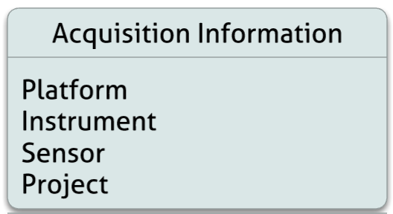
Figure C.10. Acquisition Information

Platform
See UMM-Common Platform element for full documentation and examples.

Tags
Required, Free Text Search, Parameter Search, Controlled Vocabulary, Faceted, Validated Relationship

Sample Mappings
ECHO 10 Granule | /Granule/Platforms/Platform/ShortName
ISO 19115-2 | /gmi:MI_Metadata/gmi:acquisitionInformation/gmi:MI_AcquisitionInformation  /gmi:platform/eos:EOS_Platform[gmi:instrument[@xlink:href='#d7e54']]/gmi:identifier  /gmd:MD_Identifier/gmd:code/gco:CharacterString  and  /gmi:MI_Metadata/gmd:identificationInfo/gmd:MD_DataIdentification  /gmd:descriptiveKeywords/gmd:MD_Keywords[gmd:type  /gmd:MD_KeywordTypeCode[@codeList = 'http://www.ngdc.noaa.gov  /metadata/published/xsd/schema/resources/Codelist/gmxCodelists.xm  l#MD_KeywordTypeCode'][@codeListValue = 'platform'][. = 'platform']]  /gmd:keyword/gco:CharacterString
ISO 19115-1 | /mdb:MD_Metadata/mdb:acquisitionInformation/mac:MI_AcquisitionInformation  /mac:platform/eos:EOS_Platform[mac:instrument[@xlink:href="#d22e142"]]  /mac:identifier/mcc:MD_Identifier/mcc:code/gco:CharacterString  and  /mdb:MD_Metadata/mdb:identificationInfo/mri:MD_DataIdentification  /mri:descriptiveKeywords/mri:MD_Keywords[mri:type/mri:MD_KeywordTypeCode  [@codeList="codeListLocation#MD_KeywordTypeCode"][@codeListValue="platform"]]  /mri:keyword/gco:CharacterString

Instrument
See UMM-Common Instrument element for full documentation and examples.

Tags
Required, Free Text Search, Parameter Search, Controlled Vocabulary, Faceted, Validated Relationship

Sample Mappings
ECHO 10 Granule | /Granule/Platforms/Platform/Instruments/Instrument/ShortName
ISO 19115-2 | /gmi:MI_Metadata/gmi:acquisitionInformation/gmi:MI_AcquisitionInformation/  gmi:instrument/eos:EOS_Instrument[@id='d7e54'][gmi:citation/gmd:CI_Citation  /gmd:title/gco:CharacterString[.='ACRIM']]/gmi:identifier/gmd:MD_Identifier  /gmd:code/gco:CharacterString  and  /gmi:MI_Metadata/gmd:identificationInfo/gmd:MD_DataIdentification  /gmd:descriptiveKeywords[2]/gmd:MD_Keywords[gmd:type  /gmd:MD_KeywordTypeCode[@codeList = 'http://www.ngdc.noaa.gov  /metadata/published/xsd/schema/resources/Codelist/gmxCodelists.xml  #MD_KeywordTypeCode'][@codeListValue = 'instrument'][. = 'instrument']]  /gmd:keyword/gco:CharacterString
ISO 19115-1 | /mdb:MD_Metadata/mdb:acquisitionInformation/mac:MI_AcquisitionInformation  /mac:instrument/eos:EOS_Instrument/mac:identifier/mcc:MD_Identifier/mcc:code  /gco:CharacterString  and  /mdb:MD_Metadata/mdb:identificationInfo/mri:MD_DataIdentification  /mri:descriptiveKeywords/mri:MD_Keywords[mri:type/mri:MD_KeywordTypeCode  [@codeList="codeListLocation#MD_KeywordTypeCode"][@codeListValue="'instrument"]]  /mri:keyword/gco:CharacterString

Sensor
See UMM-Common Sensor element for full documentation and examples.

Tags
Free Text Search, Parameter Search, Controlled Vocabulary, Faceted, Validated Relationship

Sample Mappings
ECHO 10 Granule | /Granule/Platforms/Platform/Instruments/Instrument/Sensors/Sensor/ShortName
ISO 19115-2 | /gmi:MI_Metadata/gmi:acquisitionInformation/gmi:MI_AcquisitionInformation  /gmi:instrument/eos:EOS_Instrument/eos:sensor/eos:EOS_Sensor[eos:citation  /gmd:CI_Citation/gmd:title/gco:CharacterString[ . = 'ACR&gt;']]/eos:identifier  /gmd:MD_Identifier/gmd:code/gco:CharacterString
ISO 19115-1 | /mdb:MD_Metadata/mdb:acquisitionInformation/mac:MI_AcquisitionInformation  /mac:instrument/eos:EOS_Instrument/eos:sensor/eos:EOS_Sensor/eos:identifier/  mcc:MD_Identifier/mcc:code/gco:CharacterString

Project
See UMM-Common Project element for full documentation and examples.

Tags
Required, Free Text Search, Parameter Search, Controlled Vocabulary, Faceted, Validated Relationship

Sample Mappings
ECHO 10 Granule | /Granule/Campaigns/Campaign/ShortName
ISO 19115-2 | /gmi:MI_Metadata/gmi:acquisitionInformation/gmi:MI_AcquisitionInformation  /gmi:operation/gmi:MI_Operation[gmi:description/gco:CharacterString  [. = 'Campaign/ShortName' ]]/gmi:identifier/gmd:MD_Identifier/gmd:code/gco:CharacterString  and  /gmi:MI_Metadata/gmd:identificationInfo/gmd:MD_DataIdentification  /gmd:descriptiveKeywords/gmd:MD_Keywords[gmd:type  /gmd:MD_KeywordTypeCode[@codeListValue="project"]  [@codeList="http://www.ngdc.noaa.gov/metadata/published/xsd/schema/resources/  Codelist/gmxCodelists.xml#MD_KeywordTypeCode"]]/gmd:keyword/gco:CharacterString
ISO 19115-1 | /mdb:MD_Metadata/mdb:acquisitionInformation/mac:MI_AcquisitionInformation  /mac:operation/mac:MI_Operation[mac:description/gco:CharacterString  [. = 'Campaign/ShortName' ]]/mac:identifier/mcc:MD_Identifier/mcc:code/gco:CharacterString  and  /mdb:MD_Metadata/mdb:identificationInfo/mri:MD_DataIdentification  /mri:descriptiveKeywords/mri:MD_Keywords[mri:type/  mri:MD_KeywordTypeCode[@codeListValue="project"]  [@codeList="codeListLocation#MD_KeywordTypeCode"]]/mri:keyword/gco:CharacterString

APPENDIX C-1 Deprecated Fields
C-1.1 Measured Parameters
The ECHO granule metadata in its current iteration contains the concept of a "Measured Parameter" or Variable. The Measured Parameter is used to expose variable level quality information about the granule.

Example
<MeasuredParameter>
<ParameterName>Water Vapor Mass Mixing Ratio</ParameterName>
<QAStats/>
<QAFlags>
<AutomaticQualityFlag>Passed</AutomaticQualityFlag>
<AutomaticQualityFlagExplanation>
Based on percentage of product that is good.
Suspect used where true quality is not known.
</AutomaticQualityFlagExplanation>
</QAFlags>
</MeasuredParameter>

ECHO Granule Source: https://api.echo.nasa.gov:443/catalog-rest/echo_catalog/granules/G203262173-GSFCS4PA

Corresponds to roughly to variable 'H20_MMR' from the HDF file.

This field will not be included in the unified granule model. Variable level metadata will be promoted to its own concept within the CMR via the unified metadata model for Variables (UMM-Var). This will allow the CMR to create parameter linkages at both the collection and granule level and expose a variable data catalog that can be exploited by service implementers. More details related to this concept is described in a separate document.
C-1.2 Price
This field is not currently in use (all collected sample data contained values of '0' or '0.0') and is not indexed for search via Free Text Search or parameter search.
C-1.3 Orderable
The Orderable field was originally introduced to identify granules as orderable via a provider-implemented ordering service. Determining whether a granule is orderable is now managed via external management applications. Thus, the Orderable field is no longer relevant in granule metadata.
C-1.4 Visible
The Visible field was originally introduced to identify granules as public/private. Determining whether a granule is visible to a particular user is now managed via external management applications and access control levels (ACLs). Thus, the Visible field is no longer relevant in granule metadata.

APPENDIX C-2 Tags Glossary
The following table lists all tags used in this model and provides a description of the tags' usage.

Tag Name | Description
Optional | This field is not required.
Required | This field is required.
Controlled Vocabulary | This field will be populated with a vocabulary that will be used to validate the value. This task will most likely be performed via a vocabulary management service.
Free Text Search | This field will be indexed by the CMR as part of the free text search.
Parameter Search | This field will be indexed by the CMR and will be exposed via the CMR API and a specific parameter. For example, the CMR will expose a "platform" search parameter, so the "Platform" field will have this tag.
Deprecate | This field should be deprecated in a future revision of the UMM-G
Validated | This field is validated against the parent collection
Addition | This field is recommended for addition to the ECHO Granule schema
Faceted | This field should be exposed by the CMR catalog via a faceted search response.
Markdown Support | This class supports markdown-formatted text. Additional information on markdown can be found at http://en.wikipedia.org/wiki/Markdown
Validated Relationship | Any associated granules use this field for validation against the collection, or associated collections are check for validity

APPENDIX C-3 Tag Index
C-3.1 Required
These fields are required.
Granule Universal Identifier
Insert Time
Last Update
Parent Collection Identifier (with Options)
Universal Reference Identifier
C-3.2 Optional
These fields are not required.
Access Constraint Description
Access Constraint Value
Additional Attributes - Content Information
Additional Attributes - Descriptive Keywords
Additional Attributes - Geographic Identifier
Additional Attributes - Instrument Information
Additional Attributes - Platform Information
Additional Attributes - Quality Information
Additional Platform Orbit Information
Browse Graphic
Project/Campaign
Cloud Cover
Data Format
Day Night Flag
File Size
Input Granules
Instrument
Instrument Characteristics
Instrument Operation Modes
Local Version Identifier
Related URL
Platform
Platform Orbit Information

Spatial Extent (with Options)
Temporal Extent (with Options)
C-3.3 Controlled Vocabulary
These fields will have a vocabulary that will be used to validate the value. This will most likely be done via a vocabulary management service.

Project/Campaign
Data Format
Day Night Flag
Instrument
Platform
Two Dimensional Coordinate System
Vertical Spatial Domain
C-3.4 Free Text Search
These fields will be indexed by the CMR as part of the free text keyword search. This is similar to data returned using 'csw:anyText' query parameter on a CSW implementation.
Additional Attributes - Content Information
Additional Attributes - Descriptive Keywords
Additional Attributes - Geographic Identifier
Additional Attributes - Instrument Information
Additional Attributes - Platform Information
Additional Attributes - Quality Information
Project/Campaign
Granule Universal Identifier
Instrument
Parent Collection Identifier Option 1 - Entry Id (Short Name + Version)
Parent Collection Identifier Option 2 - Entry Title (Dataset Id)
Platform
Producer Identifier
Spatial Locality
Universal Reference Identifier
C-3.5 Parameter Search
These fields will be indexed by the CMR to facilitate specific parameter search via the CMR API. For example, the CMR will allow a "platform" search parameter, so the "Platform" field will have this tag.
Additional Attributes - Content Information
Additional Attributes - Descriptive Keywords
Additional Attributes - Geographic Identifier
Additional Attributes - Instrument Information
Additional Attributes - Platform Information
Additional Attributes - Quality Information
Project/Campaign
Cloud Cover
Day Night Flag
Insert Time
Instrument
Last Update
Parent Collection Identifier Option 1 - Entry Id (Short Name + Version)
Parent Collection Identifier Option 2 - Entry Title (Dataset Id)
Platform
Producer Identifier
Spatial Extent
Temporal Extent
C-3.6 Deprecate
These fields should be deprecated in a future revision of the UMM-G
Instrument Characteristics
Instrument Operation Modes
Local Version Identifier
Reprocessing Plan Note
Sensor Characteristics
Spatial Locality
C-3.7 Validated with Parent
These fields are validated against the parent collection
UMM-G Field | Related UMM-C Validated Field
Additional Attributes - Content Information | ProductSpecificAttribute
Additional Attributes - Descriptive Keywords | ProductSpecificAttribute
Additional Attributes - Geographic Identifier | ProductSpecificAttribute
Additional Attributes - Instrument Information | ProductSpecificAttribute
Additional Attributes - Quality Information | ProductSpecificAttribute
Additional Attributes - Platform Information | ProductSpecificAttribute
Additional Platform Orbit Information | SpatialCoverage/HorizontalSpatialDomain/Orbit
Project/Campaign | Project/Campaign
Instrument | Platform/Instrument
Instrument Operation Modes | Platform/Instrument/Instrument Operation Mode
Parent Collection Identifier Option 1 - Entry Id (Short Name + Version) | Entry Id
Parent Collection Identifier Option 2 - Entry Title (Dataset Id) | Entry Title
Platform | Platform
Sensor | Platform/Instrument/Sensor
Spatial Extent | Spatial Extent
Temporal Extent | Temporal Extent
C-3.8 Addition
This field is recommended for addition to the ECHO Granule schema

Parent Collection Identifier Option 1 - Entry Id (Short Name + Version)

APPENDIX C-4 Tiling Identification Systems
The following table outlines all tiling systems (formerly 2D coordinate systems) used in CMR and their corresponding format in the ISO translation. This table also includes information on a generic translation used if none of the known tiling systems is applicable.

Tiling System | Sample ISO Translated Format
CALIPSO | o29309,29310p171,171
MISR | p232b1-180
MODIS Tile EASE | h12v14
MODIS Tile SIN | h0v9
WRS-2 | p158r4
WRS-1 | p24-24r28-28
WELD Alaska tile | uses generic translation
WELD CONUS tile | uses generic translation
generic ISO to ECHO translation | x2-12y3-18
More information may be found at the following link related to the MENDS Working Group documentation (URS Login Required): https://wiki.earthdata.nasa.gov/display/NASAISO/Two-Dimensional+Coordinate+Systems

APPENDIX C-5 Additional Attributes Categorization
For the latest mapping of additional attributes and their various categorizations, see the following link:

https://cdn.earthdata.nasa.gov/iso/resources/transforms/additionalAttributeType.xml

APPENDIX C-6 Field Summary
The following table shows how various metadata formats accommodate the UMM-G fields.
(Latest updates are available at: https://wiki.earthdata.nasa.gov/display/CMR/UMM-G%3A+Granule+Metadata+Mapping+Summaries)
 | UMM-G Field | Required? | Full Documentation | ECHO 10 | ISO 19115-2 | ISO 19115-1
 | METADATA INFORMATION
1 | Metadata Language |  | UMM Common | N | Y | Y
2 | Metadata Standard |  | UMM Common | Y | Y | Y
3 | Metadata Dates |  | UMM Common | Y | Y | Y
 | DATA IDENTIFICATION
4 | Universal Reference Identifier | YES | UMM Common
5 | Data Language |  | UMM Common | N | Y | Y
6 | Data Dates | YES | UMM Common | Y | Y | Y
7 | Producer Identifier |  | UMM-G | Y | Y | Y
8 | Local Version Identifier |  | UMM-G | Y | Y | Y
9 | Browse Graphic |  | UMM Common | Y | Y | Y
10 | Data Format |  | UMM -G | Y | Y | Y
11 | Access Constraint Value |  | UMM Common | Y | Y | Y
12 | Parent Collection Identifier | YES | UMM-G | Y | Y | Y
 | DESCRIPTIVE KEYWORDS
13 | Spatial Locality |  | UMM-G | Y | Y | Y
 | SPATIAL INFORMATION
14 | Spatial Extent |  | UMM Common | Y | Y | Y
15 | Tiling Identification System (Formerly TwoDCoordinateSystem) |  | UMM Common | Y | Y | Y
 | TEMPORAL INFORMATION
16 | Temporal Extent |  | UMM Common | Y | Y | Y
 | COVERAGE INFORMATION
17 | Additional Attributes - Content Information |  | UMM Common | Y | Y | Y
18 | Day Night Flag |  | UMM-G | Y | Y | Y
19 | Cloud Cover |  | UMM-G | Y | Y | Y
 | DISTRIBUTION INFORMATION
20 | Related URL |  | UMM Common | Y | Y | Y
21 | Distribution |  | UMM Common | Y | Y | Y
 | ACQUISITION INFORMATION
22 | Platform |  | UMM Common | Y | Y | Y
23 | Instrument |  | UMM Common | Y | Y | Y
24 | Sensor |  | UMM Common | Y | Y | Y
25 | Project |  | UMM Common | Y | Y | Y
26 | Platform Orbit Information |  | UMM Common | Y | Y | Y
27 | Additional Attributes - Platform Information |  | UMM Common | Y | Y | Y
 | DATA QUALITY INFORMATION
28 | Additional Attributes - Quality Information |  | UMM Common | Y | Y | Y
29 | Reprocessing Lineage |  | UMM-G | Y | Y | Y
30 | Production Date Time |  | UMM-G | Y | Y | Y
31 | Product Generation Executive (PGE) Information |  | UMM-G | Y | Y | Y
32 | Input Granules |  | UMM-G | Y | Y | Y
 | Format has a mapping for this field documented in the UMM-C
 | The exact mapping for this field is still under discussion.
 | Format does have a mapping for this field

APPENDIX C-7 NASA ESDIS Echo 10 Granule elements to UMM Mapping (Cross-walk)
Table below presents a cross-walk of ECHO 10 Granule elements to corresponding UMM-G elements. 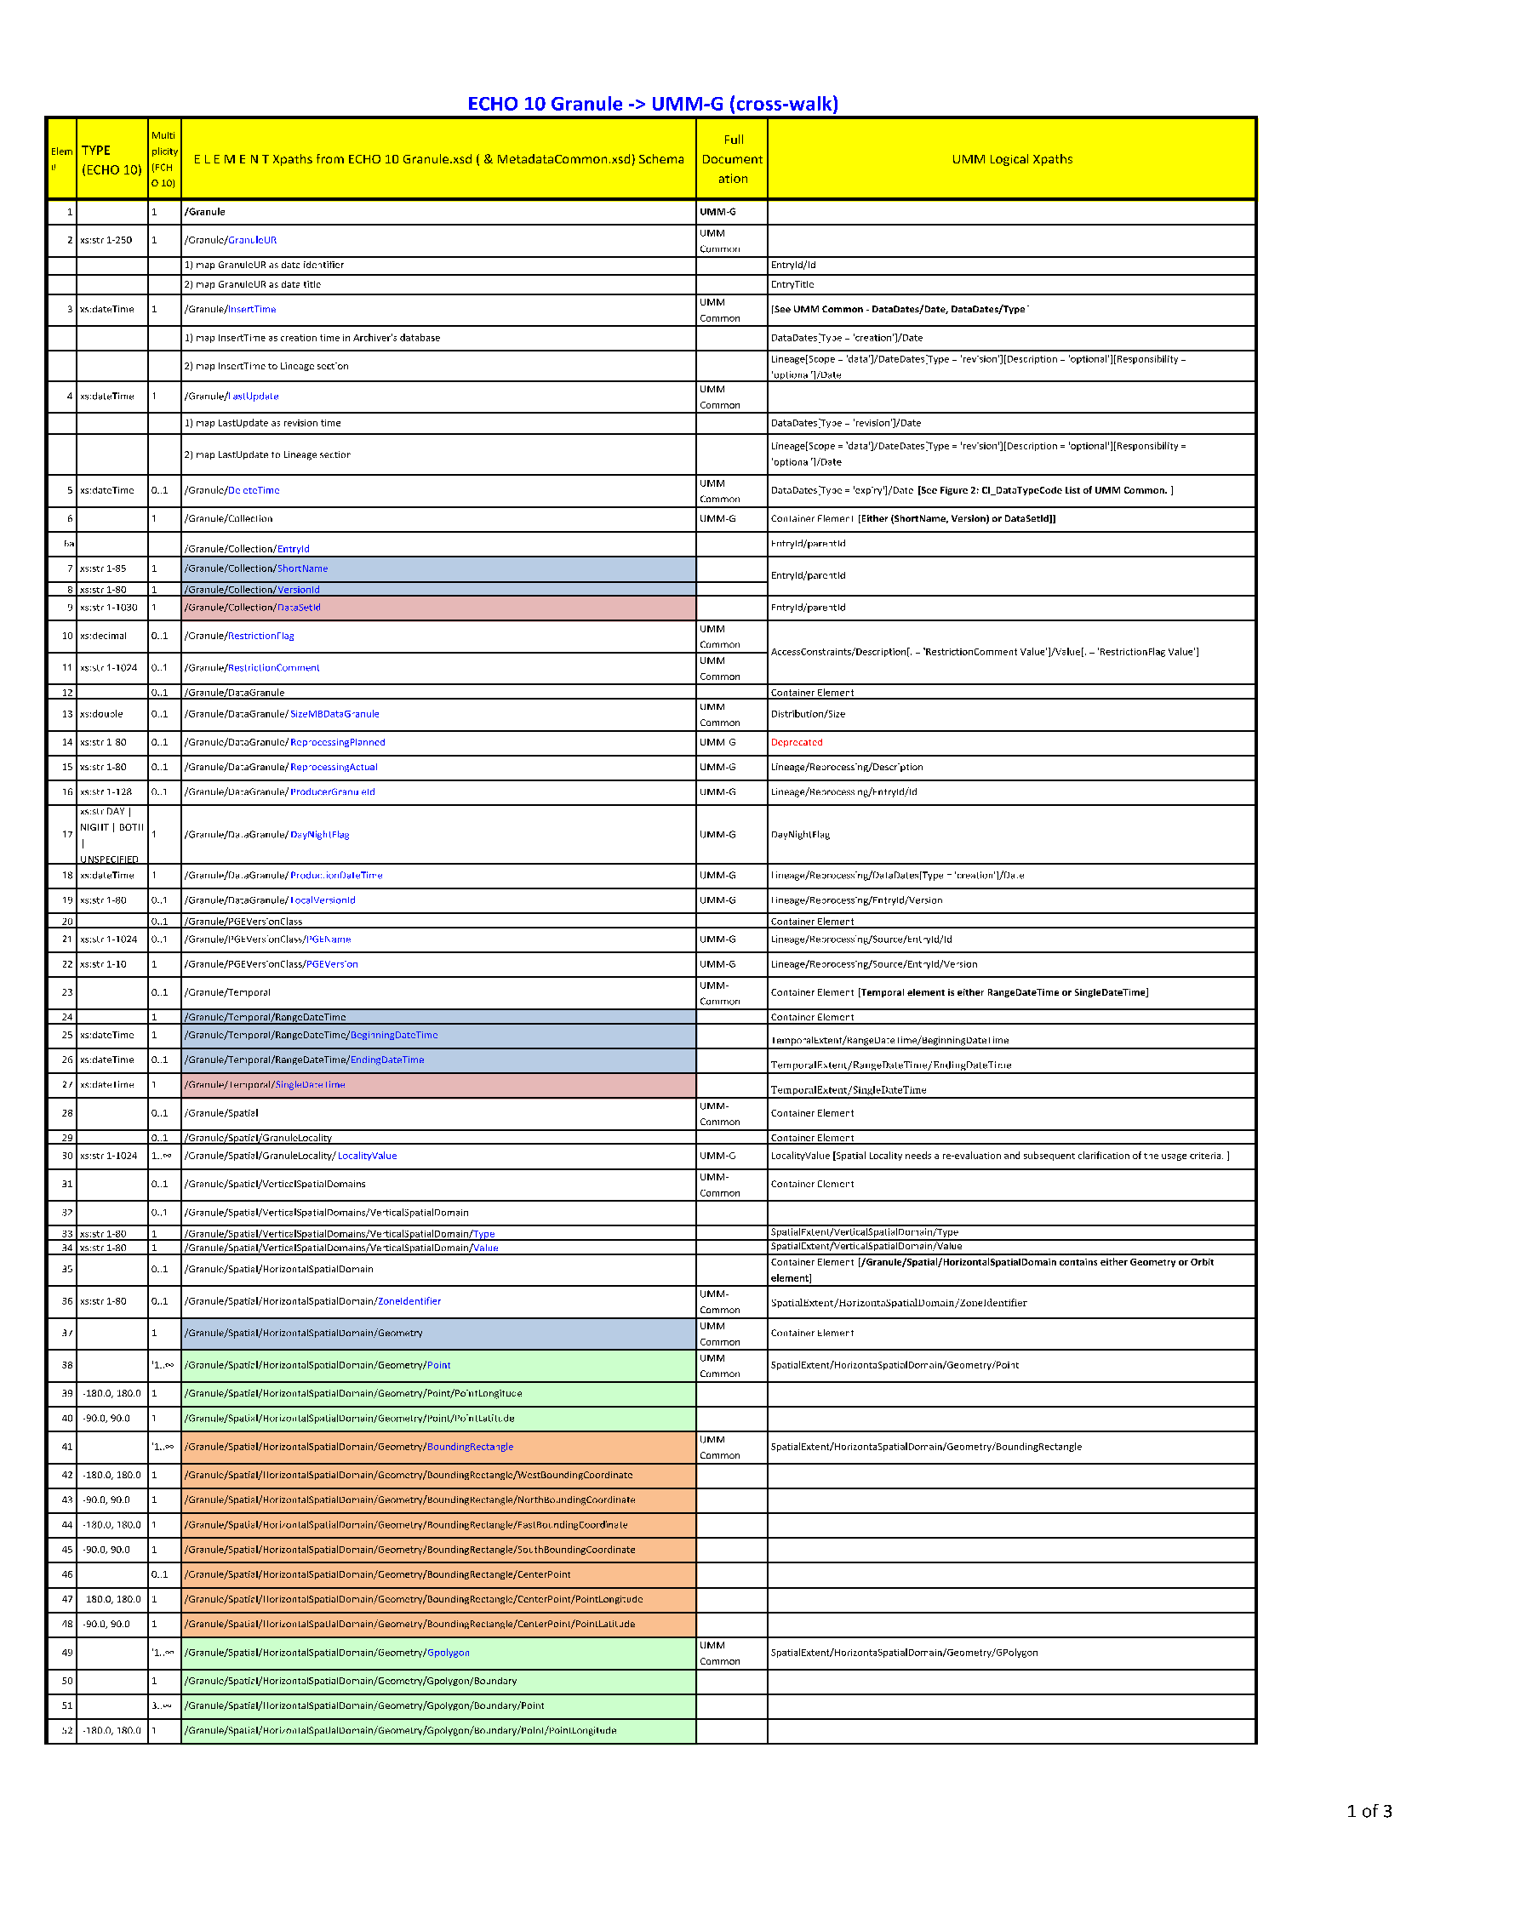
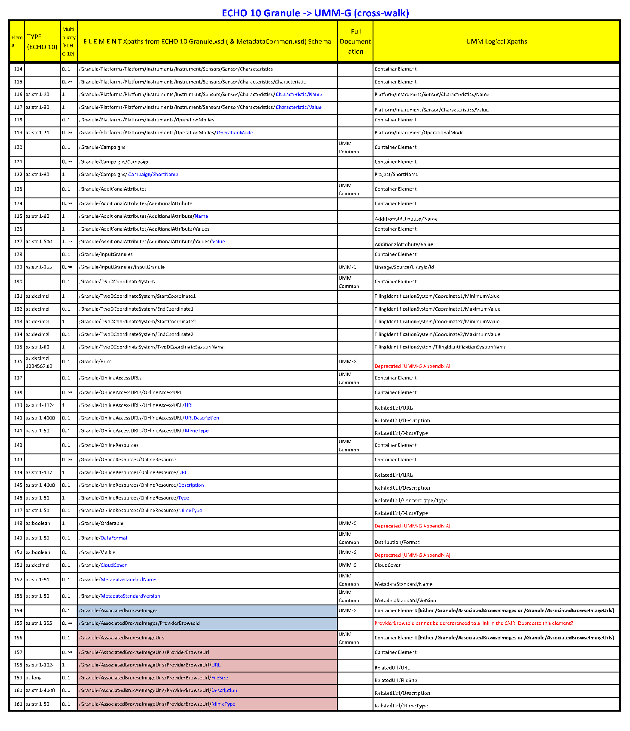

APPENDIX C-8 NASA ESDIS Granule profile of ISO 19115 Compatible with ECHO 10 Granule Information Content (Cross-walk)
Table below presents a cross-walk of ECHO 10 Granule elements to corresponding ISO 19115 elements. 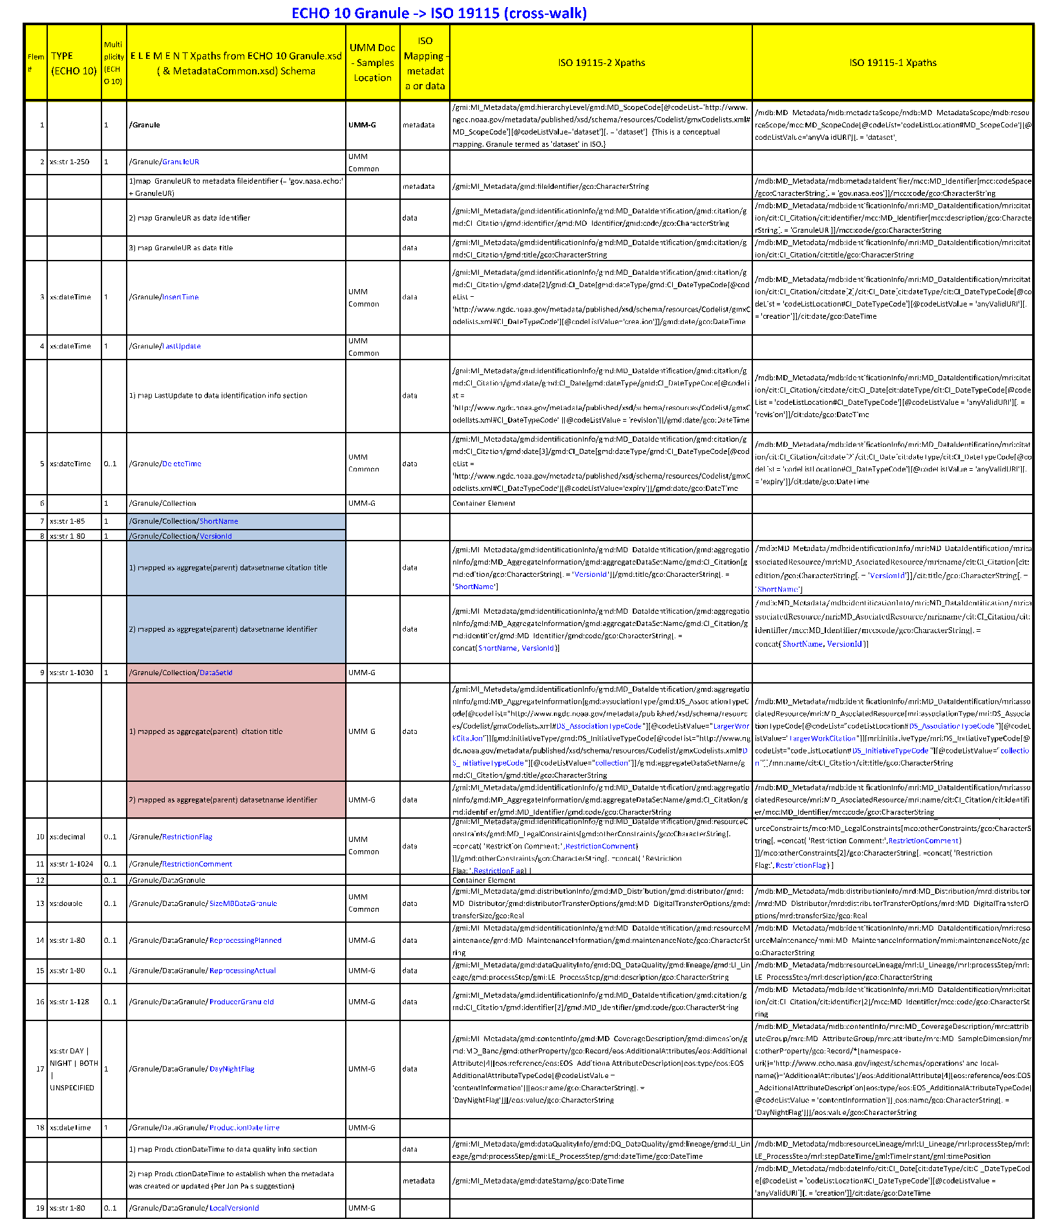
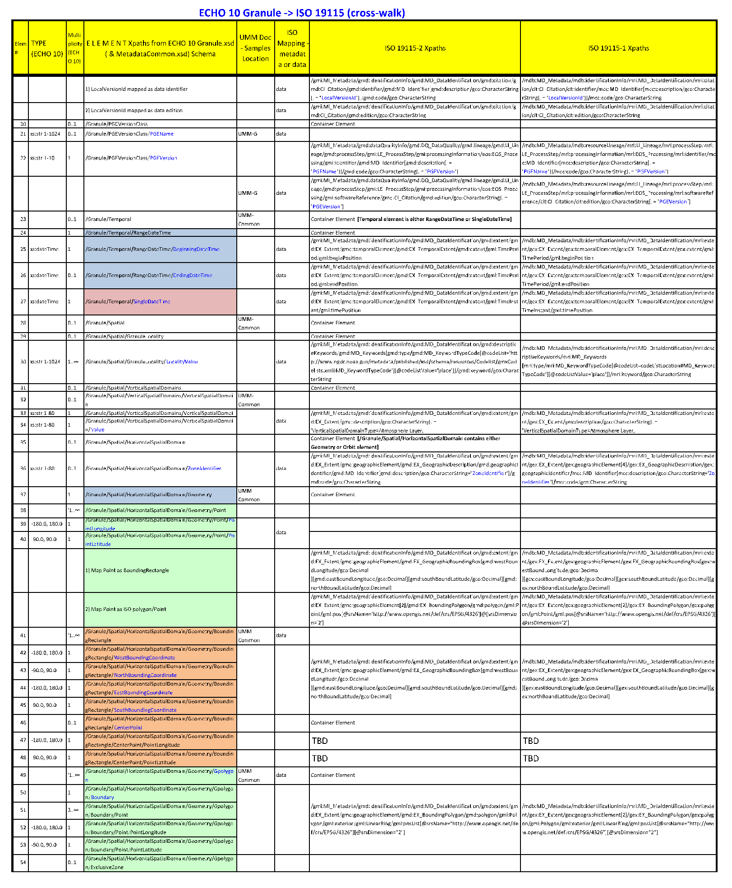
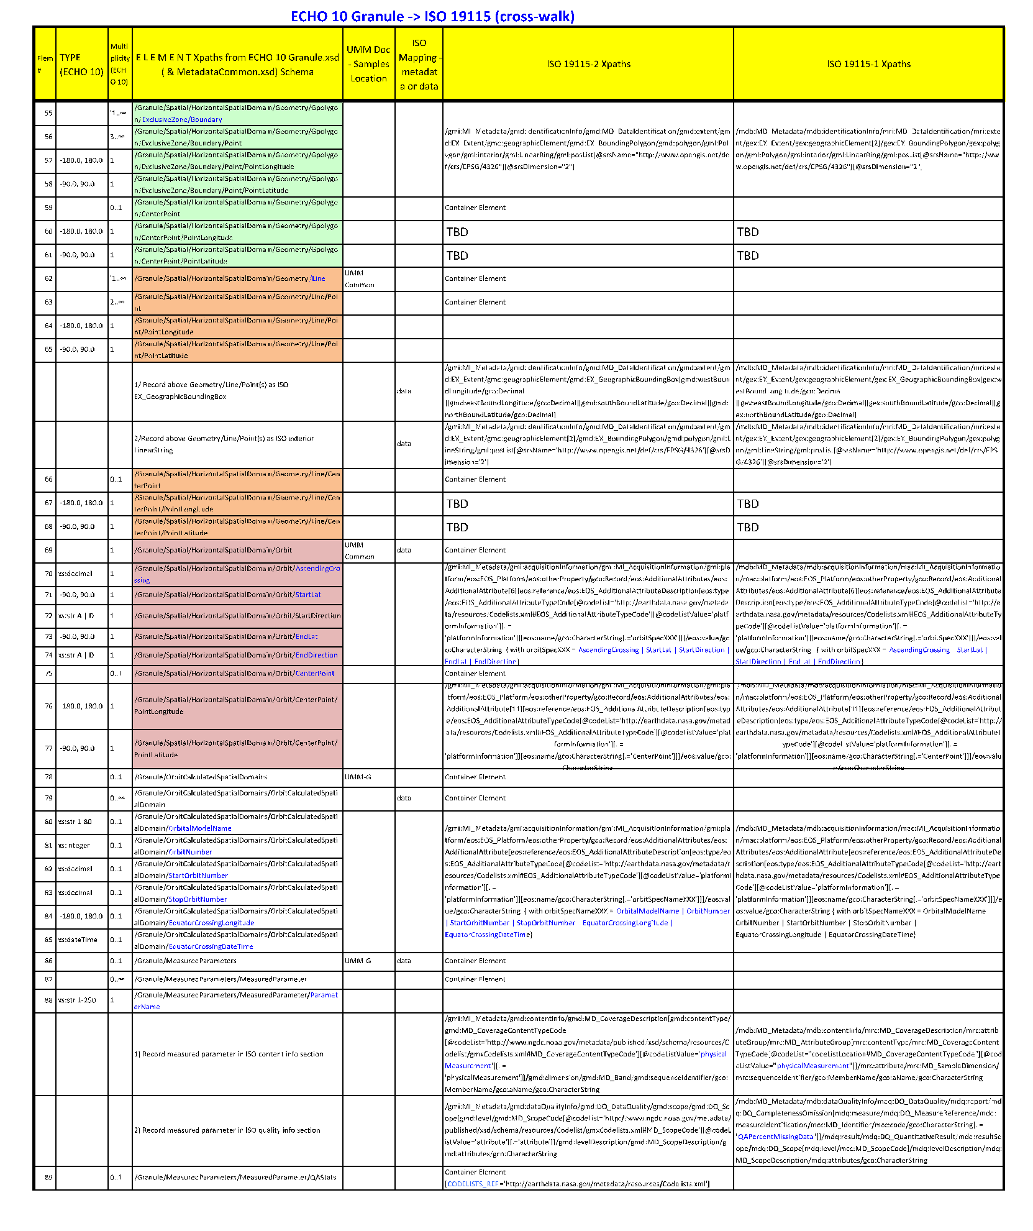
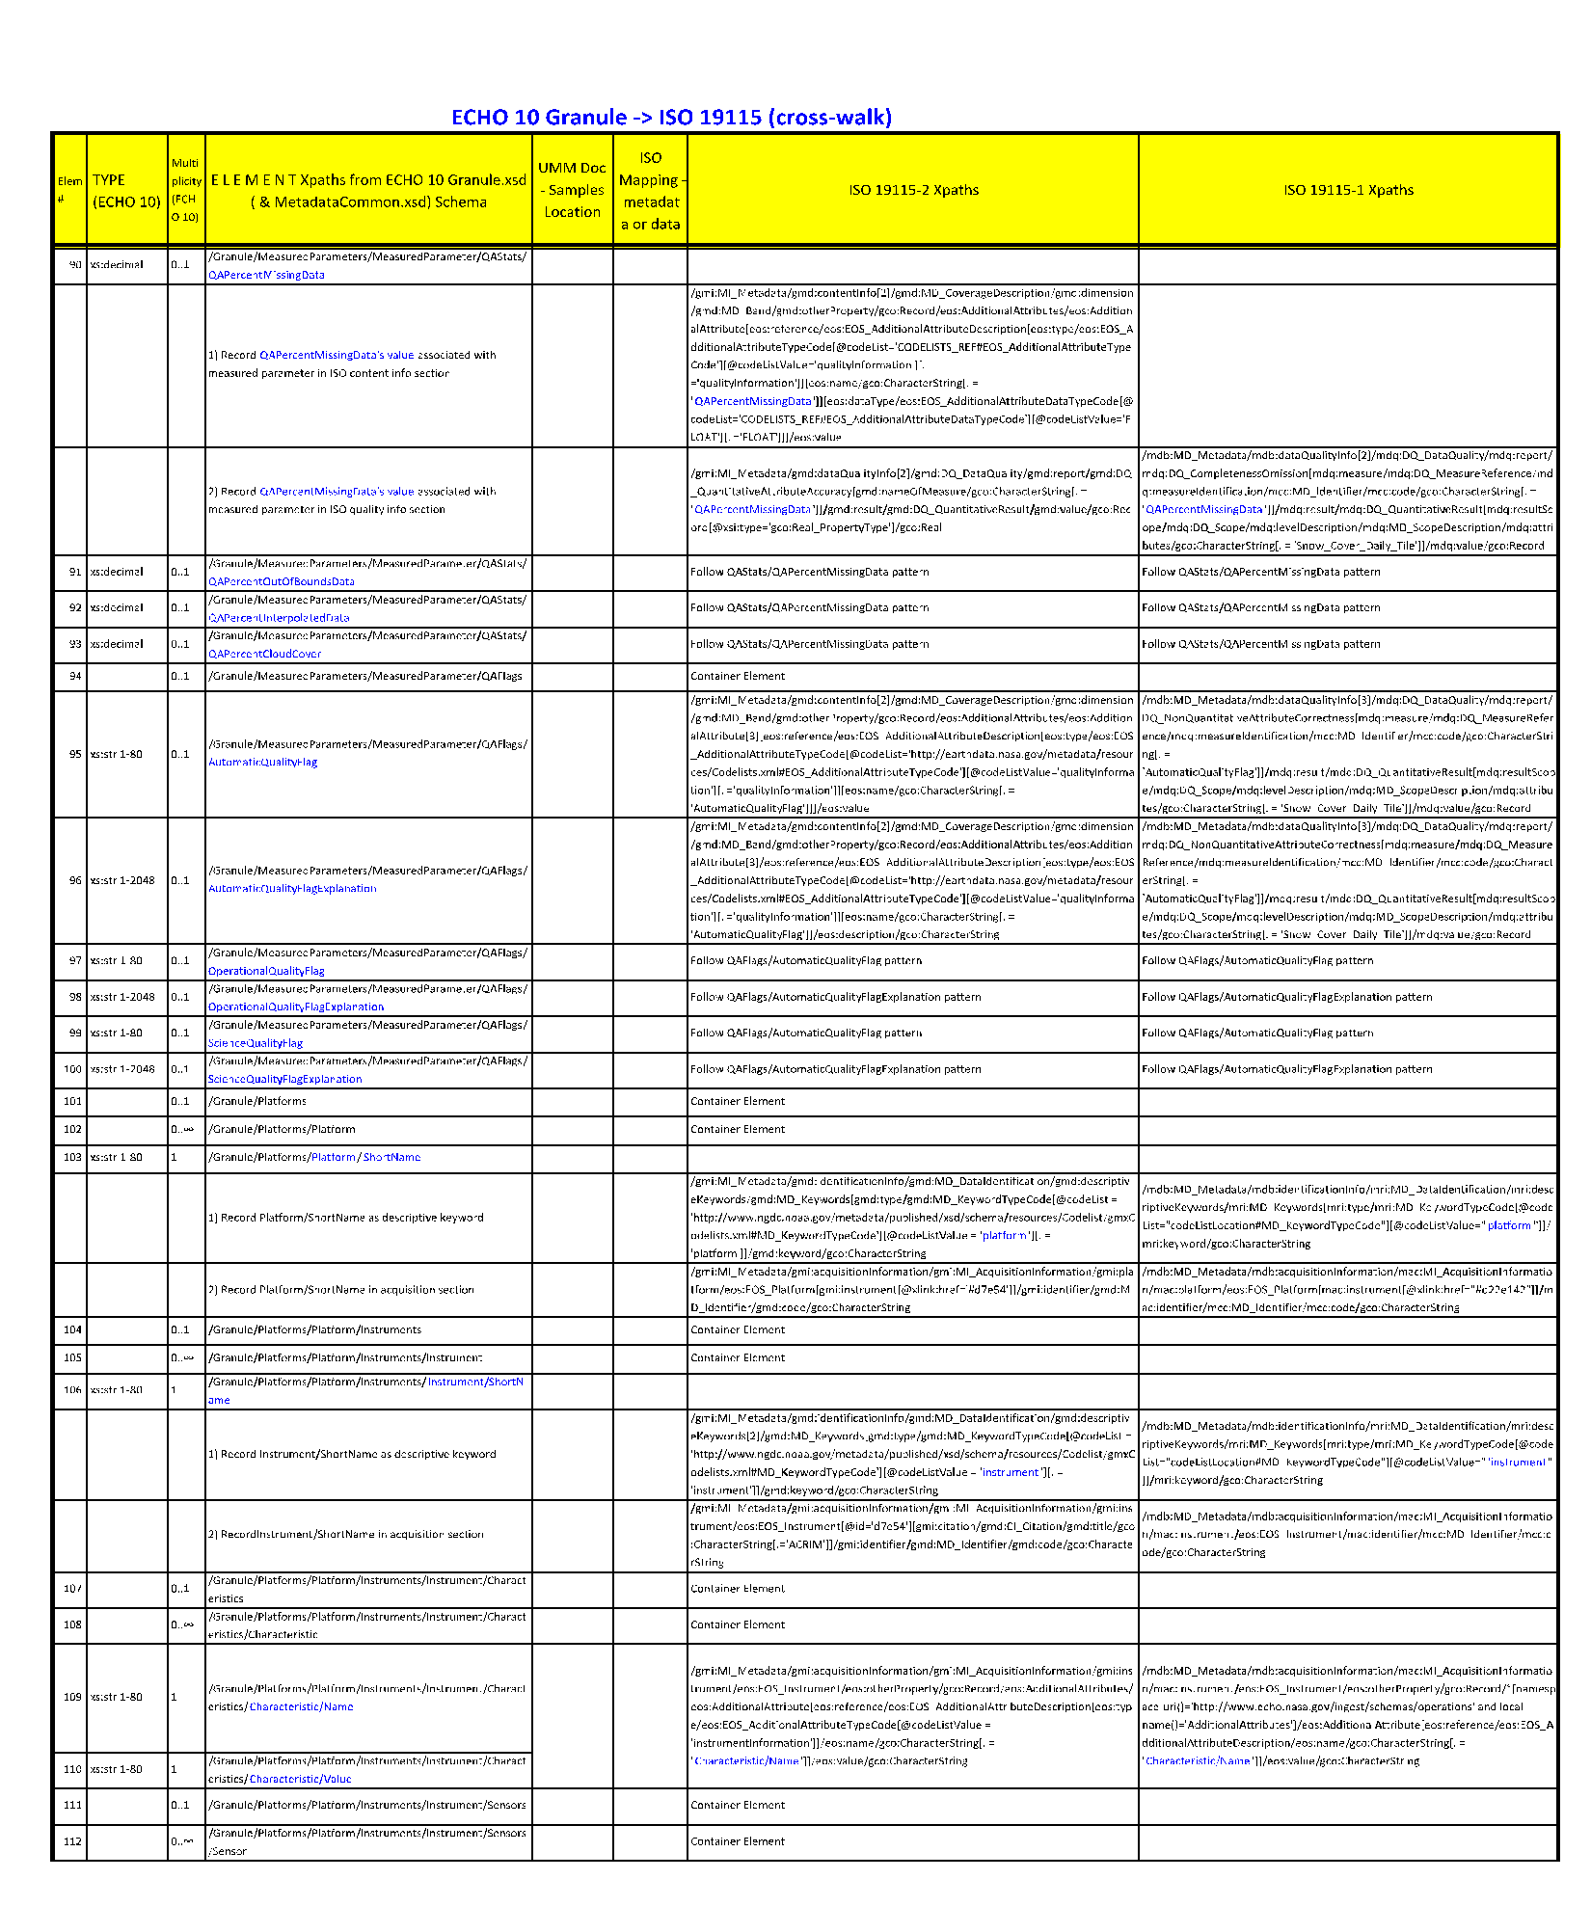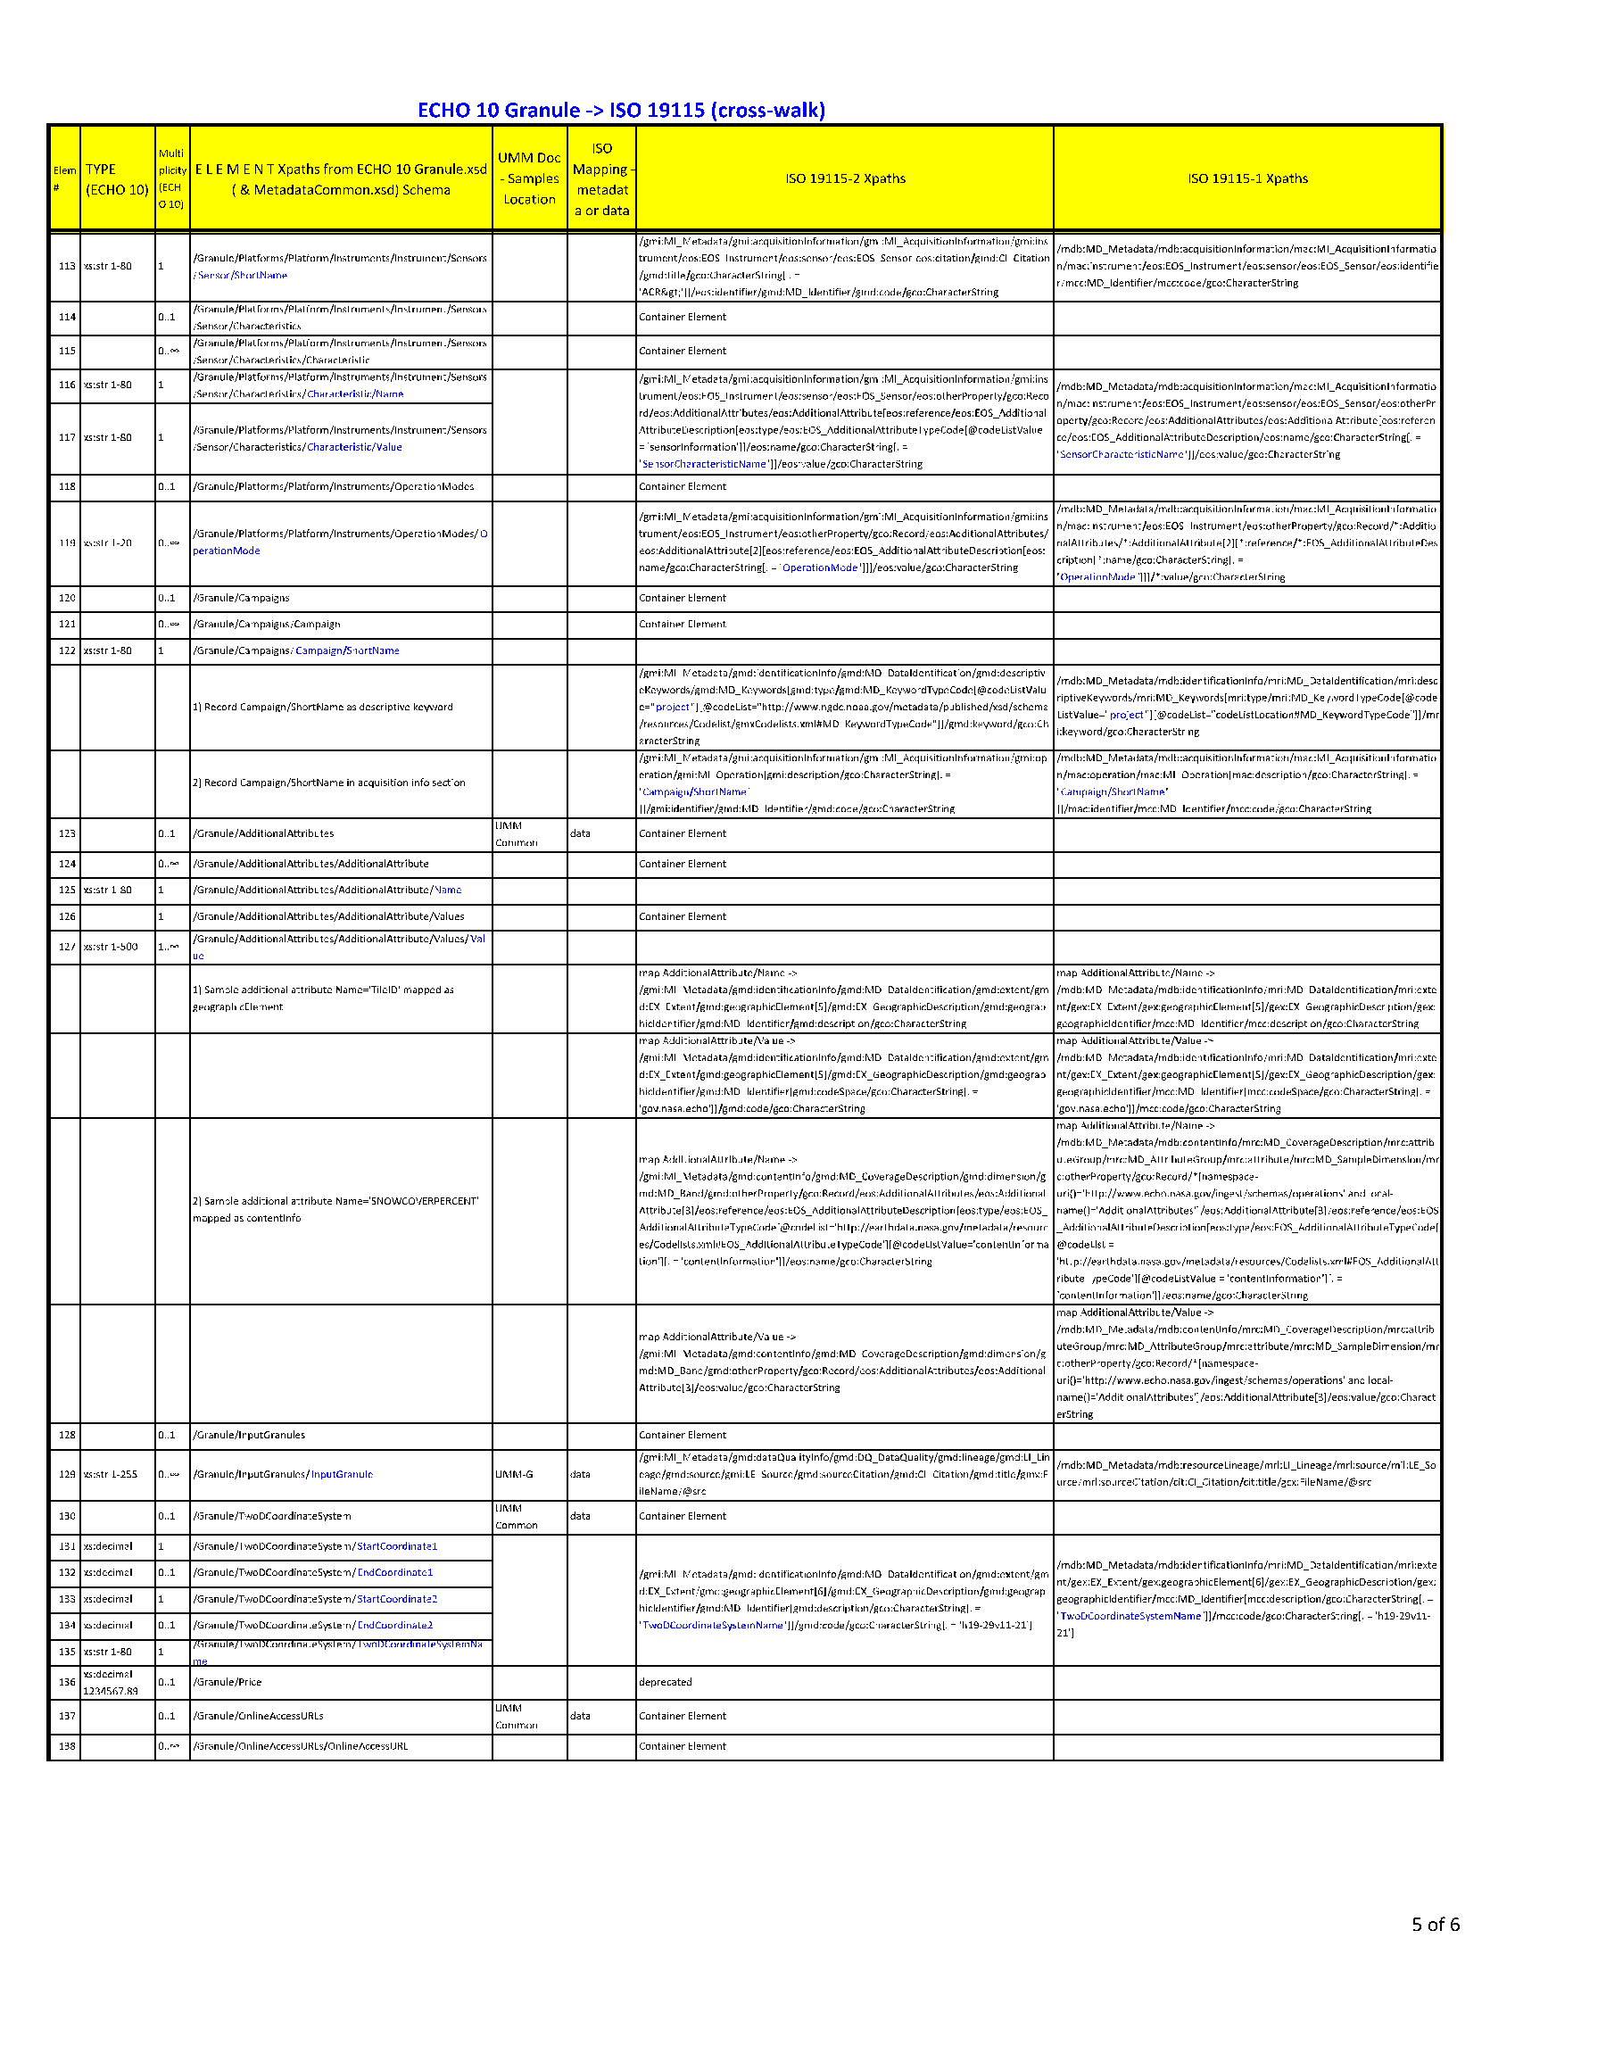
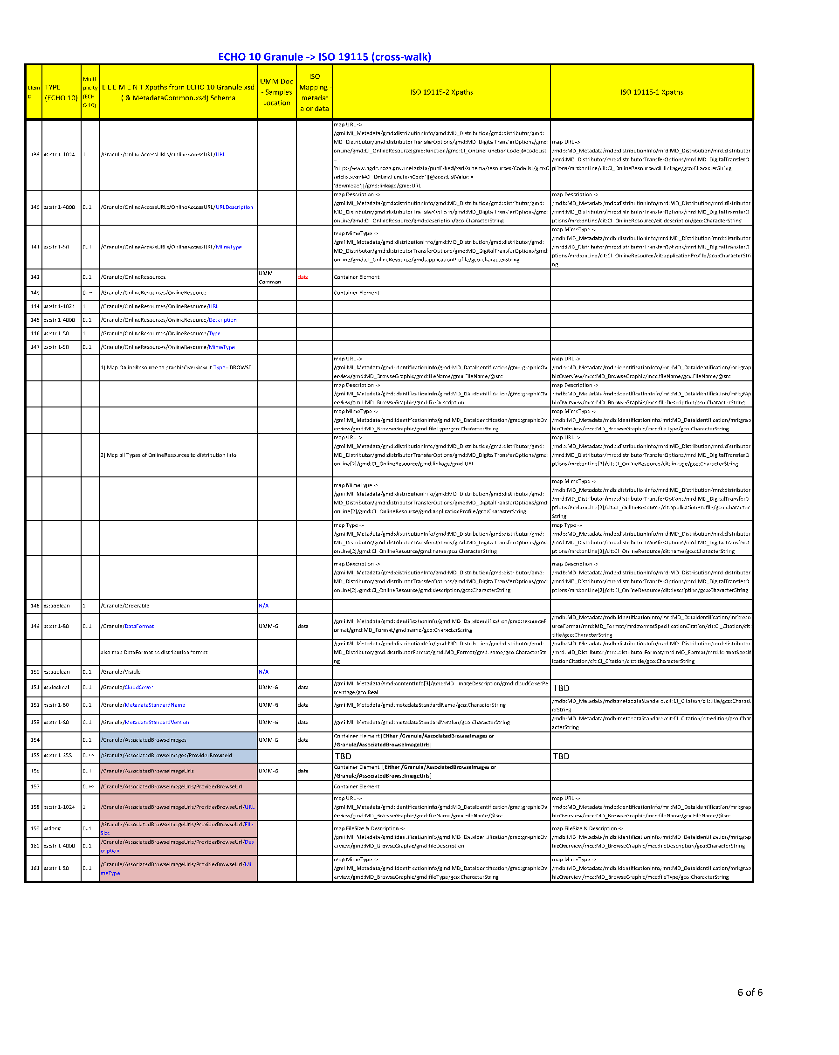
APPENDIX C-9 Abbreviations and Acronyms
ACL | Access Control List
CMR | Common Metadata Repository
DAAC | Distributed Active Archive Center
DOI | Digital Object Identifier
ECHO | Earth Observing System (EOS) Clearing House
EOS | Earth Observing System
EOSDIS | Earth Observing System Data and Information System
ESDIS | Earth Science Data and Information System
ISO | International Organization for Standardization
KMS | Keyword Management System
MAS | Metadata Architecture Studies
MENDS | Metadata Evolution for NASA Data Systems
NASA | National Aeronautics and Space Administration
NOAA | National Oceanic and Atmospheric Administration
UML | Unified Modeling Language
UMM | Unified Metadata Model
UMM–C | Unified Metadata Model – Collections
UMM–G | Unified Metadata Model – Granules
UMM–M | Unified Metadata Model – Metadata
UMM–S | Unified Metadata Model – Services
UMM–V | Unified Metadata Model – Visualization
UMM–Var | Unified Metadata Model – Variables
UMM–Vis | Unified Metadata Model – Visualization
URI | Uniform Resource Identifier
URL | Uniform Resource Locator
URS | User Registration System
XML | Extensible Markup Language
XPath | XML Path Language

